**2013**



Armario, Casurao, Carillo, Cruz, Fajardo, Federico, Galvez, Gerobiese, Jaldon, Luces, Peralta, Rimbao, Simon, Tan, Uygongco

**[FINAL DELIVERABLE]**

CENTRAL REPORTING AND INFORMATION SYSTEMS FOR PARTICIPANTS AND/OR PROGRAMS (CRISP)

CERTIFICATE OF AUTHORSHIP 6

Business Case 7

I. Company Overview 7

Background and Short History 7

Organization Mission and Vision 7

Organizational Structure 8

Products/ Services of the Organization 11

Customers of the Organization 11

BPAP-CHED-SEI Project 11

II. Current Situation 14

BPAP-CHED-SEI Project Title 14

Importance 14

Current Programs Offered 15

Problem Overview 17

III. Possible Projects 19

Central Reporting and Information Systems for Participants and/or Programs (CRISP) 19

Alternative 1: Separate Systems for each program 22

Alternative 2: Multiple-Database Reporting System using a Reporting Server 23

Alternative 3: EXCEL-Based Operations 24

Qualitative Model 24

Quantitative Analysis 27

Analysis 31

IV. Project Scope 32

Project Summary 33

Rational or Benefit of the Project 36

Technical Requirements 45

Limits and Exclusions 46

V. Project Charter 47

VI. The Project Plan 48

Project Organization and Team Organization 48

Work Breakdown Structure 60

Gantt Chart 68

Project Estimation 74

Notes: 76

Assumption: 76

Risk Management 76

Change Request Management 80

Change Request Process 80

Communications Management 81

Quality Assurance 85

Measures of Quality 85

Quality of Output 88

People in Charge 89

Project Monitoring and Tracking 89

Schedule and progress 89

Budget 90

Scope 91

Project Status at Final Deliverable Deadline 91

Project Closure 92

Lessons Learned 92

Appendix 93

Client Contact Information 93

Jopat Lelay 93

Glossary of Terms 94

Abbreviations 97

Computations for BPAP-CHED-SEI Project 99

Risk aspects: 99

Commercial Aspects: 99

Internal Operating Aspects: 100

Other Aspects: 100

Importance Weight: 100

Solving for NPV: 107

Solving for ROI: 108

Analysis 115

BPAP-CHED Implementation Timeline Summary 116

CHED BUDGET PROGRAM 117

Resume 118

WBS Dictionary 133

Task Description Worksheets 133

Risk Management Documents 175

Data Flow Diagrams 190

Status Reports 191

Status Report # 1 191

Status Report # 2 195

Status Report # 3 199

Minutes of the Meeting 203

Meeting Date: 09/09/13 203

Meeting Location 203

Meeting Start 203

Agenda 203

Meeting End 203

Decisions/recommendations 203

Next Meeting 203

Meeting Date: 09/11/13 203

Meeting Location 203

Meeting Start 203

Agenda 203

Meeting End 204

Decisions/recommendations 204

Next Meeting 204

Meeting Date: 09/20/13 204

Decisions/recommendations 208

Next Meeting 210

Meeting Date: 09/27/13 210

Decisions/RECOMMENDATIONS 211

CONTRACT OF AGREEMENT 212

Rubrics for Member Performance 231

Attendance Sheet 234

Status Report Template 235

Problem Report Template 236

Change Request Log 239

Analysis of Forms from GCAT, SMP, BEST, ADEPT 240

## CERTIFICATE OF AUTHORSHIP

**CERTIFIED**

We hereby certify that this submission **Big Bang Final Deliverable** abides by the principles stipulated in the DISCS’ Academic Integrity Policy document. We further certify that we are the authors of this program/ project/ report/ paper and that any assistance we received in its preparation is fully acknowledged and disclosed in the documentation. We have also cited all sources from which we obtained data, ideas, or words that are directly copied or paraphrased in this document. Sources are properly credited according to accepted standards for professional publication.

Joy Federico Francis Fajardo Paolo Luces

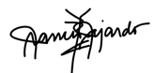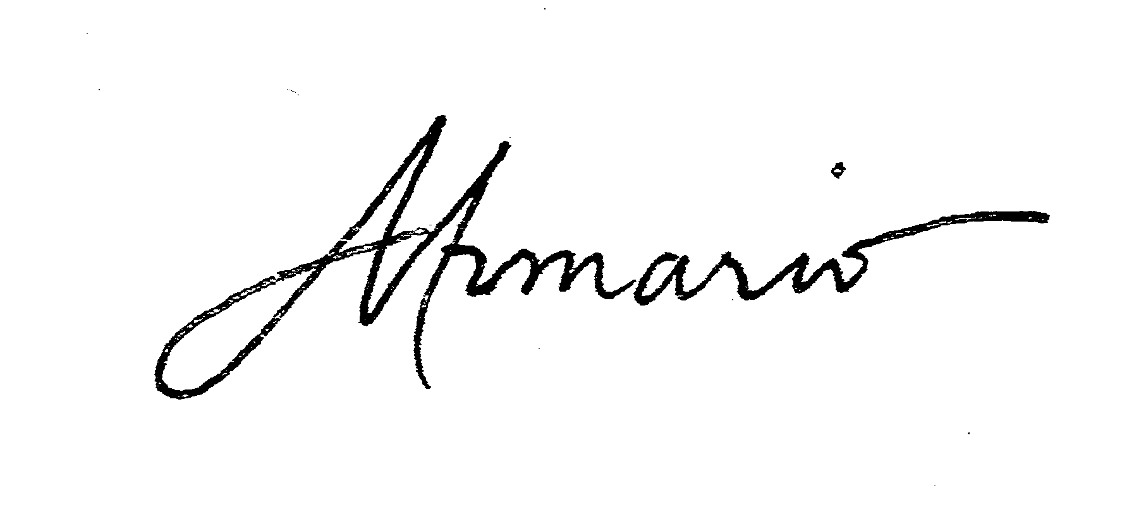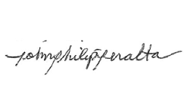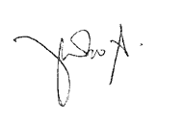

Raymond Cruz Dayanara Simon Philip Peralta



Gerard Uygongco Alecxandra Rimbao Aaron Casurao

Trishia Gerobiese Simone Jaldon Michelle Armario

____________

Chelsea Galvez Evan Tan Raphael Carrillo



Submitted to: Joselito Olpoc, Sandra Lovenia Date of Submission: October 9, 2013

As required in: MIS141

Sources: Please refer to document citations.

# Business Case

# Company Overview

## Background and Short History

Business Process Association of the Philippines, or BPAP, is a non-profit organization founded in 2004 supported by many stakeholders which comprise of the Philippine Government, Chambers of Commerce, and other allied industries (BPAP, 2013. Web). It has grown significantly from starting from a two-person operation, located in a managed serviced facility, to having Executive directors for information and research, talent development, industry affairs, and external affairs. Their staffs work full-time to support investment and expansion. Currently, it serves as a one-stop information and advocacy gateway for the industry and has been credited for the major role it played in the massive growth of the Business Processing industry in the Philippines (BPAP, 2013. Web).

## Organization Mission and Vision

**Mission**

Promote the competitive advantages and the growth potential of the Philippines in existing and new areas of outsourcing and support the industry in areas such as offshore marketing, education and training, security and privacy, legislation and public policy, among others. (BPAP, 2013. Web).

**Vision**

To make the Philippines the number one destination for voice and non-voice services worldwide (BPAP, 2013. Web)

## Organizational Structure

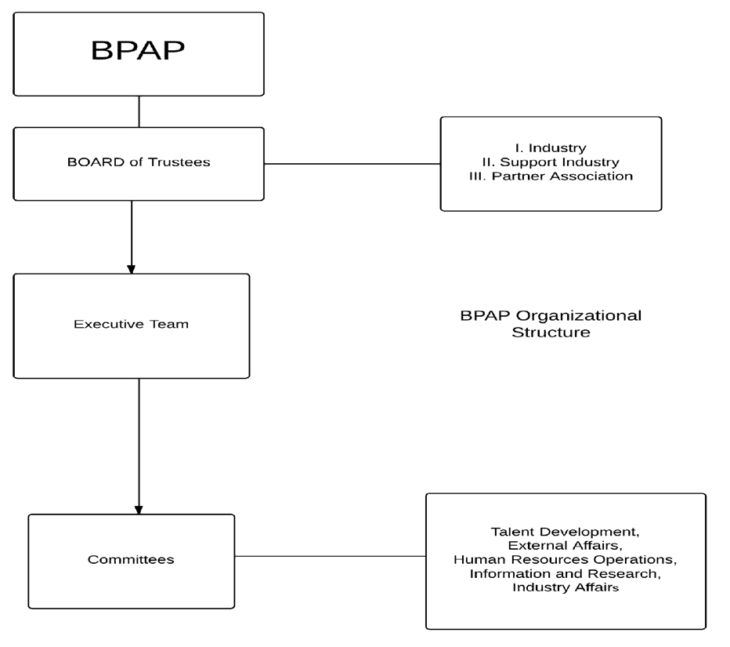

**Figure 1. Diagram of BPAP's Organizational Structure**

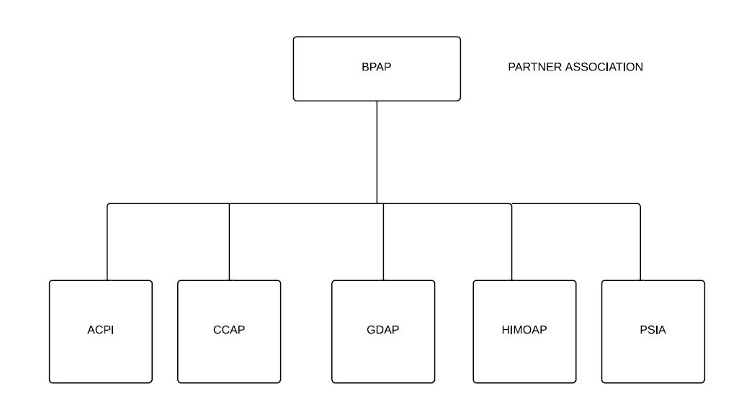

**Figure 2. Diagram of BPAP's Partner Association Structure**

**Board of Trustees**

The Board of Trustees is elected by the BPAP members to oversee the activities of the association. The Board governs the association by setting policies and objectives and ensuring the financial stability of the association. Each director is also assigned a specific supervisory role for major initiatives.

The board members are divided into three by the key role they represent: industry, supporting industry, and partner association. Five board members represent industry players, three represent supporting industries, and four represent partner associations. The BPAP President and CEO also sit on the board.1

**Executive Team**

The Executive Team leads the organization to its intended objectives and strategic goals. The President leads marketing initiatives to promote the Philippines as an outsourcing destination. In BPAP,

1 “IBPAP Board of Trustees*.” IT Business Processing Association of the Philippines*. 2013. [http://www.bpap.org/about-us/board-of-](http://www.bpap.org/about-us/board-of-trustees)  [trustees](http://www.bpap.org/about-us/board-of-trustees) (accessed August 11, 2013).

the Chairman of the Executive Committee executes BPAP’s strategic initiatives, the Senior Executive Director is in charge of the marketing research line, and the Executive Directors for Talent Development, External Affairs, Project Management Office, and Human Resources are responsible in leading their respective committees.2

**Partner Associations**

* ***Animation Council of the Philippines (ACPI)***

ACPI aims to create an identity for the Philippines as the preferred country for the provision of professional services to the global animation industry. It is a non-profit organization that is recognized and supported by the Philippine government.3

* ***Contact Center of the Philippines (CCAP)***

CCAP aims to promote the Philippines as the preferred country for contact center services, development of professional standards and practices, organization of learning and networking events, and working with various stakeholders to improve the industry’s contribution to national economy and strengthen its worldwide market position.4

* ***Game Developers Association of the Philippines (GDAP)***

GDAP aims to promote the game development industry in the Philippines. It is a non-profit organization with strong ties to various entities including the government and the International Game Developers Association.5

* ***Healthcare Information Management Outsourcing Association of the Philippines***

HIMOAP aims to promote the Philippines as the preferred destination for quality Healthcare Information Management (HIM) outsourcing services. It is a non-profit organization recognized by the Philippine government.6

2 “Executive Team.*” IT Business Processing Association of the Philippines*. 2013. [http://www.bpap.org/about-](http://www.bpap.org/about-us/executive-team) [us/executive-team](http://www.bpap.org/about-us/executive-team) (accessed August 11, 2013).

3 “Partner Associations.*” IT Business Processing Association of the Philippines*. 2013. [http://www.bpap.org/about-us/partner-](http://www.bpap.org/about-us/partner-association)  [association](http://www.bpap.org/about-us/partner-association) (accessed August 11, 2013).

4 Ibid.

5 Ibid.

* ***Philippine Software Industry Association (PSIA)***

PSIA aims to promote the software industry of the Philippines.7

## Products/ Services of the Organization

The organization assists the industry’s investor in order for them to set up easily and quickly here in the Philippines. They also provide support service to their partner companies by providing relevant research, programs for HR development and business development, knowledge sharing and network opportunities (BPAP, 2013. Web).

## Customers of the Organization

The organization primarily serves foreign investors looking to outsource their business processes here in the country and BPO companies where they provide support in order to maintain the competitiveness of these companies in order to maintain its growth (BPAP, 2013. Web). They also partner with the Philippine government to create policies in order to provide an environment where the Business Processing industry will thrive.

## BPAP-CHED-SEI Project

**Overview**

Currently BPAP and SEI has partnered with CHED in a P132M education and training program in an effort to help selected SUCs across the nation to produce higher quality graduates especially in IT and Business Administration (BA) courses to maintain the growth of the Business Processing industry in the Philippines (Dulce, 2013. Interview). This effort to bridge the gap between “Education” and “Industry” is currently in its implementation phase and if successful, will open the possibility to create similar programs for other courses and industries.

6 Ibid.

7 Ibid.

The BPAP-SEI-CHED project is in its first year of implementation in 17 State University and Colleges (SUC) all across the country, with the teachers and students enrolled in the following talent development programs: T3, SMP, e-AdEPT, Best, and GCAT (Dulce, 2013. Interview). These programs are coached by the industry professionals provided by BPAP, who are tasked to train the teachers, and then teach the students (Dulce, 2013. Interview).

**Project Partners**

* ***Commission on Higher Education (CHED)***

As the leader of the Philippine higher education system, CHED’s role mainly consists in partnering with other higher education stakeholders to establish innovation capacity and human capital towards development of a Filipino nation.

CHED is responsible in the formulation and implementation of policies, plans, and programs to better develop quality education systems for tertiary and graduate students. CHED is working in partnership with other higher education stakeholders to develop the skill set and competencies of the country’s human capital.8 CHED plays a vital role in Philippine education by means of: (1) promoting relevant and quality higher education (i.e. higher education institutions and programs are at par with international standards and graduates and professionals are highly competent and recognized in the international arena), (2) ensuring that quality higher education is accessible to all who seek it particularly those who may not be able to afford it, (3) guaranteeing and protecting academic freedom for continuing intellectual growth, advancement of learning and research, development of responsible and effective leadership, education of high level professionals, and enrichment of historical and cultural heritages, and (4) committing to moral ascendancy that eradicates corrupt practices, institutionalizes transparency and accountability and encourages participatory governance in the Commission and the subsector.9

CHED is currently working on stepping up college students toward the standards of what the labor

8 "CHED." *Commission on Higher Education.* 2010. <http://www.ched.gov.ph/chedwww/index.php> (accessed August 11, 2013).

9"CHED." *Commission on Higher Education.* 2010. [www.**ched**.gov.ph/**ched**www/index.../CMO%20No.46%20s2012.pdf](http://www.ched.gov.ph/chedwww/index.../CMO%20No.46%20s2012.pdf) (accessed September 11, 2013).

market needs. The Commission identifies priority courses based on national development plans, manpower demands for 2011-2015 and the Department of Labor and Employment’s in-demand jobs.10 Some of these priority courses include: Engineering, Agriculture, Health Sciences, Teacher Education, Information Technology, etc. (Pazzibugan, 2013)

* ***Department of Science and Technology – Science Education Institute***

The Science Education Institute (SEI) is one of the attached agencies of DOST under the Scientific and Technological Services division. They are created as part of Executive Order 128 “REORGANIZING THE NATIONAL SCIENCE AND TECHNOLOGY AUTHORITY” in order to make National Science and Technology Authority more effective and responsive to the scientific and technological needs of the country. DOST-SEI partners with educational institutions to propel the growth of science education and research for nation building.11

**Value that Customers want from BPAP**

Together, CHED and SEI approached BPAP to implement a project to students of State Colleges and Universities (SUCs). BPAP, being part of the business processing industry, is expected to bring value and excellence in developing the skill sets of IT & BA students which they would eventually bring with them after graduation and eventually during their seeking of employment. Moreover, programs rolled out by BPAP can bring a significant amount of progress as a tool or medium for teaching and training students and teachers.

The value and importance of this project have even reached the news - the collaboration seeks to improve the Business Processing workforce of the nation by integrating an industry- based curriculum into the SUC.12 This will help 20,000 students and more than 500 teachers so that by 2016, more Filipinos will be employed. Without a doubt, the collaboration of CHED, SEI, and BPAP will impact the nation’s human resources greatly.

10 “CHEd identifies 'priority courses' to fill needs of workforce.” *Philippine Daily Inquirer.* 2013. http://newsinfo.inquirer.net/460907/ched-identifies-priority-courses-to-fill-needs-of-workforce (accessed August 12, 2013).

11“Science Education Institute-Department of Science and Technology.” *Department of Science and Technology.* (n.d.). <http://www.sei.dost.gov.ph/ts/sei_msp.pdf>(accessed August 12, 2013).

12 “New SMP accord seeks to boost BPO skills of state college students.” *Business Mirror.*  [http://businessmirror.com.ph/index.php/en/news/top-news/10010-new-smp-accord-seeks-to-boost-bpo-skills-of-](http://businessmirror.com.ph/index.php/en/news/top-news/10010-new-smp-accord-seeks-to-boost-bpo-skills-of-state-college-students(accessed)  [state-college-students (accessed](http://businessmirror.com.ph/index.php/en/news/top-news/10010-new-smp-accord-seeks-to-boost-bpo-skills-of-state-college-students(accessed) August 12, 2013).

# Current Situation

## BPAP-CHED-SEI Project Title

Developing State University and College Graduates Towards Global Competitiveness, National Productivity and Development Project

## Importance

This project will benefit the state universities by increasing the number of the graduates employed in the business processing industry. It will also develop the critical mass of industry competency-aligned teachers. The schools will also have a sustainable partnership model with business processing firms that will increase enrolment and source alternative development funds. The significance of this BPAP-SEI- CHED project is divided among the project goals, purpose, and resources. As a result of achieving the program objectives, it is expected that there will be an increase in the employment percentage of male and female graduates from the participating SUCs in the Business Processing sector (ideally 70%). Other than that, it is also expected that the program will be fully implemented in the 17 SUCs involved. This plan is carried out through the teacher training and student participation in the different programs that BPAP implements. These programs, are the following: Global Competitiveness Assessment Tool (GCAT), Basic English Skills Training (BEST), Electronic Advanced English Proficiency Training (e-ADEPT), Service Management Program (SMP).

## Current Programs Offered

* + **GCAT**

Global Competitiveness Assessment Tool (GCAT) is an online profiling test that appraises the competence of the test taker in certain qualities deemed useful in the field of employment. Characteristics such as English proficiency, empathy, communication, reliability skills, etc. are measured by this test.

BPAP has partnered with AAI (Advanced Analytics Institute) to provide this assessment tool to the students wanting to take part in the test. Taking the GCAT is done by batches where students have to register with their respective SUC and the test itself is done within computer labs of the SUC. Only upon registering will the student be provided with the product key (or given access) to this online test. AAI then evaluates, and sends the results to BPAP to be stored and kept track of.

* + **BEST**

Basic English Skills Training (BEST) is another program implemented by BPAP to the respective SUCs. BEST is an e-learning platform designed to enhance one’s communication skills through feedback of the user’s skill in the English language. BEST however, is a self- paced program wherein progress is up to the owner of the key itself on when he or she would like to complete the program, as long as it is within the designated period.

To utilize BEST, a participant is given a CD along with a card containing a product key that activates the program good for four months. For this, BPAP has partnered with Edulynx provide this software and the product keys needed. BPAP then has to keep track and make sure that the product keys they obtain goes to an individual as well. This is also then kept track of and serves as a marker to say that the student has undertaken BEST.

* + **e-AdEPT**

Electronic-Advanced English Proficiency Training (e-AdEPT) is another software provided by Edulynx designed to target the student’s English skills. Similar to BEST, this is more advanced and designed as a further improvement of English skills. The process for distribution is also the same, and BPAP has to keep track of the product keys and their respective recipients as well. Those who do receive the e-Adept platform are then considered to have taken this.

* + **SMP**

Service Management Program (SMP) is a minor program that is offered within the different SUCs which is integrated to the students’ course (with eligible students coming from either IT or BA). To attain this minor, a total of 21 units consisting of 7 different subjects/courses must have been taken and qualified for by the student. The curriculum for SMP is as follows:

**Table 1. Service Management Program (SMP) Curriculum**

|  |  |  |  |
| --- | --- | --- | --- |
| 3rd Year -First Semester | Second Semester | 4th Year - First Semester | Second Semester |
| Business Communication | Service culture | n/a | n/a |
| BPO101 | BPO102 | Systems Thinking | Internship |

This curriculum for the minor program (SMP) has already been approved by CHED and is being implemented. Currently, students have already undertaken the earlier subjects of the SMP. BPAP then has to keep track of these students and their performance.

## Problem Overview

* + **Student Rollout**

As already stated, an estimated tracking of 20,000 students per year is expected upon the full implementation of the programs from BPAP (GCAT, BEST, e-Adept, SMP). To be considered part of BPAP’s intervention (and with it to be registered and tracked by BPAP itself), a student must have participated in AT LEAST one of these programs. However, each of these programs has different qualifications to register and with it different prerequisites and data to be tracked. Since the problem of BPAP arises in the lack of system for storing and monitoring results, BPAP needs to track participants’ progress.

**Table 2. Program Qualifications, Prerequisites, and Data Needed To Be Tracked**

|  |  |  |  |
| --- | --- | --- | --- |
| **Program** | **Prerequisites** | **Data to be tracked (specific)** | **Source** |
| GCAT | Test must be taken | Performance | SUCs’ registration/signup and AAI data |
| BEST | Student received product key | Reception of key | Manually filled up list of key and owner |
| e-Adept | Student received product key | Reception of key | Manually filled up list of key and owner |
| SMP | Course of IT or BA, taken up the subject for minor | Courses undertaken, performance, | SUC data |

The fact that 17 SUCs are in different locations nationwide, and have different administrations, following different methods of recording, transmitting and saving said data is an issue in the initial stage of being part of the BPAP-SEI-CHED project. This project has been identified to have two levels.

The first level would be the different SUCs that data are gathered from. An example is the way BEST and e-AdEPT is implemented. For some of the SUCs, these are credited units which students have to sign up for and as such, the SUC can provide the details to the project manager from BPAP keeping track of this data. However, it can only be considered as extra- curricular for other SUCs and with that, the data would have to be taken in a different method, outside of the school’s records.

On the second, more macro level, different data is also collected with respect to the different programs present. One example would be the difference between BEST and SMP. With BEST being a software that has to be given to students, BPAP only keeps track of its reception through the manual process of noting down the product key received by a student as it is physically handed out. However, SMP is a program that consists of actual courses, thus the need to take note of records that can be given to BPAP project managers for them to keep track of.

* + **T3**

Though the end target of the BPAP-SEI-CHED project is geared towards the students who would be affected, the main part of the BPAP intervention effort is directed at training the teachers involved, hence the acronym “T3” (Train The Teachers). BPAP also has to keep track of the relationships of the training sessions among the teachers, students and the programs. With this in mind, trainers are also hired by BPAP to introduce new courses and enhance the teaching skills of a targeted 500++ teachers. These teachers will be trained depending on which program they are placed in. BPAP gives 2-day training for BEST, 6-day training for e-Adept, and finally, a training course for each subject under SMP.

To determine project effectiveness, BPAP also has to keep track of the relationships of the trainings given to the teacher, and the teacher to the students involved. These relationships, performance measures, and even the status of having participated in a program would help in determining the level of impact of each program and of the interventions as a whole.

The BPAP-SEI-CHED project is currently in its early stage, with students having taken GCAT, BEST, e-ADEPT, and the early half of the SMP intended for the 3rd year students. However, in spite of the ongoing implementation of the BPAP project, the recording of the data mentioned earlier is falling behind, with their current process being a translate-to-Excel arrangement. This has already caused problems with reporting and information organization. The project managers are expressing their difficulty in accessing specific data.

# Possible Projects

## Alternative 1: Central Reporting and Information Systems for Participants and/or Programs (CRISP)

As mentioned in the previous sections, this BPAP-CHED-SEI project has many students, teachers, and programs under it. By themselves, the data should not be too problematic; however, the problem with these data is how they will look like mapped out when viewed from a relational perspective. Teachers can be considered students since they will be trained by mentors of BPAP but at the same time, there are various students under them. At the same time, a participant can enter multiple programs.

Due to the project’s enormity and complexity, it might be the better option to build a system from scratch. The needs of the company are as follows: capturing the data, monitoring the data, and providing reports. The system the three groups are proposing answers all those through three separate subsystems. The Central Reporting and Information Systems for Participants and Programs, or CRISP, is composed of the following components of data capture and report generation.

The first component of the system involves capturing transactional data, which is in other words called “data capturing”. The system will need to acquire the necessary data from the different SUCs and the third-party participants mentioned before this section (Edulynx and AAI) through the use of software packages. Considering the fact that data coming from different SUCs are not necessarily exactly the same, there needs to be a means by which these data gathered are stored in a standardized manner.

This data capturing portion involves three activities: (1) importing data sent by Edulynx and AAI, (2) enabling web distribution of PINs for e-Adept and BEST and collection of data stemming from this, (3) importing data from the SUCs to the BPAP representative who is handling these data items. The data will then be sent to the next vital component for processing.

The second component involves the extracting, transformation, and loading (ETL) of the data provided by the first component by aggregating said data items in a single location, then these data will be monitored through an interface.

Tracking and consolidating a high volume of participants from different schools will be problematic as data consistency and integrity might become an issue. For instance, there might be duplicates of primary keys. The first process of this subsystem will ensure that the data input is correct and consistent by *extracting* the data from the sources over the cloud and validating them by checking if it is in the right format, *transforming* them to be consistent with the rest of the data set, and *loading* them into a database for storage and querying. This is known as the Extract-Transform-Load (ETL) process. The sources of the raw data are the SUCs.

As mentioned above, the users of the system will be able to control and manage the data through an interface which will take the form of a web application. This web application will

have different functionalities such as viewing the data, having means of communicating with the different SUCs, giving notifications of data abnormalities, approving entry to the database, etc. The final component involves generating reports from the database. On an executive level, BPAP will need a tool to help them in assessing the progress of each participant and each program.

**Cost**

The total cost of ownership (TCO) of the database goes beyond initial implementation. Over a period of years, the continuing cost will very likely exceed the cost of the initial implementation. The annual cost for the maintenance of the database often runs between 40% to 60% of the implementation cost. (Adelman)

Maintenance includes the contractual maintenance cost of the hardware and software (usually 15% to 20% of the software retail or purchase price). If the hardware was purchased, the depreciation of the hardware should be included. For leased hardware, the leasing costs must be included. New or upgraded software and hardware may be required if the system does not perform as expected or if the usage and complexity go beyond initial estimates. Technical personnel will always be required establish and run backup and recovery procedures, to monitor and tune the system, and, with the normal turnover, there will be an additional cost with the introduction of new technical people. There will always be requirements for, and costs associated with, assimilating new data, new capabilities, and new users into any successful data warehouse. (Adelman)

New data will be added, sometimes more than for the initial implementation. The design most likely will change, and the database will need to be tuned. Additional historical data will increase CPU and disk requirements. New software will be introduced, new releases will be installed and some interfaces will have to be rewritten. As the database grows, the hardware and network will have to be upgraded.

The typical cost of building and running a personal good-sized database is 19,000 USD to 25,000 USD per terabyte per year. On the other hand, cloud-based database can be cheaper. Amazon offers a cloud based database, Amazon Redshift, which provides 2 terabytes of data per year for 2000 USD. (Henschen, 2012)

## Alternative 2: Separate Systems for each program

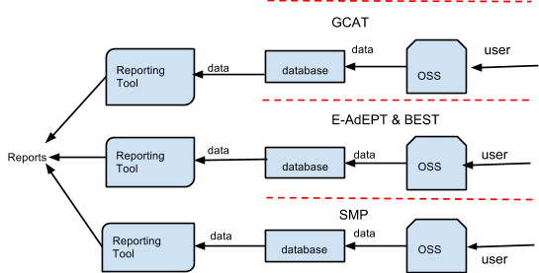

**Figure 3. Diagram of Separate Systems Project**

This project will construct separate systems for eAdept and Best and, for SMP. Each program will have its own data-gathering, data monitoring, and reporting service. The reporting service will use reporting tools such as SQL Reporting Services, Crystal Reports and other software. Each system will have its own database. This will eliminate the need for single repository of data such as a database. An employee in BPAP may gather all of these.

One advantage of this is the elimination of the need to construct a large database, which is costly. In addition, reports needed for each of BPAP’s programs (GCAT, BEST, E-AdEPT, SMP) will produce its own reports faster because the data relationships are less as compared to a single repository that contains all the data from other programs. This kind of design is best when the organization is focusing on the programs as separate entities. The main disadvantage is that reporting tools alone cannot process large data efficiently. Gathering individual data from the different systems would come as a challenge since records are stored on different locations. It would also be very hard to consolidate all the records and reports since each has its own system. Furthermore, it would come as redundant if participants are enrolled in multiple programs.

## Alternative 2: Multiple-Database Reporting System using a Reporting Server

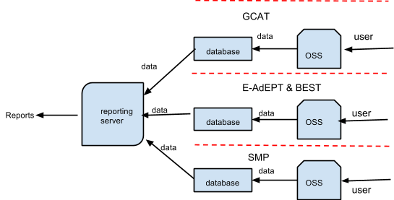

**Figure 4. Diagram Using Multiple Database Reporting System (Reporting Server)**

A web server for reporting configures data sources from each database of the separate systems of GCAT, eAdept and BEST and SMP. Then, the server will copy all the data using various database replication tools, sharing information to ensure consistency and accessibility. This gets all necessary data onto one server. It will not be contained in a single set of tables. Rather, it will combine data from sources to be generated into reports. Depending on how many queries are built, it usually cleans and processes data more efficiently than regular reporting tools. The logical design is almost the same as the first alternative; however, instead of using reporting tools, a reporting server will be used to create reports. (Knox)

## Status Quo: EXCEL-Based Operations

Developed by Microsoft Corporation, Excel is an application that has a spreadsheet and database capability. Excel is generally easy to use but it also has its own limitations. Using the enterprise features of the Excel, users can easily sort, filter, reorganize, add, and upload records over a network. It can be used as a database for keeping track certain information and basic business processes. In addition, reporting and data analysis tools are also available within the program. The problem comes when the file gets bigger over time. BPAP expects the records to grow to around fifty five thousand (55k+) records for all of the participants of the learning program in a few years. Excel files would not be able to handle the amount of data.

## Qualitative Model

Following the comparative benefit model (quick sort method), the group considered four projects and the one with the most benefit to the organization is selected.

**Table 3. Possible Projects Pros and Cons**

| **Projects** | **Pros** | **Cons** |
| --- | --- | --- |
| **Central Reporting and Information Systems for Participants and/or Programs (CRISP)** | * Data retrieval is faster * Will enable queries to access data from different sources * Can integrate data from multiple source systems * User friendly interface * Provides ease with regard to consolidating * Can customize the functionalities that would better address the needs of the organization * Can work with different processes (ex. Additional programs and profiling) * Software and resources are provided by the client * Restructure the data so that it delivers excellent query performance, even for complex analytic queries, without impacting the [operational](http://en.wikipedia.org/wiki/Operational_system)  [systems](http://en.wikipedia.org/wiki/Operational_system). (Inmon, 1992) * Can provide a single common data model for all data of interest regardless of the data's source * Can present the organization's information consistently * Can be used to improve data quality by providing consistent codes and descriptions, flagging or even fixing bad data * System can help mitigate the problems and inconsistencies in the source systems * Extensibility of the system can provide BPAP with more projects. * Would be able to keep track of historical data and access at a relatively faster rate | * Users may be unfamiliar with queries * Needs internet connection * Users may be resistant to change * Complex relationships and architecture * Project may contain security flaws due to bad security design and existence of sensitive information * High costs due to maintenance cost and payment to IT personnel * May need people knowledgeable about * Databases |

| **Projects** | **Pros** | **Cons** |
| --- | --- | --- |
| **Central Reporting and Information Systems for Participants and/or Programs (CRISP)** | * System can help mitigate the problems and inconsistencies in the source systems * Extensibility of the system can provide BPAP with more projects. |  |
| **Separate System for Programs** | * Elimination of the need to construct a large data warehouse * More focus on the programs * Data retrieval and reporting for a single program is relatively faster * Reusable and extensible * Can create customized reports * Software and resources are provided by the client | * Complexity of the data relationships needed can be a toll to the system performance * A challenge to gather individual data from different sources and consolidate them into a single report * Users may be unfamiliar with queries * Needs internet connection * Users may be resistant to change * Redundancy: Profiles can be repeated across the different systems * Data mining can be a challenge |
| **Reporting Server** | * Gets data onto one server improving performance * Cleans and processes data more efficiently * Cheaper compared to a full sized data warehouse * Can create customized reports * Extensible in terms of reports and additional programs * Elimination of the need to construct a data warehouse * User friendly interface * Software and resources are provided by the client | * The group may have to look for IT personnel with programming background to maintain the system * Slow performance when there are several reports * Not as effective as a data warehouse * Difficult to query since data of interest might spread across many databases * Slower report generation * Users may be unfamiliar with queries * Needs internet connection * Users may be resistant to change * Data mining can be a challenge |
| **Excel-based Operations** | * Easier to acquire since there are available MS Office software in the market * Off-the-shelf software so it relatively cheaper option * All-in-one program that yields usability for users (i.e. easy to create, update, and maintain, program using Excel VBA Programming) * No/little training needed because it is a familiar environment to users * Excel files can be password protected for added security * Portable than the other options in terms of uploading, sharing, and opening in different hardware * capable of connecting directly to OLAP databases | * Increased vulnerability (e.g. viruses that can attach to macros, cells and formulas can be easily altered) * May be an inconvenience for users considering its slow program execution and in terms of consolidating records across different Excel files * May yield inaccuracies in data due to human error (e.g. calculations done on spreadsheets will be wrong if there are errors in the formula) * Cannot create reports like those of databases * Not scalable for accessing and manipulating large data volumes * Does not give the levels of confidence in case of data duplication |

## Quantitative Analysis

### Scoring Method

|  |
| --- |
| Legend: Weight importance |
| 1- low |
| 2- low-medium |
| 3- medium |
| 4- medium high |

|  |  |  |
| --- | --- | --- |
| **Client-Favorable** |  | |
| Comprehensiveness of data processing | Refers to the coverage of how much data processing is done by the system in terms of volume, and complexity | |
| Long Projected lifetime | Refers to the estimated amount of time that the system can be used by the client | |
| Ease of deployment | The degree of difficulty encountered when installing the system on new computers | |
| Extensibility | Answers whether the project allows future expansion with regards to the programs or the clients that are using the same framework. | |
| Scalability | Answers whether the project has the ability in catering bigger amounts of data. (in addition to the target) | |
| Need for training of employees | The need to train or develop employees for the proper implementation of the project | |
| Need for additional work force | The need to hire additional employees for the project | |
| Time saved | The time saved upon use of the proposed project | |
| Ease of use | The degree of difficulty encountered upon new introduction to the project | |
| Familiarity of client with possible software/UI | The familiarity of the user with the project Interface | |
|  |  | |
| **Project Team-Favorable** |  | |
| Length to finish the project | Answers the question of pressure present on finishing the given project on time | |
| Technical skills needed to develop system | Refers to the mastery of different proficiencies required to develop, and implement system | |
| Need for additional resources | Answers the question of how much resources: manpower, software, or hardware are needed to complete the project | |
| Complexity of troubleshooting | Refers to the degree of difficulty when troubleshooting the project. Takes into account the different languages of the system, the amount of time spent for troubleshooting | |
| Need for maintenance | Refers to the frequency of maintenance needed for the system | |
| Easy to monitor | Refers to the degree of difficulty in monitoring system activity | |
| Range of skills needed | The amount of different skills (in terms of programming language, platforms, OS, etc.) needed to complete the system | |
| Complexity of System | Refers to the degree of interconnectedness of the system to the client's current processes | |
|  |  | |
| |  |  |  |  |  |  |  |  |  |  | | --- | --- | --- | --- | --- | --- | --- | --- | --- | --- | |  |  | CRISP | | Separate Systems | | Reporting Server | | Excel based operations | | | Criteria | Weight | Score | Weighted Score | Score | Weighted Score | Score | Weighted Score | Score | Weighted Score | |  |  |  |  |  |  |  |  |  |  | | **Client-Favorable** |  |  |  |  |  |  |  |  |  | | Comprehensiveness of data processing | 5 | 3 | 15 | 2 | 10 | 2 | 10 | 2 | 10 | | Long Projected lifetime | 2 | 3 | 6 | 3 | 6 | 3 | 6 | 2 | 4 | | Ease of deployment | 4 | 3 | 12 | 1 | 4 | 1 | 4 | 3 | 12 | | Extensibility | 4 | 2 | 8 | 3 | 12 | 2 | 8 | 1 | 4 | | Scalability | 3 | 2 | 6 | 3 | 9 | 2 | 6 | 1 | 3 | | Need for training of employees | 1 | 3 | 3 | 3 | 3 | 3 | 3 | 2 | 2 | | Need for additional work force | 1 | 2 | 2 | 2 | 2 | 2 | 2 | 2 | 2 | | Time saved | 2 | 3 | 6 | 2 | 4 | 3 | 6 | 2 | 4 | | Ease of use | 2 | 3 | 6 | 2 | 4 | 3 | 6 | 3 | 6 | | Familiarity of client with possible software/UI | 3 | 2 | 6 | 1 | 3 | 2 | 6 | 3 | 9 | | ***Subtotal*** |  |  | 70 |  | 57 |  | 57 |  | 56 | | **Project Team-Favorable** |  |  |  |  |  |  |  |  |  | | Length to finish the project | 5 | 2 | 10 | 3 | 15 | 2 | 10 | 1 | 5 | | Technical skills needed to develop system | 4 | 3 | 12 | 3 | 12 | 3 | 12 | 2 | 8 | | Need for additional resources | 1 | 2 | 2 | 3 | 3 | 3 | 3 | 2 | 2 | | Complexity of troubleshooting | 2 | 2 | 4 | 2 | 4 | 1 | 2 | 3 | 6 | | Need for maintenance | 4 | 1 | 4 | 1 | 4 | 1 | 4 | 1 | 4 | | easy to monitor | 3 | 3 | 9 | 3 | 9 | 3 | 9 | 2 | 6 | | range of skills needed | 3 | 2 | 6 | 2 | 6 | 1 | 3 | 3 | 9 | | Complexity of System | 1 | 3 | 3 | 1 | 1 | 3 | 3 | 1 | 1 | | Subtotal |  |  | 50 |  | 54 |  | 46 |  | 41 | | Total |  |  | 120 |  | 111 |  | 103 |  | 97 | |  |  |  |  |  |  |  |  |  |  | | |  | |
|  |  | |

### Analysis

## CRISP is the most viable project. Although a separate systems is the most favorable for the project team, the client favorableness outweighs it and is considered a more important factor in the project selection. Excel based operations is the least favorable project for both the client and the project team.

### Project Costing

|  |  |
| --- | --- |
| Project Cost | Total |
| **Salaries** |  |
| Development | 46500 |
| System Analysis | 90650 |
| Project Manager | 146775 |
| BPM Consultation | 57600 |
|  | **341525** |
| **Hardware** |  |
| Development Capable Laptops (30,000 per unit *3 units) | 90000 |
|  | **90000** |
|  |  |
| **Miscellaneous** |  |
| Parking | 3600 |
| Fuel | 10800 |
|  |  |
|  |  |
| Co-working space (2 mos at 14000/mo) | 28000 |
|  | **42400** |
| **Project Cost** | **473925** |

Savings

|  |  |  |  |  |
| --- | --- | --- | --- | --- |
| **Reporting & Consolidation** |  |  |  |  |
| **Reports needed per year:** | Quantity | Days saved | Wages per day of PM | Savings |
| Quarterly | 4 | 10 | 2200 | 22000 |
| Monthly | 12 | 30 | 2200 | 66000 |
| Yearly | 1 | 2.5 | 2200 | 5500 |
| Per need basis estimate | 20 | 50 | 2200 | 110000 |
| **Total** | 37 | 92.5 | 2200 | **203500** |

|  |
| --- |
| **Assumptions:** |
| It takes 2.5 days (in working hours) for the current employee to consolidate and finish a single report |
| All Wages are based on Philippine averages. Difference in wages takes into account raise based on experience Taken from: |
| http://myjobstreet.jobstreet.com.ph/career-enhancer/basic-salary report.php?param=Project%20Manager%7C%7C170%7C%7Cph |
| <http://www.salaryexplorer.com/salary-survey.php?job=762&jobtype=3&loctype=1&loc=171> |
| **Benefit Analysis:** |
| Based on costs, savings per year due to estimated needs for reporting saves a total of P203,500. Payback will take approximately 2-3 years from closure. |

# Project Scope

Project Title:

Central Reporting and Information System for Programs and Participants

## Project Team

|  |  |
| --- | --- |
| Member | Position |
| Joy Federico | Overall Project Manager |
| Francis Fajardo | Project Manager for the Policies and Standards Team |
| Paolo Luces | Project Manager for the Development Team |
| Raymond Cruz | Head Developer |
| Dayanara Simon | User Interface Developer |
| Philip Peralta | Reports Developer |
| Gerard Uygonco | Quality Assurance Lead |
| Alecxandra Rimbao | Systems Analyst |
| Aaron Casurao | Standards |
| Trishia Gerobiese | Systems Analyst |
| Simone Jaldon | Standards |
| Michelle Armario | Systems Analyst |
| Chelsea Galvez | Standards |
| Evan Tan | Systems Analyst |
| Raphael Carrillo | Standards |

### Project Summary

The objective of the BPAP-CHED-SEI project is to bridge education and employability. Currently in its first year of implementation, the involved bodies are experiencing problems in data consolidation and report generation since there is still no existing set of standards being strictly followed in the different processes of the project, most especially in the data gathering process. To solve this, the group will create a web-based participant data capturing and reporting system called Central Reporting and Information Systems for Programs and Participants (CRISP) in order to better capture and monitor the information of the participants and progress of the programs. At the same time, CRISP will also be able to generate front-end analytics, in the form of reports, needed for decision-making and monitoring. Additionally, the group will formulate a set of policies and procedures that will then be implemented by BPAP in order to properly execute and monitor the different programs under the project. User trainings will also be conducted along with the production of both technical and user manuals in order to aid in the further implementation of the group’s project. This project should be done at the cost of no more than P470, 000 within the time span of 103 days.

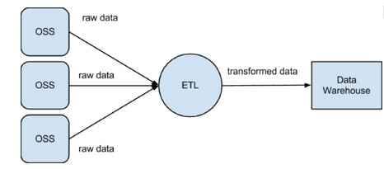

**Figure 5. The Central Repository and Information System for Participants and Programs (CRISP)**

*This system captures, stores, and creates reports based on the standardized data gathered from the different sources.*

With the BPAP-CHED-SEI project’s main goal of increasing student employability in mind, the company wishes to measure the effectiveness of the program and this can only happen if they are able to properly capture and monitor participant and the program information; these are the information needed for creating further analysis. However, there is currently no standardized way of gathering the data from the SUCs. Since the SUCs are geographically dispersed, data is sent over the cloud or through SMS as a more efficient and less costly means of capturing data. These data items can be in the form of Excel worksheets, email, or text messages. BPAP representatives will then manually encode and save the compiled data in an Excel worksheet which is stored in the BPAP office. For now, this system of recording and storing data may be sufficient for the company but due to the target volume of participants, this might prove inefficient and time-consuming in the coming years. Chances of data errors and redundancies might increase given the lack of proper formats and standards in the organization of data. Addressing these issues, the system will focus on three phases: (1) input, (2) process, and (3) output.

*Input*. Data to be gathered will consist of: (1) teacher and student information, (2) GCAT scores, (3) BEST and e-AdEPT scores, (4) SMP progress, and (5) T3 and class information. Sent by the respective VP for Academic Affairs of the different SUCs, encoders will then input received data on a web-based system which will store these in the main database. A standard format will be followed to regulate and properly organize the data coming from the different SUC

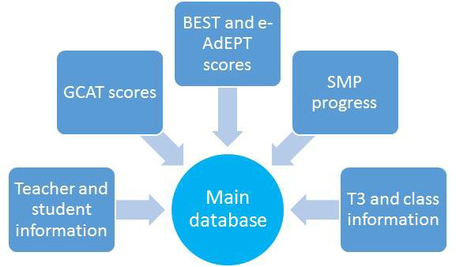

**Figure 6. Diagram of Programs Loaded into the Database**

*Process*. Consolidation of the data items should be done in such a way that the data are consistent with each other and that there is no redundant data. To accomplish this, the group will be developing means of connecting all SUCs to BPAP over the cloud. The group will also design the database where all of the sent data from the SUCs will be stored. The group will be following the ETL (Extracting, Transforming, Loading) process for this task. Extracting involves getting the data from the SUCs. Transforming involves cleaning the data to check for errors. Loading involves putting the data in the database.

*Output*. The outputs needed by BPAP are reports which would indicate the progress of the program, showing the performances of the students and teachers involved. As there are no set standards yet, the group will take charge of creating report templates to suit the needs of the different project managers as well as representatives from the partner companies. The group will be identifying key indicators that will be found in the report which would identify where it is that the company needs to improve on and other important points managers need to take note of. As seen in figure 7, there are four levels of reporting needed by the company. From highest level to lowest level, these are: organizational, departmental, project level, and SUC level. From this, there are four types of reports that were identified to aid BPAP in their decision-making: program report, SUC report, reports for stakeholders, and report for COA. In addition to creating the standard and templates of the report, the group must also develop an interface connecting the backend with the users.

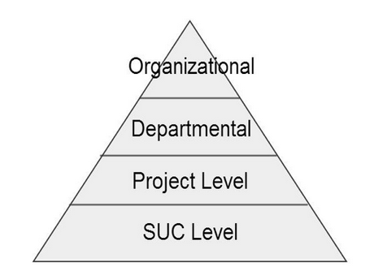

**Figure 7. Levels of Reporting**

These are the four levels of reporting needed by the company: SUC level, project level, departmental level, and organizational level.

Through this system, the group wishes to enable BPAP to capture data which are complete, reliable, accurate, relevant, and sufficient. At the same time, the group wishes to enable BPAP to monitor their progress by giving them a clearer view of the program participants from a granular and higher-level perspective. It is granular because it will present the progress of each participant. Correspondingly, it is considered higher-level because it will give BPAP the data of the entities as a whole by consolidating all data from the SUCs. At the same time, the users of this system will be able to map out the relationships between the teachers, the students, and the programs. For example, the user would be able to see the list of students that a teacher has taught or the list of programs that a student has taken. The system should be able to generate reports that would reflect this progress. This will be useful in terms of analysis and allocation planning. On a relevant note, the system will also serve as a tool for decision-making.

### Rational or Benefit of the Project

Implementing CRISP in its entirety prove to be beneficial in many aspects. For one, its business process reengineering (BPR) and standardization plans pave the way for a more organized and systematic way of data capturing storing, and report generation. Currently, there are no proper standards being applied by the different SUCs and BPAP encoders. Different formats are being followed and no Standard Operating Procedures (SOPs) are implemented as to how and when to do the data capture and reporting. This makes it difficult for the BPAP encoders to properly organize and compile all the data needed within a specified period of time. By strictly following the standards plan suggested by the group, coordination between BPAP and the different SUCs will become easier. The data gathered will also be accurate, wherein errors on data mismatch, redundancy, and validity can be prevented across all the different data sources.

With the implementation of the project, the database will prove to be the best storage of data. Instead of using different Excel files to store data, a single storage of data will prevent data misplacement and loss. In addition, with the number of data expected to increase as the project is continually implemented, the database is able to effectively serve as the main repository, holding thousands of data, showing their relationships, and even maintaining data history. This allows project managers and other stakeholders to keep track of the progress of the project, assess its impact to the participants, and make further improvements. Also, it is important to note that the different SUCs are dispersed geographically, thus, a central repository of data makes it easy and convenient to access data.

Finally, CRISP provides an efficient reporting tool important in creating and summarizing essential details needed by the different bodies involved. The current process of reviewing data through Excel has proven to take up a lot of time, is more prone to accidental error, and can even cause confusion especially with the large volume of data contained per sheet. By filtering the data based on each of their needs, involved parties can have access to a specific set of information, presented in an organized manner. Government institutions, such as DOST-SEI and CHED, need these reports in order to assess the performance of the students involved as well as to analyze which parts of the project proved to be the most beneficial and which aspects still need improvement. This also allows BPAP to have full transparency and proper disclosure to their different partners as well as in showing full compliance to the policies of COA, avoiding any run in with the law.

**Comparison with Alternative Projects**

Although there are still other options on how to go about the project, we have found that CRISP is the most beneficial and effective project compared to the available alternatives. Basically, these alternatives have problems with data capacity when all the data coming from the different SUCs are consolidated as one. Per SUC basis, Excel files and reporting servers may be effective but when data from all SUCs are dumped and compiled, it would not be able to handle the large amount of data. Performing queries would be slow since it needs to go through hundreds of rows from a number of different tables in order to form relationships and generate the needed reports. CRISP is able to address this problem by using a main database, containing normalized tables that properly show the different relationships of the gathered data. Reports can then be generated based on these data.

Additionally, there is a possibility of several data re-appearing across the individual databases maintained for each of the programs. This can happen especially when there are students and teachers who took more than one program or test. Not only does this cause data redundancy but also a waste of memory allocation. By having a single database integrating all data from the different programs, it is possible to avoid this, even using existing data to validate the changes or updates to be made.

To further prove this point, several quantitative computations were done on the three projects. As shown in the table below, all proposed projects have the same payback period of one (1) year. Even with that, not all generate the same results in the other factors. Separate System received the lowest result in both NPV and ROI, garnering P116, 239,760.87 and 58, respectively, while an Excel-based System received the lowest weighted score of 55. Generating the highest value in all three criteria--NPV, ROI, and weighted score—is CRISP

**Table 22. Comparison of the Alternative Projects**

|  |  |  |  |  |
| --- | --- | --- | --- | --- |
| Possible Projects | NPV | ROI | Payback | Weighted Score |
| CRISP | P116,469,760.87 | 98.41% | 1 year after project ended | 60 |
| Separate System | P116,239,760.87 | 98.05% |  | 58 |
| Reporting Server | P116,374,760.87 | 98.26% |  | 56 |
| Excel-based System | P116,369,520.87 | 98.25% |  | 55 |

Based on both qualitative and quantitative comparisons, CRISP as a whole provides the most benefits to BPAP, CHED, and SEI among the other three possible projects.

**Project Stakeholders**

The following entities invest and benefit in the project and are thus considered as major stakeholders:

* + **BPAP-employed Product Managers.** These are the BPAP product managers who will need to implement the system in order for their respective projects to reach their goals and objectives. With Mr. Jopat Lelay as the Overall Project Director and Miss Reli Neo in-charge of Monitoring and Evaluation, the program managers are: Ella Antonio, Arra Uri, Victor Loyola (CHED-SMP Project); Myra Santos (DOST-SEI Project); and Zoe Diaz De Rivera (BEST and AdEPT). Mr. Lelay will be the main contact of the group to whom all major concerns and updates will be addressed to since he is the one with the overall knowledge of the BPAP-CHED and SEI projects. Whenever necessary, the different program managers will be contacted in order to gather further details needed in the implementation of the project.
  + **Commission on Higher Education (CHED).** As the government body in-charge of collegiate education and as main initiator of the project, CHED provides BPAP with the monetary funds and relies on the proper implementation of the whole project in order to help improve the quality of higher education in the country, specifically that of BA and IT courses under the 17 participating SUCs. This then leads to an increased employability rate of college graduates who belong to the IT-BPO industry, contributing to a better national economy. Data gathered by the system will provide them with the relevant information they need for analysis on student performance evaluation as well as in making points on how to further improve the project, possibly using them as basis for future programs to be applied in other colleges and universities located in the different regions of the Philippines.
  + **Science Education Institute (SEI).** Also providing funds to BPAP, SEI relies on the proper implementation of the project to provide high quality trainings to enrolled DOST scholars and hired faculty members, equipping them with a higher skills and knowledge. The data gathered can serve as basis in assessing the participants’ performance and suggest ways on how to improve the program.
  + **Partner industry firms in the IT and BPO sectors.** These are the companies that also invested their resources in partnering with BPAP with the goal of hiring the students involved in the project, especially after gaining better competence. For SMP-enrolled students, they are the ones that will provide the students with a site for their 600-hour internship course during the last semester of their 4th year in college.

The 17 different SUCs as well as the enrolled students and teachers can also be considered stakeholders of the project since they can also reap the benefits of the project’s success. By implementing the project, the SUCs will then be able to provide higher quality education and training to its students, enabling them to arrive to their full potential and become competent graduates. On the other hand, teachers will also be given the chance to enhance their knowledge and skills, which they can use to handle their classes.

**Measures of Success**

| **Categories** | **Objectives** | **Measures of Success** |
| --- | --- | --- |
| Project Financial | To ensure that the project is executed in accordance with the specified cost allocated for Information Technology. | Project costing should not exceed P470,000 on initial buildup. |
| Project Quality | To create a web-based system that gathers relevant, consistent, and correct data from the different SUCs and other data involved in the project. | Relevant: All data fields must be used in the reports needed by the managers.  Consistent: All of the data gathered should be stored in the database following a specified format.  Correct: Data validation, through cross- checking with a student and teacher master list provided by the Office of the Registrar of the SUCs, would yield at most 5% error. |
|  | To implement a system which allows for a fast and efficient relay of data from SUC to BPAP | A reduction of at least two days compared to the average number of days it previously took to receive and manually record the data should be observed. |
|  | To produce reports that would be helpful for managers in their decision-making. | Reports showing information and data needed, such as participant information and performance scores, should be generated and used by managers during important meetings. |
| Consumer Communication | To provide a series of updates and establish good communication with the client, Mr. Florentino Dulce and other involved project managers of BPAP regarding the project. | All class and client deliverables should be submitted to Mr. Dulce and other involved project managers of BPAP. |

**Deliverables**

The team is expected to provide the following to the client:

* + Current System Analysis Document
  + Proposed System Design Document
    - Business Process Design
    - Reports Template
    - Database Design
  + Technical Requirements Document
    - Software
    - Hardware
  + Prototype of User Interface Design
  + Fully Developed System
  + Test Case Documentation
    - Results of Alpha Test

o Results of Beta Test

o Results of Stress Test

* + Manuals
    - Operational
    - User
  + User Acceptance Document
  + Project Sign-Off Document

**Milestones**

|  |  |
| --- | --- |
| Acceptance of the policy in data collection and, acceptance of the monitoring and evaluation policies and procedure. | Third week of October 2013 |
| Acceptance of the monitoring and evaluation templates | Fourth week of October 2013 |
| Acceptance of database design. | Second of November 2013. |
| Acceptance of system Design. | First week of December  2013. |
| Completion of the system prototype. | First Week of January 2014. |
| Completion of the different tests, which include alpha, beta, stress testing. | Fourth week of January 2014 |
| Completion of installation of CRISP onsite. | Fourth week of January 2014 |
| Acceptance of the result of user training. | First week of February 2014. |
| Go Live | First week of February 2014 |
| Sign Off | Second week of February 2014 |

## Technical Requirements

**System Technical Requirements**

|  |  |
| --- | --- |
| **Software** | **Purpose** |
| MySQL | Database Management System |
| .Net Framework 4.0 | Framework to utilize C# developed software |

The project’s greatest software requirement is the .NET Framework, version 4 at the very least for it to run C#, which will be the language used for the system. Therefore, the minimum hardware requirements will be for the .NET Framework.

The CRISP, which will be used by BPAP, will have to run on a Windows-based OS with the following specifications:

|  |  |
| --- | --- |
| **Hardware** | **Minimum Requirements** |
| Processor | 1 GHz |
| RAM | 512 MB |
| Disk Space | 850 MB (32-bit), 2 GB (64-bit) |
| OS | Windows XP SP3 |

**Development Technical Requirements**

The software requirements for development are similar to those of the system requirements, with the addition of Visual Studio 2010, serving as the Integrated Development Environment (IDE).

**Software Purpose**

Visual Studio 2010 IDE

Below are the minimum hardware requirements for running Visual Studio 2010:

|  |  |
| --- | --- |
| **Hardware** | **Minimum Requirements** |
| Processor | 1.6 GHz or faster processor |
| RAM | 1GB (1.5 GB if running on a virtual machine) |
| Hard drive storage capacity | 10 GB available, (10.6 GB if using language packs) |
| Hard drive speed | 5400 rpm |
| Video Card | DirectX 9 capable video card (1024 x 768 or higher resolution) |

## Limits and Exclusions

Based on the agreed scope of the project, listed below are points and other factors not included in the project:

* + The team is not in charge of acquiring the hardware and software needs of the system.
  + The team will not be responsible for the distribution of the memorandum of standards and system implementation to the different SUCs. Additionally, the group is not responsible for ensuring that these SUCs are fully complying with them.
  + The team is not responsible for the provision of maintenance personnel.
  + The team will only provide a means for data gathering and reports generation. Further analyses, such as recommendations on program and performance improvement, are beyond the team’s responsibilities.
  + The team will only train BPAP-appointed trainers regarding the technical and nontechnical aspects of the system. They, in turn, will be in-charge of training the actual users of the system.

# V. Project Charter

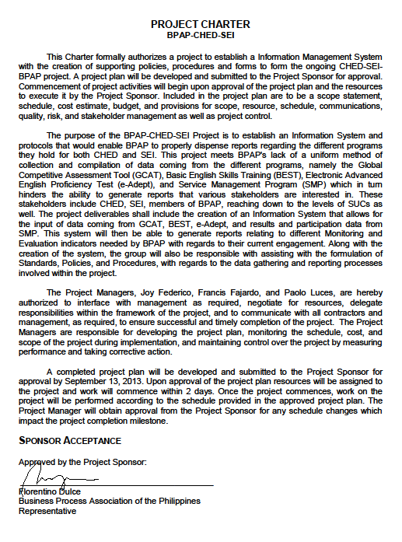

# VI. The Project Plan

## Project Organization and Team Organization

**Skills Inventory Worksheet**

|  |  |
| --- | --- |
| **SKILLS INVENTORY WORKSHEET** | |
| **Project Name** | BPAP-CHED-SEI |
| **Project Manager** | Joy Federico |
| **Date Prepared** | 9/11/2013 |

|  |  |  |  |  |  |  |  |  |  |  |  |  |  |  |
| --- | --- | --- | --- | --- | --- | --- | --- | --- | --- | --- | --- | --- | --- | --- |
|  | **CSS** | **SQL programming** | **HTML** | **PHP** | **Verbal Comm** | **Written Comm** | **System Analysis** | **Researching** | **Documentation** | **Abstraction** | **E-Weight** | **I Weight** | **N Weight** | **Total** |
| ***Joy Federico*** | **N** | **E** | **I** | **N** | **I** | **I** | **E** | **I** | **E** | **E** | 60 | 40 | 10 | **110** |
| Dayanara Simon | **E** | **E** | **E** | **I** | **E** | **E** | **E** | **I** | **I** | **E** | 105 | 30 | 0 | **135** |
| Philip Peralta | **N** | **E** | **I** | **N** | **I** | **I** | **I** | **I** | **I** | **I** | 15 | 70 | 10 | **95** |
| Michelle Armario | **I** | **I** | **I** | **N** | **E** | **E** | **E** | **E** | **E** | **I** | 75 | 40 | 5 | **120** |
| Alecxandra Rimbao | **I** | **E** | **I** | **N** | **E** | **E** | **I** | **E** | **I** | **I** | 60 | 50 | 5 | **115** |
| ***Paolo Luces*** | **N** | **E** | **N** | **N** | **E** | **E** | **E** | **I** | **E** | **E** | 90 | 10 | 15 | **115** |
| Raymond Cruz | **I** | **E** | **E** | **E** | **N** | **I** | **I** | **I** | **I** | **E** | 60 | 50 | 5 | **115** |
| Aaron Casurao | **N** | **N** | **I** | **I** | **E** | **E** | **I** | **I** | **E** | **E** | 60 | 40 | 10 | **110** |
| Simone Jaldon | **N** | **I** | **I** | **N** | **E** | **E** | **I** | **E** | **E** | **E** | 75 | 30 | 10 | **115** |
| Trishia Gerobiese | **I** | **E** | **I** | **I** | **I** | **E** | **I** | **E** | **E** | **E** | 75 | 50 | 0 | **125** |
| ***Francis Fajardo*** | **N** | **I** | **N** | **N** | **E** | **E** | **I** | **E** | **I** | **I** | 45 | 40 | 15 | **100** |
| Chelsea Galvez | **I** | **E** | **I** | **N** | **N** | **I** | **I** | **E** | **E** | **I** | 45 | 50 | 10 | **105** |
| Raphael Carillo | **N** | **E** | **N** | **I** | **E** | **E** | **I** | **E** | **I** | **I** | 60 | 40 | 10 | **110** |
| Glu Uygongco | **N** | **I** | **N** | **N** | **N** | **I** | **I** | **E** | **E** | **I** | 30 | 40 | 20 | **90** |
| Evan Tan | N | I | N | N | I | N | E | E | N | E | 45 | 20 | 25 | 90 |
|  |  |  |  |  |  |  |  |  |  |  |  |  |  |  |
| Council Totals: | 110 | 190 | 135 | 105 | 175 | 190 | 175 | 195 | 185 | 190 |  |  |  |  |
| Average | 7.33 | 12.67 | 9.00 | 7.00 | 11.67 | 12.67 | 11.67 | 13.00 | 12.33 | 12.67 |  |  |  |  |

**Responsibility Matrix**

|  |  |
| --- | --- |
| **Responsibility** | |
| **Project Name** | BPAP-CHED-SEI |
| **Project Manager** | Joy Federico |
| **Date Prepared** | 9/11/2013 |

|  | Joy Federico | Paolo Luces | Francis Fajardo | Alecx Rimbao | Aaron Casurao | Simone Jaldon | Trishia Gerobiese | Mitch Armario | Chelsea Galvez | Evan Tan | Raphael Carillo | RJ Cruz | Ara Simon | Phil Peralta | Glu Uygungco |
| --- | --- | --- | --- | --- | --- | --- | --- | --- | --- | --- | --- | --- | --- | --- | --- |
| **Tasks** |  |  |  |  |  |  |  |  |  |  |  |  |  |  |  |
| CRISP  * 1. **Conduct Data Gathering** | | | | | | | | | | | | | | | |
| **1.1.1 Conduct Standards Research** | | | | | | | | | | | | | | | |
| 1.1.1.1 Obtain GCAT Data |  |  | A | R | S | S | S |  |  |  |  |  |  |  |  |
| 1.1.1.2 Obtain SMP Data |  |  | A | S | S | S | R |  |  |  |  |  |  |  |  |
| 1.1.1.3 Obtain Documents for BEST / AdEPT |  |  | A | S | R | S | S |  |  |  |  |  |  |  |  |
| 1.1.1.4 Obtain T3 Data |  |  | A | S | S | R | S |  |  |  |  |  |  |  |  |
| 1.1.2 Obtain Existing Frameworks |  | A |  |  |  |  |  | S | R | S | R |  |  |  |  |
| 1.1.3 Obtain Existing Reports and Templates | A | R | R |  |  |  | S |  | S |  | S |  |  |  |  |
| 1.1.4 Obtain M & E Manual |  | A |  |  |  |  |  | S | R | S | R |  |  |  |  |
| 1.1.5 Interview Project Managers |  |  |  |  |  |  |  |  |  |  |  |  |  |  |  |
| 1.1.5.1 Interview Project Manager of M & E | A | R |  |  |  |  |  | S | S | S | S |  |  |  |  |
| 1.1.5.2 Interview Project Managers of the Project Delivery Team | A |  | R | S | S | S | S |  |  |  |  |  |  |  |  |
| **1.2 Analyze Data Gathered** | | | | | | | | | | | | | | | |
| 1.2.1 Analyze GCAT Data | S |  | A | S | S | S | S |  |  |  |  |  |  |  |  |
| 1.2.2 Analyze SMP Data | S |  | A | R | S | S | S |  |  |  |  |  |  |  |  |
| 1.2.3 Analyze T3 Data | S |  | A | S | S | S | R |  |  |  |  |  |  |  |  |
| 1.2.4 Analyze BEST and AdEPT Data | S |  | A | S | S | R | S |  |  |  |  |  |  |  |  |
| 1.2.5 Analyze frameworks | S | A | S |  |  |  |  | S | R | R | R |  |  |  |  |
| 1.2.6 Analyze Existing Reports and Templates | A | R | R | S | S | S | S | S | S | S | S |  |  |  |  |
| **1.3 Formulate Policies and Procedures** | | | | | | | | | | | | | | | |
| **1.3.1 Formulate Policy Content for BEST and AdEPT** | | | | | | | | | | | | | | | |
| 1.3.1.1 Draft the Policy Content for BEST and AdEPT | S |  | A | S | R | R | S |  |  |  |  |  |  |  |  |
| 1.3.1.2 Evaluate the Policy Content for BEST and AdEPT | A |  | R | S | S | S | S |  |  |  |  |  |  |  |  |
| 1.3.1.3 Create Final Version of the Policy Content for BEST and AdEPT | S |  | A | S | R | R | S |  |  |  |  |  |  |  |  |
| **1.3.2 Formulate Policy Content for SMP Data Collection** | | | | | | | | | | | | | | | |
| 1.3.2.1 Draft the Policy Content for SMP Data Collection | S |  | A | R | S | S | R |  |  |  |  |  |  |  |  |
| 1.3.2.2 Evaluate the Policy Content for SMP Data Collection | A |  | R | S | S | S | S |  |  |  |  |  |  |  |  |
| 1.3.2.3 Create a Final Version for the Policty Concten of SMP Data Collection | S |  | A | R | S | S | R |  |  |  |  |  |  |  |  |
| **1.3.3 Create Input Data Forms for BEST and AdEPT** | | | | | | | | | | | | | | | |
| 1.3.3.1 Draft Input Data Forms for BEST and AdEPT | S |  | A | S | R | R | S |  |  |  |  |  |  |  |  |
| 1.3.3.2 Evaluate Input Data Forms for BEST and AdEPT | A |  | R | S | S | S | S |  |  |  |  |  |  |  |  |
| 1.3.3.3 Create Final Version of the Input Data Forms for BEST and AdEPT | S |  | A | S | R | R | S |  |  |  |  |  |  |  |  |
| 1.3.4 Create Input Data Forms for SMP Data Collection |  |  |  |  |  |  |  |  |  |  |  |  |  |  |  |
| 1.3.4.1 Draft Input Data Forms for SMP | S |  | A | R | S | S | R |  |  |  |  |  |  |  |  |
| 1.3.4.2 Evaluate Input Data Forms for SMP Data Collection | A |  | R | S | S | S | S |  |  |  |  |  |  |  |  |
| 1.3.4.3 Create Final Version of the Input Data Forms for SMP Data Collection | S |  | A | R | S | S | R |  |  |  |  |  |  |  |  |
| **1.3.5 Create M & E Framework** | | | | | | | | | | | | | | | |
| 1.3.5.1 Create M & E Report Templates |  |  |  |  |  |  |  |  |  |  |  |  |  |  |  |
| 1.3.5.1.1 Draft M & E Report Templates | S | A |  |  |  |  |  | R | S | S | S |  |  |  |  |
| 1.3.5.1.2 Evaluate M & E Report Templates | A | R |  |  |  |  |  | S | S | S | S |  |  |  |  |
| 1.3.5.1.3 Create Final Version of M & E Report Templates | S | A |  |  |  |  |  | R | S | S | S |  |  |  |  |
| **1.3.5.2 Create M&E Policies and Procedures** | | | | | | | | | | | | | | | |
| 1.3.5.2.1 Draft M&E Policies and Procedures | S | A |  |  |  |  |  | S | R | S | S |  |  |  |  |
| 1.3.5.2.2 Evaluate M&E Policies and Procedures | A | R |  |  |  |  |  | S | S | S | S |  |  |  |  |
| 1.3.5.2.3 Create Final Version of M&E Policies and Procedures | S | A |  |  |  |  |  | S | R | S | S |  |  |  |  |
| 1.3.6 Conduct Brainstorming Session | A | R | S | S | S | S | S | S | S | S | S |  |  |  |  |
| 1.4 Researching for Technical Requirements |  |  |  |  |  |  |  |  |  |  |  |  |  |  |  |
| 1.4.1 Research on Software Requirements |  | A |  |  |  |  |  |  |  |  |  | R | S | R | S |
| 1.4.2 Research on Hardware Requirements |  | S |  |  |  |  |  |  |  |  |  | R | S | R | S |
| 1.4.3 Research on Programming Language |  | A |  |  |  |  |  |  |  |  |  | R | R | R | S |
| **1.5 Create System Design** | | | | | | | | | | | | | | | |
| 1.5.1 Generate the Functional Requirements Document |  | R | R | S | R | S | R | S | R | S | R |  |  |  |  |
| 1.5.2 Create a User Interface Design |  |  |  |  |  |  |  |  |  |  |  |  |  |  |  |
| 1.5.2.1 Create a Wireframe |  | A |  |  |  |  |  |  |  |  |  | S | R | S | S |
| 1.5.2.2 Design Forms |  | A |  |  |  |  |  |  |  |  |  | S | R | S | S |
| **1.5.3 Generate a Data Flow Diagram** | | | | | | | | | | | | | | | |
| 1.5.3.1 Create the Current Logical Data Flow Diagram | S | S | S | S | R | A | R | S | R | R | S |  |  |  |  |
| 1.5.3.2 Create the Current Physical Dataflow Diagram | S | S | S | S | R | A | R | S | R | R | S |  |  |  |  |
| 1.5.3.3 Create the Proposed Logical Data Flow Diagram | S | S | S | R | S | R | S | R | S | A | R |  |  |  |  |
| 1.5.3.4 Create the Proposed Physical Data flow Diagram | S | S | S | R | S | R | S | R | S | A | R |  |  |  |  |
| 1.5.4 Create the Data Dictionary | S | S | S | A | R | S | S | R | S | S | S |  |  |  |  |
| 1.5.5 Creating a Use Case Diagram | S | S | S | S | S | R | R | S | A | R | R |  |  |  |  |
| 1.5.6 Creating an Entity Relationship Diagram | S | S | S | S | R | S | R | A | S | R | S |  |  |  |  |
| 1.5.7 Creating a Logical Data |  |  |  | R | S | R | S | R | R | R | A |  |  |  |  |
| Map |  |  |  |  |  |  |  |  |  |  |  |  |  |  |  |
| 1.5.8 Get System Design Approved | A | S | R |  |  |  |  |  |  |  |  |  |  |  |  |
| 1.5.9 Get Database Design Approved | A | R | S |  |  |  |  |  |  |  |  |  |  |  |  |
| **1.6 System Development** | | | | | | | | | | | | | | | |
| 1.6.1 Develop System Prototype |  |  |  |  |  |  |  |  |  |  |  | A | S | R | S |
| 1.6.2 Evaluation of System Prototype |  | A |  |  |  |  |  |  |  |  |  | R | S | S | S |
| 1.6.3 Generating the Final Version |  |  |  |  |  |  |  |  |  |  |  | A | S | R | S |
| 1.7 Conduct Testing |  |  |  |  |  |  |  |  |  |  |  |  |  |  |  |
| 1.7.1 Generate Test Scenarios |  |  |  |  |  |  |  |  |  |  |  |  |  |  |  |
| 1.7.1.1 Generate Tester Applications |  |  |  |  |  |  |  |  |  |  |  | S | S | S | R |
| 1.7.1.2 Generate Dummy Data |  |  |  |  |  |  |  |  |  |  |  | A | S | S | R |
| 1.7.1.3 Generate Test Cases |  | A |  |  |  |  |  |  |  |  |  | S | S | S | R |
| 1.7.2 Conduct Alpha Testing |  |  |  |  |  |  |  |  |  |  |  | A | S | S | R |
| 1.7.3 Conduct Beta Testing |  |  |  |  |  |  |  |  |  |  |  | A | S | S | R |
| 1.7.4 Conduct Stress Testing |  |  |  |  |  |  |  |  |  |  |  | A | S | S | R |
| **1.8 Create Manuals** | | | | | | | | | | | | | | | |
| **1.8.1 Create Operational Manual** | | | | | | | | | | | | | | | |
| 1.8.1.1 Draft Operational Manual |  |  |  |  |  |  |  |  |  |  |  | A | R | R | S |
| 1.8.1.2Evaluate Operational Manual |  |  |  |  |  |  |  |  |  |  |  | A | R | R | S |
| 1.8.1.3 Create Final Version of Operational Manual |  |  |  |  |  |  |  |  |  |  |  | A | R | R | S |
| **1.8.2 Create User Manual** | | | | | | | | | | | | | | | |
| 1.8.2.1 Draft User Manual | A | S | S |  |  | R |  | R |  |  |  |  |  |  |  |
| 1.8.2.2 Evaluate User Manual | A | R | R |  |  | S |  | S |  |  |  |  |  |  |  |
| 1.8.2.3 Create Final Version of User Manual | A | S | S |  |  | R |  | R |  |  |  |  |  |  |  |

|  |  |  |  |  |  |  |  |  |  |  |  |  |  |  |  |
| --- | --- | --- | --- | --- | --- | --- | --- | --- | --- | --- | --- | --- | --- | --- | --- |
| **1.9 Implementing the CRISP** | | | | | | | | | | | | | | | |
| **1.9.1 Installation** | | | | | | | | | | | | | | | |
| 1.9.1.1 Install System onsite | S | S | S |  |  |  |  |  |  |  |  | A | R | R | S |
| 1.9.1.2 Set-up Network | R | R | R |  |  |  |  |  |  |  |  | A | S | S | S |
| 1.9.2 On Site Testing | A | S | S |  |  |  |  |  |  |  |  | R | R | R | R |
| 1.9.3 Conduct User Training | S |  | S | R | R | R | A/R |  |  |  |  |  |  |  |  |
| 1.10 Go Live | A | R | R |  |  |  | S |  | S |  |  | S |  |  |  |
| 1.11 Project Sign-Off | A/R | R | R |  |  |  | S |  | S |  |  | S |  |  |  |

|  |  |  |  |  |  |  |  |  |  |  |  |  |  |  |  |
| --- | --- | --- | --- | --- | --- | --- | --- | --- | --- | --- | --- | --- | --- | --- | --- |
| **number of A** | 18 | 13 | 16 | 1 | 0 | 2 | 0 | 1 | 1 | 2 | 1 | 11 | 0 | 0 | 0 |
| **number of R** | 1 | 12 | 13 | 10 | 11 | 13 | 11 | 8 | 9 | 6 | 7 | 5 | 8 | 10 | 7 |
| **number of S** | 26 | 13 | 15 | 22 | 22 | 21 | 24 | 15 | 14 | 13 | 14 | 6 | 12 | 10 | 13 |
| **number of A/R** | 1 | 0 | 0 | 0 | 0 | 0 | 1 | 0 | 0 | 0 | 0 | 0 | 0 | 0 | 0 |

**Group Skills Analysis and Discussion**

Common skill requirements have been identified to ensure a positive outcome to the project and contribute growth to the team. The team was able to assess each member’s confidence level on skills identified as well as measure through previous work depending how comfortable and equipped the member is. The levels range from novice, intermediate to expert. Overall, the group is equipped with various skills that have been agreed upon to be critical for the project’s success. Generally, the skills defined to be required and suitable for this project are programming, verbal communication, analytical and documentation.

Programming skills needed for this project are expertise in SQL and PHP, as well as knowledge in HTML and CSS. These skills are required for the fact that without them, the group might find difficulty in developing the actual system and might have the need to outsource which may incur costs. With the skills matrix as the basis, the group has been able to point out the strengths in each member. SQL programming appears to be the strongest with the score of 190 having 9 experts. Knowledge in PHP and HTML were also identified as critical skills but were somewhat weaker compared to the previous two mentioned. They have a score of 105 and 135, respectively with only 1 PHP expert and 2 experts 2 in HTML. Improving these technical skills quickly by taking free online courses and self-learning the skills through available resources online will definitely help. In addition, majority of the members have acquired different experiences needed to hone their programming expertise in the real corporate setting. Internships with multinational and technology savvy companies, such as Teradata, Accenture, IBM, Ogilvy, as well as various CS and MIS projects, such as SAD have all contributed to the development of the strength of the team when it comes to programming.

Another set of skills required for this project is the expertise on PR which is necessary so the project would be able to stay on track. With a project that involves a lot of coordination, communication is of the essence. The skill matrix shows data about the PR skills of each member, in verbal and written fields. Overall, the team is strong in both, with scores of 190 and 175, and having 8 and 9 members as experts. Internships with PR-extensive companies such as AVA.ph, Citibank, Unionbank, etc. and different course and organization projects from marketing presentations, to general assemblies, all contributed to the gained PR strength of the team.

Logic and Analytical skills have been also defined by the group as essential to the project’s success. They are critical for with this skill evident within a group, scheduling/timing allocation, systems development, and project flow will be reasonably controlled. Systems analysis and abstraction have garnered scores of 175 and 190, respectively in the skill matrix.

Although, it is shown that only 5 members of the group are experts in systems analysis, it can also be seen that none of the members are novices in which contribute to strength of the group. Also, 8 members have expertise when it comes to abstraction. With the data found in the skills matrix and different experiences of the members regarding needed level for analysis and logic, especially within the field of Systems Analysis and Design, the group is equipped with the skill that the project requires.

Lastly, the skill of document creation has been identified for the project clearly needs different documents to track its progress, control the project flow, and as well safeguard it and the group from complications. The skills matrix showed that the team is both strong in research and documentation with scores of 195 and 185, respectively. This might prove to be the strongest skill of the group, in which there are 9 experts on research and 8 experts on documentation, with only 1 novice (documentation) for both fields. Services of skilled and seasoned document creators are available for group use in creation of all the documents needed for the project such as contracts, deliverables, etc.

Increased active participation and involvement in the project will definitely enhance skills mentioned and group members who are considered as experts can definitely help intermediately skilled members leading to improved performance and more opportunities to grow. Moreover, according to the skills matrix, the group does not see the need yet to outsource services but frequent consultation to professionals and experts in the group to further enhance these skills is considered. Self-training is also a key to developing technical skills and is integral to the group since these skills do save the group man hours to get tasks done. Reading and watching online tutorials, reading technical books, attending relevant classes and spending time with people with the knowledge on skills will definitely help accelerate the development of these technical skills that the group may lack. Furthermore, more skills are yet to be examined and improved but can be viewed through the lens of group dynamics as the project continues.

**Organizational Structure**

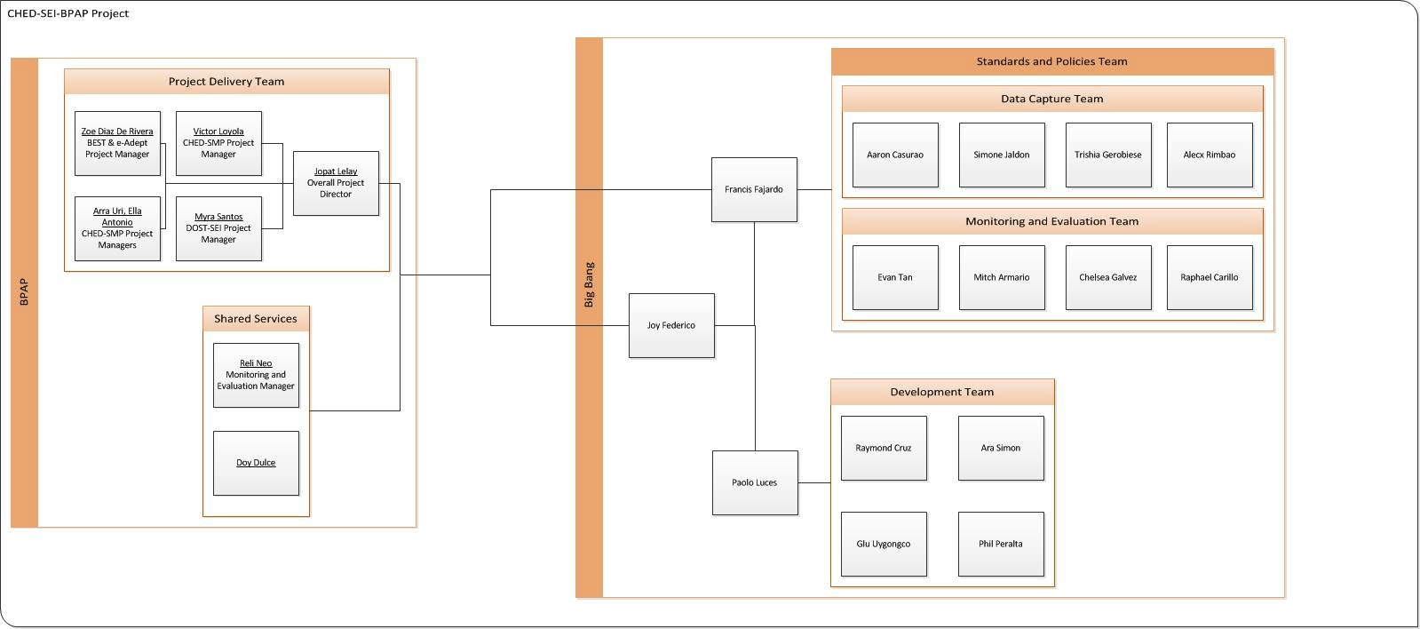

**Figure 8.1.** The organizational chart of the people involved in the BPAP-CHED-SEI Project and Big Bang.

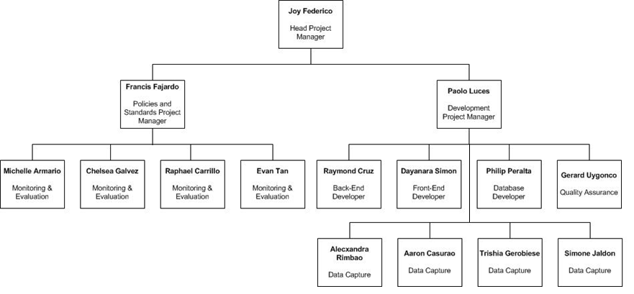

**Figure 8.2.** The hierarchy of Big Bang.

1. **Internal Structure (Team Structure)**

Big Bang is a thesis group composed of 15 members. The Project Manager for Big Bang is Joy Federico. Under her are two teams: the Standards and Policies Team and the Development Team. Each team will have a person in charge as detailed later on in this section.

The Project Manager’s role is to ensure that the project is moving forward by supervising the task of each members and coordinating with the client. She will make sure that the deliverables are passed on time and solve any internal and external conflicts the group might have.

**Standards and Policies Team (S&P)**

With regards to their current system, the client has identified issues such as validation concerns, data redundancy issues, frequency of human error, etc. The Standards and Policies Team aims to create a strong foundation for the BPAP-CHED-SEI project by standardizing its processes and procedures. There are two branches under the S&P team: Monitoring and Evaluation and Data Capture.

The *Monitoring and Evaluation* team (M&E), led by Paolo Luces, is in charge of creating standards for reports. Report generation is one of the duties of M&E; but with the BPAP-CHED-SEI project on its first year of implementation, M&E needs support in laying the foundation of the frameworks and report templates. The creation of the report standards will be the objective of the team. This team consults and coordinates with the M&E Manager of BPAP, Reli Neo.

The *Data Capture* team (D&C), led by Francis Fajardo, deals with communication between the SUCs and BPAP. The SUCs are scattered around the country. It will be a problem for BPAP when the data gathered are insufficient or there is the existence of errors. The team aims to help BPAP in creating standards and policies regarding the BPAP-CHED-SEI program. Anything that has to do with the

standards and policies of SUCs and the school programs are under this team. This team will analyze existing processes and re-engineer them to make them more efficient and effective.

**Development Team**

The Development Team, led by Paolo Luces, is the group who will code the entire system. They are the programmers who will either create the system based on the analysis of the S&P team. The Back- end Developer is the one in-charge of handling the entry of information into the system and how the system will process the incoming data. The Front-end Developer is in charge of creating the user interface design, reports template design, and wireframes. The Database Developer will focus on coding the database system. The Quality Assurance Person ensures that the modules, when integrated, are working properly and running smoothly.

**Documentation**

The S&P team will each have a member in charge of their team’s respective documentation. Their responsibilities include keeping documents of all teams up-to-date and correct, documenting every step and progress of the group, to make sure that deliverables submitted to the client are professional, timely, well-organized, and correct.

**Ii. External Structure (Client Side)**

Big Bang will be coordinating with three groups: Project Delivery, Shared Services, and Enablers. These groups have a different stake and contribution in the project and are also sources of knowledge about the BPAP-CHED program that the group must work with.

**Project Delivery Team**

This is the team that deals with the BPAP-CHED-SEI project. The overall project director, Jopat Lelay, is the one who is in charge of the strategic decision-making of the project and coordinates with the other project managers of BPAP. Under the project director are four other project managers who have their own part of the program in the Project. The CHED-SMP is managed by Victor Loyola, Arra Uri, and

Ella Antonio, Best & eAdept by Zoe Diaz de Rivera, and DOST-SEI by Myra Santos.

**Shared Services**

The Shared Services are a part of BPAP’s own organizational structure. They are the branch that caters to all of BPAP’s departments. One of their branches is the Monitoring & Evaluation team which is led by Reli Neo. Simply, this department is in charge of creating the reports each department of BPAP needs in the organizational level.

**Enabler**

The Enablers are the third-party entities who also have a role in the BPAP-CHED-SEI project. They are Advanced Analytics Institute (AAI) and Edulynx, institutions that have programs which aim to enhance a person’s knowledge or skill set, depending on their focus. They contribute to the BEST, eAdEPT, and GCAT programs.

## Work Breakdown Structure

**Work Breakdown Structure Outline**

|  |  |
| --- | --- |
| **Project Name** | BPAP-CHED-SEI |
| **Project Manager** | Joy Federico |
| **Date Prepared** | September 11,2013 |

| **Task Id** | **Name** | **Task Owner** | **Deliverable** |
| --- | --- | --- | --- |
| 1.0 | **1.0 CRISP** |  |  |
| 1.1 | **1.1 Conduct Data Gathering** |  |  |
| 1.1.1 | **1.1.1 Conduct Standards Research** |  |  |
| 1.1.1.1 | 1.1.1.1 Obtain GCAT Data | Francis Fajardo | Consolidated GCAT Data |
| 1.1.1.2 | 1.1.1.2 Obtain SMP Data | Francis Fajardo | Consolidated SMP Data |
| 1.1.1.3 | 1.1.1.3 Obtain Documents for BEST / AdEPT | Francis Fajardo | Consoldated BEST and AdEPT Documents |
| 1.1.1.4 | 1.1.1.4 Obtain T3 Data | Francis Fajardo | Consolidated T3 Data |
| 1.1.2 | 1.1.2 Obtain Existing Frameworks | Raphael Carillo | Consolidated Existing Frameworks |
| 1.1.3 | 1.1.3 Obtain Existing Reports and Templates | Joy Federico | Consolidated Existing Reports and Templates |
| 1.1.4 | 1.1.4 Obtain M & E Manual | Chelsea Galvez | M&E Manual |
| 1.1.5 | **1.1.5 Interview Project Managers** |  |  |
| 1.1.5.1 | 1.1.5.1 Interview Project Manager of M & E | Paolo Luces | M&E Team Meeting Minutes |
| 1.1.5.2 | 1.1.5.2 Interview Project Managers of the Project Delivery Team | Francis Fajardo | Project Delivery Team Meeting Minutes |
| 1.2 | **1.2 Analyze Data Gathered** |  |  |
| 1.2.1 | 1.2.1 Analyze GCAT Data | Alecxandra Rimbao | GCAT Data Analysis |
| 1.2.2 | 1.2.2 Analyze SMP Data | Trishia Gerobiese | SMP Data Analysis |
| 1.2.3 | 1.2.3 Analyze T3 Data | Simone Jaldon | T3 Data Analysis |
| 1.2.4 | 1.2.4 Analyze BEST and AdEPT Data | Aaron Casurao | BEST and AdEPT Data Analysis |
| 1.2.5 | 1.2.5 Analyze frameworks | Paolo Luces | Frameworks Analysis |
| 1.2.6 | 1.2.6 Analyze Existing Reports and Templates | Joy Federico | Existing Reports and Templates Analysis |
| 1.3 | **1.3 Formulate Policies and Procedures** |  |  |
| 1.3.1 | **1.3.1 Formulate Policy Content for BEST and AdEPT** |  |  |
| 1.3.1.1 | 1.3.1.1 Draft the Policy Content for BEST and AdEPT | Francis Fajardo | Policy Content Document for BEST and AdEPT |
| 1.3.1.2 | 1.3.1.2 Evaluate the Policy Content for BEST and AdEPT | Joy Federico | Policy Content Document Evaluation for BEST and AdEPT |
| 1.3.1.3 | 1.3.1.3 Create Final Version of the Policy Content for BEST and AdEPT | Francis Fajardo | Finalized Policy Content Document |
| 1.3.2 | **1.3.2 Formulate Policy Content for SMP Data Collection** |  |  |
| 1.3.2.1 | 1.3.2.1 Draft the Policy Content for SMP Data Collection | Francis Fajardo | Policy Content Document for SMP |
| 1.3.2.2 | 1.3.2.2 Evaluate the Policy Content for SMP Data Collection | Joy Federico | Policy Content Evaluation for SMP |
| 1.3.2.3 | 1.3.2.3 Create a Final Version for the Policty Content of SMP Data Collection | Francis Fajardo | Policy Content for SMP |
| 1.3.3 | **1.3.3 Create Input Data Forms for BEST and AdEPT** |  |  |
| 1.3.3.1 | 1.3.3.1 Draft Input Data Forms for BEST and AdEPT | Francis Fajardo | Input Data Forms for BEST and AdEPT |
| 1.3.3.2 | 1.3.3.2 Evaluate Input Data Forms for BEST and AdEPT | Joy Federico | Input Forms Evaluation for BEST and AdEPT |
| 1.3.3.3 | 1.3.3.3 Create Final Version of the Input Data Forms for BEST and AdEPT | Francis Fajardo | Finalized Input Data Forms for BEST and AdEPT |
| 1.3.4 | **1.3.4 Create Input Data Forms for SMP Data Collection** |  |  |
| 1.3.4.1 | 1.3.4.1 Draft Input Data Forms for SMP | Francis Fajardo | Input Data Forms for SMP |
| 1.3.4.2 | 1.3.4.2 Evaluate Input Data Forms for SMP Data Collection | Joy Federico | Input Forms Evaluation for SMP |
| 1.3.4.3 | 1.3.4.3 Create Final Version of the Input Data Forms for SMP Data Collection | Francis Fajardo | Finalized Input Data Forms for SMP |
| 1.3.5 | **1.3.5 Create M & E Framework** |  |  |
| 1.3.5.1 | **1.3.5.1 Create M & E Report Templates** |  |  |
| 1.3.5.1.1 | 1.3.5.1.1 Draft M & E Report Templates | Paolo Luces | M&E Report Templates |
| 1.3.5.1.2 | 1.3.5.1.2 Evaluate M & E Report Templates | Joy Federico | M&E Report Templates Evaluation |
| 1.3.5.1.3 | 1.3.5.1.3 Create Final Version of M & E Report Templates | Paolo Luces | Approved M&E Report Templates document |
| 1.3.5.2 | **1.3.5.2 Create M&E Policies and Procedures** |  |  |
| 1.3.5.2.1 | 1.3.5.2.1 Draft M&E Policies and Procedures | Paolo Luces |  |
| 1.3.5.2.2 | 1.3.5.2.2 Evaluate M&E Policies and Procedures | Joy Federico |  |
| 1.3.5.2.3 | 1.3.5.2.3 Create Final Version of M&E Policies and Procedures | Paolo Luces |  |
| 1.3.6 | 1.3.6 Conduct Brainstorming Session | Paolo Luces | Brainstorming Minutes |
| 1.4 | **1.4 Researching for Technical Requirements** |  |  |
| 1.4.1 | 1.4.1 Research on Software Requirements | Raymond Cruz | Research Findings |
| 1.4.2 | 1.4.2 Research on Hardware Requirements | Philip Peralta | Research Findings |
| 1.4.3 | 1.4.3 Research on Programming Language | Raymond Cruz | Research Findings |
| 1.5 | **1.5 Create System Design** |  |  |
| 1.5.1 | 1.5.1 Generate the Functional Requirements Document | Joy Federico | Functional Requirements Document |
| 1.5.2 | **1.5.2 Create a User Interface Design** |  |  |
| 1.5.2.1 | 1.5.2.1 Create a Wireframe | Dayanara Simon | System Wireframe document |
| 1.5.2.2 | 1.5.2.2 Design Forms | Dayanara Simon | Forms Design document |
| 1.5.3 | **1.5.3 Generate a Data Flow Diagram** |  |  |
| 1.5.3.1 | 1.5.3.1 Create the Current Logical Data Flow Diagram | Simone Jaldon | Current Logical Flow Diagram |
| 1.5.3.2 | 1.5.3.2 Create the Current Physical Dataflow Diagram | Simone Jaldon | Current Physical Flow Diagram |
| 1.5.3.3 | 1.5.3.3 Create the Proposed Logical Data Flow Diagram | Evan Tan | Proposed Logical Flow Diagram |
| 1.5.3.4 | 1.5.3.4 Create the Proposed Physical Data flow Diagram | Evan Tan | Proposed Physical Data Flow Dagram |
| 1.5.4 | 1.5.4 Create the Data Dictionary | Alecxandra Rimbao | Data Dictionary |
| 1.5.5 | 1.5.5 Creating a Use Case Diagram | Chelsea Galvez | Use Case Diagram |
| 1.5.6 | 1.5.6 Creating an Entity Relationship Diagram | Michelle Armario | Entity Relationship Dagram |
| 1.5.7 | 1.5.7 Creating a Logical Data Map | Raphael Carillo | Logical Data Map |
| 1.5.8 | 1.5.8 Get System Design Approved | Joy Federico | Formal Signoff of System Approval |
| 1.5.9 | 1.5.9 Get Database Design Approved | Joy Federico | Formal Signoff of Database Approval |
| **1.6** | **1.6 System Development** |  |  |
| 1.6.1 | **1.6.1 Develop System Prototype** |  |  |
| 1.6.1.1 | 1.6.1.1 Develop the Prototype for GCAT | Philip Peralta | Functional Code for GCAT |
| 1.6.1.2 | 1.6.1.2 Develop the Prototype for BEST and AdEPT | Dayanara Simon | Functional Code for BEST and AdEPT |
| 1.6.1.3 | 1.6.1.3 Develop the Prototype for SMP | Raymond Cruz | Functional Code for SMP |
| 1.6.2 | **1.6.2 Evaluation of System Prototype** |  |  |
| 1.6.2.1 | 1.6.2.1 Evaluate the Prototype of GCAT | Gerard Uygongco | CRISP Prototype Evaluation- GCAT |
| 1.6.2.2 | 1.6.2.2 Evaluate the Prototype of BEST and AdEPT | Gerard Uygongco | CRISP Prototype Evaluation- BEST and AdEPT |
| 1.6.2.3 | 1.6.2.3 Evaluate the Prototype of SMP | Gerard Uygongco | CRISP Prototype Evaluation- SMP |
| 1.6.3 | **1.6.3 Generating the Final Version** |  |  |
| 1.6.3.1 | 1.6.3.1 Generate the Final Version for GCAT | Philip Peralta | Edited Functional Code for GCAT |
| 1.6.3.2 | 1.6.3.2 Generate the Final Version of BEST and AdEPT | Dayanara Simon | Edited Functional Code for BEST and AdEPT |
| 1.6.3.3 | 1.6.3.3 Generate the Final Version of SMP | Raymond Cruz | Edited Functional Code for SMP |
| 1.6.4 | **1.6.4 Systems Integration** | Raymond Cruz | CRISP Program |
| 1.7 | **1.7 Conduct Testing** |  |  |
| 1.7.1 | **1.7.1 Generate Test Scenarios** | Gerard Uygongco |  |
| 1.7.1.1 | 1.7.1.1 Generate Tester Applications | Gerard Uygongco | Tester Applications |
| 1.7.1.2 | 1.7.1.2 Generate Dummy Data | Gerard Uygongco | Test Cases |
| 1.7.1.3 | 1.7.1.3 Generate Test Cases | Gerard Uygongco | Dummy Data |
| 1.7.2 | **1.7.2 Conduct Alpha Testing** | Gerard Uygongco | Alpha Test Result |
| 1.7.3 | **1.7.3 Conduct Beta Testing** | Gerard Uygongco | Beta Test Result |
| 1.7.4 | **1.7.4 Conduct Stress Testing** | Gerard Uygongco | Stress Test Result |
| 1.8 | **1.8 Create Manuals** |  |  |
| 1.8.1 | **1.8.1 Create Operational Manual** |  |  |
| 1.8.1.1 | 1.8.1.1 Draft Operational Manual | Raymond Cruz | Operational Manual Draft |
| 1.8.1.2 | 1.8.1.2Evaluate Operational Manual | Raymond Cruz | Operational Manual Evaluation |
| 1.8.1.3 | 1.8.1.3 Create Final Version of Operational Manual | Raymond Cruz | Approved Operational Manual |
| 1.8.2 | **1.8.2 Create User Manual** |  |  |
| 1.8.2.1 | 1.8.2.1 Draft User Manual | Simone Jaldon | User Manual Draft |
| 1.8.2.2 | 1.8.2.2 Evaluate User Manual | Michelle Armario | User Manual Evaluation |
| 1.8.2.3 | 1.8.2.3 Create Final Version of User Manual | Simone Jaldon | Approved User Manual |
| 1.9 | **1.9 Implementing the CRISP** |  |  |
| 1.9.1 | **1.9.1 Installation** |  |  |
| 1.9.1.1 | 1.9.1.1 Install System onsite | Raymond Cruz | System Installed on the Equipment |
| 1.9.1.2 | 1.9.1.2 Set-up Network | Raymond Cruz | Network Set-Up |
| 1.9.2 | **1.9.2 On Site Testing** | Gerard Uygongco | On Site Testing Results |
| 1.9.3 | **1.9.3 Conduct User Training** | Trishia Gerobiese | Signed User Training Contract |
| 1.10 | **1.10 Go Live** | Joy Federico | System Launch |
| 1.11 | **Project Sign-Off** | Joy Federico | Formal Sign-off of BPAP-CHED-SEI Project document |

|  |  |  |  |
| --- | --- | --- | --- |
| 1.2.2 | Analyze SMP Data | Francis Fajardo | SMP Data Analysis |
| 1.2.3 | Analyze T3 Data | Francis Fajardo | T3 Data Analysis |
| 1.2.4 | Analyze BEST and AdEPT Data | Francis Fajardo | BEST and AdEPT Data Analysis |
| 1.2.5 | Analyze frameworks | Paolo Luces | Frameworks Analysis |
| 1.2.6 | Analyze Existing Reports and Templates | Joy Federico | Existing Reports and Templates Analysis |
| **1.3** | **Formulate Policies and Procedures** | | |
| **1.3.1** | **Formulate Policy Content for BEST and AdEPT** | | |
| 1.3.1.1 | Draft the Policy Content for BEST and AdEPT | Francis Fajardo | Policy Content Document for BEST and AdEPT |
| 1.3.1.2 | Evaluate the Policy Content for BEST and AdEPT | Joy Federico | Policy Content Document Evaluation for BEST and AdEPT |
| 1.3.1.3 | Create Final Version of the Policy Content for BEST and AdEPT | Francis Fajardo | Finalized Policy Content Document |
| **1.3.2** | **Formulate Policy Content for SMP Data Collection** | | |
| 1.3.2.1 | Draft the Policy Content for SMP Data Collection | Francis Fajardo | Policy Content Document for SMP |
| 1.3.2.2 | Evaluate the Policy Content for SMP Data Collection | Joy Federico | Policy Content Evaluation for SMP |
| 1.3.2.3 | Create a Final Version for the Policty Content of SMP Data Collection | Francis Fajardo | Policy Content for SMP |
| **1.3.3** | **Create Input Data Forms for BEST and AdEPT** | | |
| 1.3.3.1 | Draft Input Data Forms for BEST and AdEPT | Francis Fajardo | Input Data Forms for BEST and AdEPT |
| 1.3.3.2 | Evaluate Input Data Forms for BEST and AdEPT | Joy Federico | Input Forms Evaluation for BEST and AdEPT |
| 1.3.3.3 | Create Final Version of the Input Data Forms for BEST and AdEPT | Francis Fajardo | Finalized Input Data Forms for BEST and AdEPT |
| **1.3.4** | **Create Input Data Forms for SMP Data Collection** | | |
| 1.3.4.1 | Draft Input Data Forms for SMP | Francis Fajardo | Input Data Forms for SMP |
| 1.3.4.2 | Evaluate Input Data Forms for SMP Data | Joy | Input Forms Evaluation for |

|  |  |  |  |
| --- | --- | --- | --- |
|  | Collection | Federico | SMP |
| 1.3.4.3 | Create Final Version of the Input Data Forms for SMP Data Collection | Francis Fajardo | Finalized Input Data Forms for SMP |
| **1.3.5** | **Create M & E Framework** | | |
| **1.3.5.1** | **Create M & E Report Templates** | | |
| 1.3.5.1.1 | Draft M & E Report Templates | Paolo Luces | M&E Report Templates |
| 1.3.5.1.2 | Evaluate M & E Report Templates | Joy Federico | M&E Report Templates Evaluation |
| 1.3.5.1.3 | Create Final Version of M & E Report Templates | Paolo Luces | Approved M&E Report Templates document |
| **1.3.5.2** | **Create M&E Policies and Procedures** | | |
| 1.3.5.2.1 | Draft M&E Policies and Procedures | Paolo Luces | M&E Policies and Procedures document |
| 1.3.5.2.2 | Evaluate M&E Policies and Procedures | Joy Federico | Policies and Procedures Evaluation |
| 1.3.5.2.3 | Create Final Version of M&E Policies and Procedures | Paolo Luces | Finalized Policies and Procedures document |
| 1.3.6 | Conduct Brainstorming Session | Paolo Luces | Brainstorming Minutes |
| **1.4** | **Researching for Technical Requirements** | | |
| 1.4.1 | Research on Software Requirements | Raymond Cruz | Research Findings |
| 1.4.2 | Research on Hardware Requirements | Philip Peralta | Research Findings |
| 1.4.3 | Research on Programming Language | Raymond Cruz | Research Findings |
| **1.5** | **Create System Design** | | |
| 1.5.1 | Generate the Functional Requirements Document | Joy Federico | Functional Requirements Document |
| **1.5.2** | **Create a User Interface Design** | | |
| 1.5.2.1 | Create a Wireframe | Dayanara Simon | System Wireframe document |
| 1.5.2.2 | Design Forms | Dayanara Simon | Forms Design document |
| **1.5.3** | **Generate a Data Flow Diagram** | | |

|  |  |  |  |
| --- | --- | --- | --- |
| 1.5.3.1 | Create the Current Logical Data Flow Diagram | Simone Jaldon | Current Logical Flow Diagram |
| 1.5.3.2 | Create the Current Physical Dataflow Diagram | Simone Jaldon | Current Physical Flow Diagram |
| 1.5.3.3 | Create the Proposed Logical Data Flow Diagram | Evan Tan | Proposed Logical Flow Diagram |
| 1.5.3.4 | Create the Proposed Physical Data flow Diagram | Evan Tan | Proposed Physical Data Flow Dagram |
| 1.5.4 | Create the Data Dictionary | Alecxandra Rimbao | Data Dictionary |
| 1.5.5 | Creating a Use Case Diagram | Chelsea Galvez | Use Case Diagram |
| 1.5.6 | Creating an Entity Relationship Diagram | Michelle Armario | Entity Relationship Dagram |
| 1.5.7 | Creating a Logical Data Map | Raphael Carillo | Logical Data Map |
| 1.5.8 | Get System Design Approved | Joy Federico | Formal Signoff of System Approval |
| 1.5.9 | Get Database Design Approved | Joy Federico | Formal Signoff of Database Approval |
| 1.6 | System Development |  |  |
| 1.6.1 | Develop System Prototype | Raymond Cruz | CRISP Prototype |
| 1.6.2 | Evaluation of System Prototype | Philip Peralta | CRISP Prototype Evaluation |
| 1.6.3 | Generating the Final Version | Raymond Cruz | CRISP |
| **1.7** | **Conduct Testing** | | |
| 1.7.1 | Generate Test Scenarios | Gerard Uygongco |  |
| 1.7.1.1 | Generate Tester Applications | Gerard Uygongco | Tester Applications |
| 1.7.1.2 | Generate Dummy Data | Gerard Uygongco | Test Cases |
| 1.7.1.3 | Generate Test Cases | Gerard Uygongco | Dummy Data |
| 1.7.2 | Conduct Alpha Testing | Gerard Uygongco | Alpha Test Result |
| 1.7.3 | Conduct Beta Testing | Gerard Uygongco | Beta Test Result |

|  |  |  |  |
| --- | --- | --- | --- |
| 1.7.4 | Conduct Stress Testing | Gerard Uygongco | Stress Test Result |
| **1.8** | **Create Manuals** | | |
| **1.8.1** | **Create Operational Manual** | | |
| 1.8.1.1 | Draft Operational Manual | Raymond Cruz | Operational Manual Draft |
| 1.8.1.2 | Evaluate Operational Manual | Raymond Cruz | Operational Manual Evaluation |
| 1.8.1.3 | Create Final Version of Operational Manual | Raymond Cruz | Approved Operational Manual |
| **1.8.2** | **Create User Manual** | | |
| 1.8.2.1 | Draft User Manual | Michelle Armario | User Manual Draft |
| 1.8.2.2 | Evaluate User Manual | Simone Jaldon | User Manual Evaluation |
| 1.8.2.3 | Create Final Version of User Manual | Michelle Armario | Approved User Manual |
| **1.9** | **Implementing the CRISP** | | |
| **1.9.1** | **Installation** | | |
| 1.9.1.1 | Install System onsite | Raymond Cruz | System Installed on the Equipment |
| 1.9.1.2 | Set-up Network | Raymond Cruz | Network Set-Up |
| 1.9.2 | On Site Testing | Gerard Uygongco | On Site Testing Results |
| 1.9.3 | Conduct User Training | Trishia Gerobiese | Signed User Training Contract |
| 1.10 | Go Live | Joy Federico | System Launch |
| 1.11 | Project Sign-Off | Joy Federico | Formal Sign-off of BPAP- CHED-SEI Project document |

## Gantt Chart

[please refer to attached file]

|  |  |
| --- | --- |
| 1.0 CRISP | 23 days |
| 1.1 Conduct Data Gathering | 23 days |
| 1.1.1 Conduct Standards Research | 21 days |
| 1.1.1.1 Obtain GCAT Data | 7 days |
| 1.1.1.2 Obtain SMP Data | 7 days |
| 1.1.1.3 Obtain Documents for BEST / AdEPT | 7 days |
| 1.1.1.4 Obtain T3 Data | 7 days |
| 1.1.2 Obtain Existing Frameworks | 7 days |
| 1.1.3 Obtain Existing Reports and Templates | 7 days |
| 1.1.4 Obtain M & E Manual | 7 days |
| 1.1.5 Interview Project Managers | 14 days |
| 1.1.5.1 Interview Project Manager of M & E | 14 days |
| 1.1.5.2 Interview Project Managers of the Project Delivery Team | 12 days |
| 1.2 Analyze Data Gathered | 17 days |
| 1.2.1 Analyze GCAT Data | 5 days |
| 1.2.2 Analyze SMP Data | 5 days |
| 1.2.3 Analyze T3 Data | 5 days |
| 1.2.4 Analyze BEST and AdEPT Data | 5 days |
| 1.2.5 Analyze frameworks | 5 days |
| 1.3 Formulate Policies and Procedures | 5 days |
| 1.3.1 Formulate Policy Content for BEST and AdEPT | 19 days |
| 1.3.1.1 Draft the Policy Content for BEST and AdEPT | 9 days |
| 1.3.1.2 Evaluate the Policy Content for BEST and AdEPT | 4 days |
| 1.3.1.3 Create Final Version of the Policy Content for BEST and AdEPT | 3 days |
| 1.3.2 Formulate Policy Content for SMP Data Collection | 2 days |
| 1.3.2.1 Draft the Policy Content for SMP Data Collection | 9 days |

|  |  |
| --- | --- |
| 1.3.2.2 Evaluate the Policy Content for SMP Data Collection | 4 days |
| 1.3.2.3 Create a Final Version for the Policty Concten of SMP Data Collection | 3 days |
| 1.3.3 Create Input Data Forms for BEST and AdEPT | 2 days |
| 1.3.3.1 Draft Input Data Forms for BEST and AdEPT | 5 days |
| 1.3.3.2 Evaluate Input Data Forms for BEST and AdEPT | 2 days |
| 1.3.3.3 Create Final Version of the Input Data Forms for BEST and AdEPT | 2 days |
| 1.3.4 Create Input Data Forms for SMP Data Collection | 1 day |
| 1.3.4.1 Draft Input Data Forms for SMP | 5 days |
| 1.3.4.2 Evaluate Input Data Forms for SMP Data Collection | 2 days |
| 1.3.4.3 Create Final Version of the Input Data Forms for SMP Data Collection | 2 days |
| 1.3.5 Create M & E Framework | 1 day |
| 1.3.5.1 Create M & E Report Templates | 9 days |
| 1.3.5.1.1 Draft M & E Report Templates | 1 day |
| 1.3.5.1.2 Evaluate M & E Report Templates | 2 days |
| 1.3.5.1.3 Create Final Version of M & E Report Templates | 2 days |
| 1.3.5.2 Create M&E Policies and Procedures | 1 day |
| 1.3.5.2.1 Draft M&E Policies and Procedures | 4 days |
| 1.3.5.2.2 Evaluate M&E Policies and Procedures | 4 days |
| 1.3.5.2.3 Create Final Version of M&E Policies and Procedures | 3 days |
| 1.3.6 Conduct Brainstorming Session | 2 days |
| 1.4 Researching for Technical Requirements | 10 days |
| 1.4.1 Research on Software Requirements | 1 day |
| 1.4.2 Research on Hardware Requirements | 1 day |
| 1.4.3 Research on Programming Language | 1 day |
| 1.5 Create System Design | 1 day |
| **1.5.1 Generate the Functional Requirements Document** | 30 days |
| 1.5.2 Create a User Interface Design | 2 days |

|  |  |
| --- | --- |
| **1.5.2.1 Create a Wireframe** | 16 days |
| **1.5.2.2 Design Forms** | 2 days |
| 1.5.3 Generate a Data Flow Diagram | 14 days |
| **1.5.3.1 Create the Current Logical Data Flow Diagram** | 9 days |
| **1.5.3.2 Create the Current Physical Dataflow Diagram** | 3 days |
| **1.5.3.3 Create the Proposed Logical Data Flow Diagram** | 3 days |
| **1.5.3.4 Create the Proposed Physical Data flow Diagram** | 3 days |
| **1.5.4 Create the Data Dictionary** | 3 days |
| **1.5.5 Creating a Use Case Diagram** | 2 days |
| **1.5.6 Creating an Entity Relationship Diagram** | 3 days |
| **1.5.7 Creating a Logical Data Map** | 7 days |
| **1.5.8 Get System Design Approved** | 2 days |
| **1.5.9 Get Database Design Approved** | 3 days |
| 1.6 System Development | 3 days |
| **1.6.1 Develop System Prototype** | 20 days |
| **1.6.2 Evaluation of System Prototype** | 20 days |
| **1.6.3 Generating the Final Version** | 5 days |
| 1.7 Conduct Testing | 10 days |
| 1.7.1 Generate Test Scenarios | 9 days |
| **1.7.1.1 Generate Tester Applications** | 6 days |
| **1.7.1.2 Generate Dummy Data** | 5 days |
| **1.7.1.3 Generate Test Cases** | 1 day |
| **1.7.2 Conduct Alpha Testing** | 2 days |
| **1.7.3 Conduct Beta Testing** | 1 day |
| **1.7.4 Conduct Stress Testing** | 1 day |
| 1.8 Create Manuals | 1 day |
| 1.8.1 Create Operational Manual | 4 days |

|  |  |
| --- | --- |
| 1.8.1.1 Draft Operational Manual | 4 days |
| 1.8.1.2Evaluate Operational Manual | 4 days |
| 1.8.1.3 Create Final Version of Operational Manual | 3 days |
| 1.8.2 Create User Manual | 1 day |
| 1.8.2.1 Draft User Manual | 4 days |
| 1.8.2.2 Evaluate User Manual | 3 days |
| 1.8.2.3 Create Final Version of Operational Manual | 3 days |
| 1.9 Implementing the CRISP | 1 day |
| 1.9.1 Installation | 3 days |
| 1.9.1.1 Install System on the Equipments | 3 days |
| 1.9.1.2 Set-up Network | 3 days |
| 1.9.2 On Site Testing | 2 days |
| 1.9.3 Conduct User Training | 1 day |
| 1.10 Go Live | 2 days |
| 1.11 Project Sign-Off | 1 day |

The group has identified 11 different phases in the project. These phases will transpire in a span of approximately 3.5 months. Within the phases, there will be different tasks to be completed for a phase to be considered as finished. Each task will have a member/s of the group who would be accountable, responsible or would serve as support. Each phase has a start and an end date that has to be followed.

1. Conduct Data Gathering

This first phase of the project will involve the gathering of data related to the standards and frameworks of modules/programs and reports. This will also involve interviewing and gathering of various resources from the project managers of BPAP.

2. Analyze Data Gathered

The second phase will involve analysis of the data of modules/programs and the formats and frameworks of reports.

3. Formulate Policies and Procedures

Policies and procedures related to the modules/programs and reports are then proposed, drafted, and finalized. These are the policy content, input data forms, and data collection templates for the modules/programs and the framework and report templates of M&E which will have to be proposed, evaluated, and finalized.

4. Researching for Technical Requirements

This phase will involve researching and familiarizing the group with the software and hardware requirements and programming language.

5. Create System Design

The generation of requirements and other functional requirements will be done at this phase along with the wireframe and design forms for the user interface and the data flow and entity-relationship diagrams. Finally, it will seek for the approval of the system and database design.

6. System Development

This phase will involve the development and evaluation of system prototype and generation of the final system version.

7. Conduct Testing

This testing phase will involve the generation of test cases, tester applications and dummy data sets as well as the alpha, beta, and stress testing.

This phase will involve the creation and evaluation of the operational and user manual.

After, creation of the final versions of these manuals will take place

8. Implementing the CRISP

Installation of the system on equipment and computers, network set-up, onsite testing, and user training will happen in this stage.

9. Go Live

The Go Live phase will involve the deployment of the system. The assumption is that all of the three subsystems should be working properly. BPAP may assist with the resources needed in the full deployment such as internet and computers needed.

10. Project Sign-off

This activity involves the sign off of Big Bang from the whole project. The group would close any responsibilities to the BPAP-CHED-SEI project. A document of completion signed by BPAP and Big Bang will serve as the deliverable. The assumption is that CRISP has already been deployed, up, and running.

## Project Estimation

**Real Estimate**

|  |  |  |  |  |  |
| --- | --- | --- | --- | --- | --- |
| **Real-Cost** |  |  |  |  | Total |
| **Salaries** | Rate | Persons | Days | Billable hours (%) |  |
| Development | 775Php | 4 | 30 | 50% | 46,500 |
| System Analysis | 700Php | 7 | 37 | 50% | 90,650 |
| Project Manager | 950Php | 3 | 103 | 50% | 146,775 |

|  |  |  |  |  |  |
| --- | --- | --- | --- | --- | --- |
| BPM Consultation | 800Php | 4 | 36 | 50% | 57,600 |
|  |  |  |  |  | **341,525** |
| **Hardware** | Price | Quantity |  |  |  |
| Development Capable Laptops | 30000 Php | 3 |  |  | 90,000 |
|  |  |  |  |  | **90,000** |
|  |  |  |  |  |  |
| **Miscellaneous** | Cost | Trips |  |  |  |
| Parking | 100 | 36 |  |  | 3,600 |
| Fuel | 300 | 36 |  |  | 10,800 |
|  |  |  |  |  |  |
|  | Rate | Duration |  |  |  |
| Co-working space (collective) | 14,000/mo | 2 mo |  |  | 28,000 |
|  |  |  |  |  | **42,400** |
| **Project Cost** | **473,925** | | | | |

**Academic Estimate**

|  |  |  |  |  |  |  |
| --- | --- | --- | --- | --- | --- | --- |
| Academic Cost |  |  |  |  |  | Total |
| **Miscellaneous** | Cost |  | Trips |  |  |  |
| Parking |  | 100 |  | 36 |  | 3,600 |
| Fuel |  | 300 |  | 36 |  | 10,800 |
| **14,400** | | | | | | |
|  | Cost |  | Persons |  | Days |  |
| **Food Allowance** |  | 100 |  | 15 | 104 | 156,000 |
| **156,000** | | | | | | |
| **Printing & Binding** | Rate (per page) | | Est. Volume (pages) | |  |  |
| B&W page |  | 1.00 Php |  | 1000 |  | 1,000 |
| Colored |  | 20.00 Php |  | 100 |  | 2,000 |

|  |  |  |  |  |
| --- | --- | --- | --- | --- |
|  |  |  |  |  |
|  | Cost | Quantity |  |  |
| Binding fee | 70 | 15 |  | 1,050 |
|  |  |  |  | **4,050** |
| **Project Cost** |  |  |  | **174,450** |

### Notes:

* + - * Rates for salaries have been taken from payscale.com and jobstreet.com. The lower to average range of yearly professional salary was calculated to a monthly and daily basis and rounded down to compensate for "no experience".
      * Rates reflect normal employees.

### Assumption:

* + - * Rates have been inclusive of the prices for deliverables (food, paperwork) to client and mentors. Academic fees still include the estimated costs coming from printing and food expenses
      * 50% of the day will be dedicated to this project

## Risk Management

These are the identified risks of the project:

1. Project deliverables and requirements are behind schedule.
2. Data needed are not provided or lacking.
3. There is a schedule conflict between client and project team.
4. Learning curve of the technologies to be used is steep.
5. Academics related activities prevent project team from accomplishing tasks.
6. Software, hardware, and other technologies to be used are unavailable.
7. Software, hardware, and other technologies to be used are incompatible.
8. BPAP or CHED backs out from the project.
9. BPAP fails to finish the documents / frameworks needed by the group on time.
10. There were last minute changes to the group project.
11. The system developed might be unstable due to it being a new technology.
12. There might be unforeseeable expenses that are outside of budget.
13. The quality of the paper might not meet client expectation.
14. There might be legal risks involved since government funds this project.

**Risk Assessment Matrix**

| **Risks Event** | **Chance** | **Impact** | **Detection Difficulty** | **Trigger point / When** | **Risk-Severity** |
| --- | --- | --- | --- | --- | --- |
| Project deliverables and requirements are behind schedule | High | High | Medium | At any point near the deadline | High |
| Data needed are not provided or lacking | High | High | Medium | During write ups and system development | High |
| There is a schedule conflict between client and project team | Medium | Medium | Low | When a meeting is scheduled | High |
| Learning curve of the technologies to be used is steep | Medium | High | Medium | During the start of the development stage. | High |
| Academics related activities prevent project team from accomplishing tasks | High | Medium | High | During the entire project. | High |
| Software, hardware, and other technologies to be used are unavailable. | Low | High | Medium | During the development and implementation phase. | Medium |
| Software, hardware, and other technologies to be used are incompatible | Low | High | Medium | During the development and implementation stage. | Medium |
| BPAP or CHED backs out from the project. | Low | High | Medium | At any point before deployment | Medium |
| BPAP fails to finish the documents / frameworks needed by the group on time. | Medium | Medium | Low | During the systems analysis portion | High |
| There were last minute changes to the group project. | Medium | Medium | High | At any point during systems analysis and development | High |
| The system developed might be unstable due to it being a new technology. | Medium | Medium | Low | During implementation | High |
| There might be unforeseeable expenses that are outside of budget. | Medium | Medium | Low | At any point during the project analysis and development | High |
| The quality of the project might not meet client expectation. | Medium | Medium | Medium | During implementation | High |
| There might be legal risks involved since this project is funded by government. | Low | High | Medium | At any point during the project analysis and development | Medium |

## Change Request Management

### Change Request Process

If the client wants to request changes or if the client finds that there are problems on the project scope or any of the functionalities in the system after it was already defined and the project is already under development, they must discuss the rationale of the change request or on what problem that they have found to the Project Managers of Big Bang. Big Bang would give them a form (*Change Request Form/Problem Report Form* [see Appendix]*)* to fill up the first part that would identify the problem or the change needed for the system and then submit it to Big Bang. The second part of the form would account the investigation period and implementation period of the changes. The third part would account the cause for the change/problem and the actions that will be taken as response to the change. The form will be submitted to BPAP to be signed for confirmation of the changes that will be done to the project. If the changes have been accepted the form would be stored by the Project Manager and give a copy of the form to BPAP for their purposes.

The team will redo all project documentation affected by the change. All the accepted change requests shall be monitored through and be added into the Change Management log by the Project Manager who will be responsible for making sure that the planned changes will be included in the execution of the project.

**Diagram**

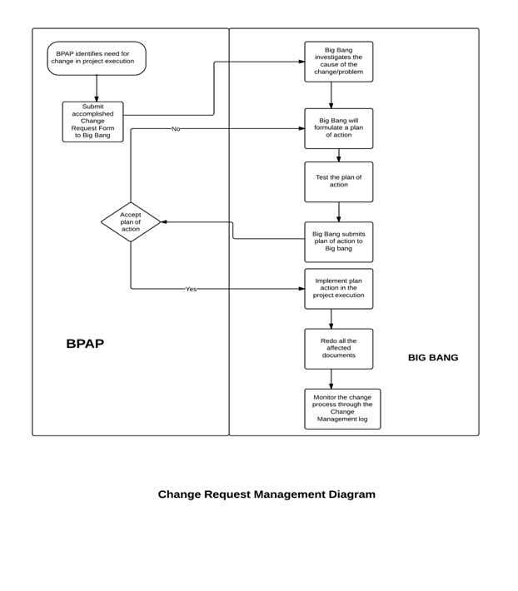

**Figure 1. Change Request Management Diagram**

## Communications Management

When disseminating important information, Big Bang’s project manager, Joy Federico, as well as the managers of the different teams within Big Bang. These team leaders are: Francis Fajardo (Data Capture teams), Paolo Luces (Monitoring and Evaluation team), and Raymond Cruz (Development team). They will serve as point persons and are in-charge of communicating with the project auditor and the BPAP project managers to set-up meetings and consultations.

Based on the team contract, weekly group meetings will be held every Monday and Tuesday wherein updates and assignment of tasks will be discussed. Unless discussed in the recent group meeting, Joy Federico will initiate group, auditor and client meetings after consulting about the group’s availability in the official Facebook group. For confirmation, the different team leaders will then send an SMS to their respective members asking if they can attend the meeting or not. If they are unable to send a reply, they can give their availability either through sending a private message to the team managers or by informing them in person.

When setting meetings with the project auditors, Mr. Joselito Olpoc and Ms. Sandra Lovenia, the team leaders will have to ask them in person and/or through e-mail or SMS about their availability based on the dates the group suggested. In the case of Mr. Olpoc, the group will check his schedule on the Google Calendar embedded on the course website. Most responses from them are usually in the form of e-mail or SMS. Additionally, meetings with BPAP project managers will also be scheduled by either Big Bang’s project manager or team leaders via e-mail or SMS.

Once the schedule is finalized, the PM will announce the details of the meeting on the Facebook group. However, if the schedules of the members and the BPAP project managers do not coincide, the group can decide to hold a conference call instead.

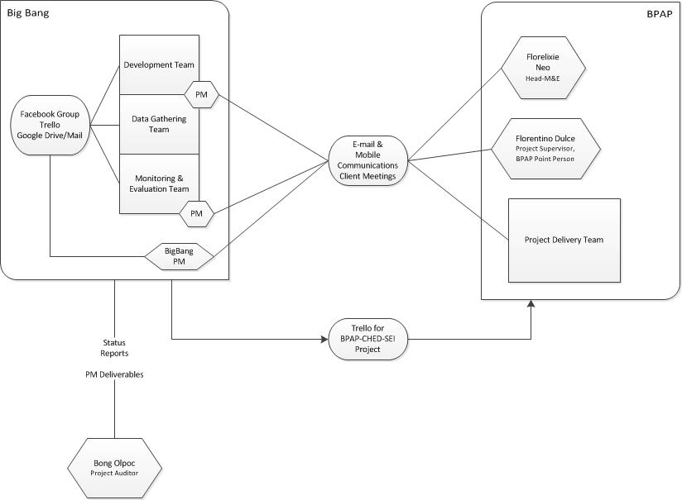

**Figure 2. Diagram of Big Bang's Communications Plan**

In terms of consolidating and archiving relevant documents such as minutes of the meetings, deliverables, and other project requirements, the group is utilizing different web-based software and applications that could be synced and stored in the members’ local drives. We are currently using Google Drive to hold all the files needed in completing the project. On the other hand, the group will use Trello in tracking the project’s progress. Only Trello will be accessible to the BPAP project managers, thus providing them with a means to monitor the status of the group in terms of activities and deliverables.

In the event of internal miscommunication, such as members’ failure to notify the group about his/her absence or tardiness during scheduled meetings, Big Bang will refer to the terms agreed upon by the members as stated in the team contract.

**Table 3 Communications Management Plan for Identified Stakeholders**

|  |  |  |  |  |
| --- | --- | --- | --- | --- |
| STAKEHOLDERS | DOCUMENT NAME | DOCUMENT FORMAT | CONTACT PERSON | DUE |
| BPAP Managers | Weekly status report | E-mail  *(.pdf or .docx attachment)* | * Mr. Doy Dulce * Mr. Jopat Lelay | Every Wednesday, unless needed sooner |
| System Requirements | First week of October 2013 |
| User Interface Design | Second week of October 2013 |
| Functional prototype | Second week of November 2013 |
| Monitoring & Evaluation | M&E report templates | E-mail  *(.pdf or .docx attachment)* | Ms. Florelixie Neo | October 22, 2013 |
| M&E framework | October 15, 2013 |
| List of measures for the M&E reports | October 15, 2013 |
| Weekly Status Report | Every Wednesday, unless needed sooner |
| Product Manager  (BEST and AdEPT) | Weekly status report | E-mail  *(.pdf or .docx attachment)* | Ms. Zoe Diaz De Rivera | Every Wednesday, unless needed sooner |
| Product Manager (T3) | Weekly status report | E-mail  *(.pdf or .docx attachment)* | Ms. Ella Antonio | Every Wednesday, unless needed sooner |
| Product Manager (SMP) | Weekly status report | E-mail  *(.pdf or .docx attachment)* | Ms. Arra Uri | Every Wednesday, unless needed sooner |
| Commission on Higher Education | Standards plan | E-mail  *(.pdf or .docx attachment)* | * Mr. Victor Loyola * Ms. Arra Uri | First week of November |
| Science Education Institute | Business Process Reorientation plan | E-mail  *(.pdf or .docx attachment)* | Ms. Myra Santos | First week of November |
| State Universities Colleges | New Policy Implementation plan | E-mail  *(.pdf or .docx attachment)* | Mr. Jopat Lelay | Second week of January |

## Quality Assurance

### Measures of Quality

The team thought of the following categories and procedures to follow in order to ensure the quality of the project:

1. Product Delivery

The team will follow the standards of code syntax as dictated by the programming language of choice, which are PHP and MySQL. Along with this, the development team will also employ standards of their own when it comes to naming conventions. This includes, but is not limited to, the use of camel cases, version numbers, and underscores to denote spaces. Together with this, comments and other forms of code documentation that can explain the type of logic used and its purpose will be employed so that it will assist in other group members’ understanding of the code. Proper code documentation will be developed and submitted to the client as part of a deliverable.

In order for the system to deliver the desired results, the team will agree on a programming language/s that will deliver the desired solutions as well as taking into consideration the developer’s knowledge of the chosen programming language. Logic of the method’s body will consist of the most appropriate functions and processes; eliminating, as much as possible, ineffective or redundant parts of the code.

During the course of the coding process, two types of testing methods will be employed by the team to ensure the development of the desired outcome. These are the unit and integration testing methods. Unit testing will be conducted alongside the development to ensure that each components and methods of the system will provide the desired output and outcome and to eliminate bugs and other defects. Integration testing will conducted between the modules of the system to ensure that the modules will be able to communicated effectively and provide the desired input, output, and outcome.

The quality measures of product delivery are: (1) the ability of the group and client to understand the program code, and (2) capability of the program to deliver the desired outcomes of the system.

1. Installation

The software upon installation must not result in errors. The system must be installed across all related departments with the same configuration. The system, if it does result in errors, must record them in a text document which includes the time and details of the error for quality audit.

The quality of measure for installation is a no-error log.

1. Documentation

To ensure the quality of the documents, the team will make sure that there will be available templates for each type of document that will be created. Each member of the team will then use this template to ensure consistency throughout the specific type of document. Because of these templates, the team will be able to work individually without compromising the consistency. Aside from the templates, consolidating the documents ensures that the documentation is coherent. By consolidating, errors and inaccuracies from the previous documents can be corrected immediately.

Glossaries will also be attached to the documents to make sure that the readers will understand the technical terms. The glossary will always be updated as new types of documents are added to the documentation. The glossary will contain words that are arranged alphabetically to ensure that words are easy to find.

The client’s approval of the documents will always be confirmed before the document is saved. Request for changes in the document will always be considered and checked. Thus, a draft will be sent to BPAP before the deadline to ensure that the document contains the different parts that they need.

All documents will be stored in folders of appropriate locations. These folders must be organized in terms of location and naming to ensure ease of navigation and sharing and must contain the appropriate and correct files and documents.

The measures of quality of the documentation will be as follows: (1) number of grammatical errors in the document (2) number of errors in information and data due to inconsistency.

1. Analysis

The analysis documents must make use of at least three analysis tools (Data Flow Diagram, Entity-Relationship Diagram, Flow Chart, etc.) to prove their quality.  The team must also consult with either Mr. Joselito Olpoc or Ms. Sandra Lovena and the client to ensure that the team is on the right track.

The measures of quality for the analysis would be: (1) use of at least three analysis tools, (2) approval of mentors, (4) approval of project managers for both the team and the client, and (3) client approval.

1. Prototyping

To ensure the quality of the designs, the format of the picture to be submitted must be in either PNG or JPEG file format, RGB, to ensure that the image will be viewable on all Operating Systems. The designs must meet the approval of both the team and the client. To gain the approval of the team, the designer must present these to the Development Team and Project Manager, who will give their approval verbally. The Project Manager will then forward them to the client who will approve of it designs via email, SMS, or personal communication.

The measures of quality for prototyping would be: (1) client approval and (2) Project Manager’s approval.

1. Data Gathering

To also ensure the quality of the document, the data gathered should also be as accurate and precise as possible. Guaranteeing accuracy means that data should be gathered as close as possible to the source. Meetings will be set and interviews will be scheduled to the possible sources of data. If the schedules don’t permit, emailing, texting, and other possible ways of communication will be considered to gather data.

The measures of quality for the data gathered are: (1) the number of requests to re-gather information which must be as low as possible, and (2) approval of the project manager of the data gathered.

### Quality of Output

Types of tests to be conducted during this stage are unit, integration, system, and user acceptance. Unit and integration tests are to be conducted during the course of the system development to ensure the functionality of each module and component of the system is incorporated. Unit testing will test the individual modules to see if each works properly. Integration testing will take place during the integration phase of the project modules in order to ensure that the modules work together as a whole. Alpha testing and Beta testing will determine if the system can work with the data provided. User acceptance testing will be the last test to determine if the users of the system will be able to efficiently use the system. Any errors before product delivery must be recorded and consolidated in a text document, which the manager for development will read and correct.

### People in Charge

The two teams in charge of systems analysis and design (Data Capture Team and Standards and Policies) will produce documents of their findings. To ensure the quality of their output, the managers for each team (Paolo Luces and Francis Fajardo respectively) will be in charge of consolidating the documents and checking the content of the documents within their respective group. Once approved, these groups will forward their documents to Philip Peralta for consolidation and formatting. He will then forward the resulting document to Trishia Gerobiese to spot grammatical errors. After approving the document, she will hand it over to the Project Manager (Joy Federico) to check for overall consistency and content.

For the minutes of the meeting, the secretaries within each group (Michelle Armario and Celina Jaldon) will present the document to their managers who will then read over it before asking the client to sign the document to ensure that both parties understood one another. Once signed, the managers will give the documents to the Project Manager for future reference.

## Project Monitoring and Tracking

### Schedule and progress

Schedule monitoring via Gantt chart and milestones

The project schedule will be tracked and monitored using the Gantt chart as a basis. The deadlines indicated in the chart will determine if the project is on, ahead, or behind schedule. The most critical deadlines are for the activities concerning deliverables. The deliverables are either documents or system components. They will be submitted to their respective project managers within Big Bang and BPAP. A 2 day allowance will be provided for deadline extension. Late deliverables will lead to the adjustment of the deadlines, overtime work, or allocation of more resources to accommodate the completion of the deliverable.

Progress monitoring via meetings

Weekly meetings will also take place to present status reports to the client. Representatives from Big Bang will meet with the project managers from BPAP to update each other on the project status. Any changes to the project will also be discussed during these meetings. Should a meeting be cancelled, the cancelling party must contact the other via email or phone, and state the reason for cancellation and agree upon a reschedule.

Progress monitoring via Trello

BPAP can also track project progress at any time via Trello, an online project-tracking tool. Trello consists of a project board that includes checklists and to-do, done, and doing cards which are editable by Big Bang and viewable by BPAP.

Internal Progress monitoring via Project Manager

Monitoring and tracking within Big Bang will be handled by the Data Capture and Monitoring & Evaluation project managers and supervised by the head PM. The head PM will delegate tasks and activities to the two PMs, and in turn they are responsible for assigning these tasks to their members. The two PMs are also responsible of getting the status of the activities they assigned to their members. They will also provide status reports to the head PM. If any of the activities should fall behind schedule, the head PM will be in charge of the necessary arrangements for the task completion.

The head PM will monitor member attendance during project-related activities. A member will receive merits or demerits based on his/her attendance. Member performance will also be monitored and graded by the head PM. A member’s performance will be measured according to rubrics. Feedback from the Data Capture and Monitoring & Evaluation PMs also influence the performance measurements of each member. The attendance and performance sheets are in the Appendix.

### Budget

Budget monitoring

Budget monitoring and tracking will be based on the project’s costing. Current cumulative cash inflows and outflows will be tracked through official receipts and bills. Given that there are allocated budgets for project expenses, the cumulative cash outflow will be computed against it to determine if the project is within budget or not. There is an allowable variance of Php 100 per meeting and Php 100 per person on food expenses. Should the project’s expenses exceed the allocated budget, the head project manager will request and collect additional funds from the project team to compensate for the added expenses.

### Scope

Scope monitoring via Project Charter

The project charter will be used as the basis for project scope monitoring and tracking. It contains the agreed-upon scope of the project with BPAP and will be cross-referenced to check if the project is within scope or not. Should scope creep occur, i.e. the project goes beyond the scope indicated in the charter, Big Bang will request and hold a meeting with BPAP to discuss the changes, as per the procedures indicated in the project’s change management plan.

Monitoring & Tracking Venue

The project team’s meeting venue will be the venue for monitoring and tracking activities. It is located in the Research Laboratory, Faura building, Ateneo de Manila University, Quezon City. Other venues are Unit 414, Burgundy Place, Katipunan Ave., QC and 29 Fokker St. Filinvest 2 Batasan Hills, QC.

## Project Status at Final Deliverable Deadline

Currently, Big Bang is gathering and analyzing data. Based on the Gantt chart, the project is on schedule. On the deadline of the final deliverable, Wednesday October 9, 2013, the project’s data gathering and analysis is already finished. Formulation of policies and procedures and the creation of the system design is underway. The user manual is also being drafted at this point. The project is on schedule and within budget and scope.

### Project Closure

The user acceptance testing will start off with an on-site testing of the finished system. When the clients declare that the objectives are met and that they are satisfied, the system will be considered accepted. User training comes after the acceptance of the clients. The group intends to have the project signed off by having our clients, BPAP’s relevant project managers, sign a legal affidavit declaring full acceptance of the system and its implementation. It comes together with the formal separation of the group and its responsibilities from the project as declared in the Limits and Exclusions.

## Lessons Learned

The lessons learned from the project are as follows:

1. Echo whatever what was said by the client to ensure that both parties are on the same page. Minutes of the meeting are important
2. Expect the unexpected and always have a back-up plan.
3. Start as soon as possible.
4. Communication across the project members as well as the client is crucial to the development and progress of the project. On that note, always have means of communicating with the members by getting their contact number, email, etc.
5. Dedicate at least a day for consolidation. It might seem trivial but it can be problematic.
6. Set an agenda for the client. Know the proper timing to steer the conversation so that the time allotted will be productive.
7. Government projects are difficult since they are unwilling to conform to certain standards. They prefer taking the traditional approach. It’s good to learn to adjust to their system.
8. Wide array of different communication skills comes in handy when conversing with different types of people
9. Standards in documentation and folder/paper management can reduce instances of confusion among project members concerning file location and version.
10. Learn to track the budget.

# Appendix

## Client Contact Information

**BPAP Address:** 5th Floor C2 Building High Street Central, 30th Street corner 7th Avenue Bonifacio Global City, Taguig 163

**Florentino Dulce, Jr.** [florentino.dulce@gmail.com](mailto:florentino.dulce@gmail.com) MIS Shared Services

|  |  |
| --- | --- |
| BPAP Point Person |  |
| **Ella Antonio** [ellaantonio@bpap.org](mailto:ellaantonio@bpap.org) PM CHED-SMP | **Arra Arielle Uri** [arraarielleuri@bpap.org](mailto:arraarielleuri@bpap.org) PM CHED-SMP |
| **Victor Loyola** [victorloyola@bpap.org](mailto:victorloyola@bpap.org) PM CHED-SMP | **Myra Santos** [myrasantos@bpap.org](mailto:myrasantos@bpap.org) PM DOST-SEI |
| **Zoe Diaz De Rivera** [zoediazderivera@bpap.org](mailto:zoediazderivera@bpap.org) PM BEST and Adept | **Reli Neo**  [relineo@bpap.org](mailto:relineo@bpap.org)  PM Monitoring and Evaluation |

### Jopat Lelay

[jopatlelay@bpap.org](mailto:jopatlelay@bpap.org)

PM Overall Project Director

## Glossary of Terms

**AAI (Advanced Analytics Institute)** is BPAP’s partner in providing GCAT to students who want to take part in the program.

**Alpha Test** is the first phase of testing in a software development process.

**Animation Council of the Philippines** (ACPI) aims to create an identity for the Philippines as the preferred country for the provision of professional services to the global animation industry. It is a non-profit organization that is recognized and supported by the Philippine government.

**BEST** stands for Basic English Skills Training. BPAP-developed intervention to improve the English proficiency of college students to a level acceptable for employment in the IT/BPO.

**Beta Test** is the second phase of software testing in which a sampling of the intended audience tries the product out.

**BPAP** is the umbrella organization for the Philippine IT-BPO industry and is developing and implementing strategies and programs aimed at achieving the industry’s growth targets.

**BPO** or the Business Processing Outsourcing sector is the priority growth industry of the project.

**BPR** stands for Business Processing Organization. It is the analysis and redesign of workflow within and between enterprises

**CHED** or the Commission on Higher Education is tasked by the Aquino administration in

partnership with BPAP to undertake the Developing State University and College Graduates Towards Global Competitiveness, National Productivity and Development Project to address the talent supply gap in the IT-BPO sector.

**CoA** or the Commission on Audit has the primary function to examine, audit and settle all accounts and expenditures of the funds and properties of the Philippine government.

**Contact Center of the Philippines** (CCAP) aims to promote the Philippines as the preferred country for contact center services, development of professional standards and practices, organization of learning and networking events, and working with various stakeholders to improve the industry’s contribution to national economy and strengthen its worldwide market position.

**CRISP** consists of the data capture and report generation system components.

**Data Dictionary** is a a collection of descriptions of the data objects or items in a data model for the benefit of programmers and others who need to refer to them

**Database** is a collection of information that is organized so that it can easily be accessed, managed, and updated.

**DBMS** or the Database Management System is a program that lets one or more computer users create and access data in a database.

**DCT** or the Data Capture Team is one of the two teams consisting of the project group which is responsible in communicating to the PDT of BPAP to get the necessary data for the whole BPAP-CHED-SEI project.

**DFD** (Data Flow Diagram) is a graphical representation of the flow of data through an information system

**eAdept or Electronic Advanced English Proficiency Program** (ADEPT) is another BPAP-developed intervention tool similar to BEST that aims to improve the English proficiency of college students to a level acceptable for employment in the IT/BPO.

**ELITES** or the Expanded Learning on IT Services Program equip teachers of IT subjects with the competency to roll out or train graduating students in the more technical aspects of the IT subjects more effectively.

**ERD** is a data modeling technique that creates a graphical representation of the entities, and the relationships between entities, within an information system.

**Game Developers Association of the Philippines** (GDAP) aims to promote the game development industry in the Philippines. It is a non-profit organization with strong ties to various entities including the government and the International Game Developers Association.

**GCAT** or the Global Competitiveness Assessment Tool is the standard assessment to determine the level of competency for the students in 5 areas: Learning (Cognitive) Ability, English Proficiency, Computer Literacy, Perceptual Speed and Accuracy, and Service Orientation.

**Healthcare Information Management Outsourcing Association of the Philippines** (HIMOAP) aims to promote the Philippines as the preferred destination for quality Healthcare Information Management (HIM) outsourcing services. It is a non-profit organization recognized by the Philippine government.

**Logical Data Map** is a type of data model that represents the abstract structure of a domain of information.

**M&E** or the Monitoring and Evaluation Team of the BPAP Council, together with the DCT, is the one responsible in communicating to the Shared Services of BPAP to get the necessary information for the to accomplish its role in the project.

**PDT** or the Project Delivery Team of BPAP is one of the two teams from BPAP, led by Sir Jopat Lelay and two project managers responsible for the BPAP-CHED-SEI project.

**Prototype** is an early sample or release of a product built to test a concept or process

**SMP** stands for Service Management Program. It is an 18-month, Php125 million project designed to help students in selected SUCs acquire the skill sets and competencies needed for entry level positions and further career development in the IT-BPO industry. The SMP is a 21-unit minor course or specialization track that the CHED has approved under CMOs 6 and 34 which authorizes Philippine higher education institutions.

**SQL** is a special-purpose programming language designed for managing data held in a database management system (DBMS).

**SST** or the Shared Services team is another team from BPAP responsible for the BPAP- CHED-SEI project.

**Stress Test** is a form of deliberately intense or thorough testing used to determine the stability of a given system or entity.

**SUC** stands for State Colleges and Universities. The participating schools for the CHED project includes Benguet State University, Don Mariano Marcos Memorial State University, Pangasinan State University, Tarlac State University, Bulacan State University, Batangas State University, Cavite State University, Laguna State Polytechnic University, Carlos C. Hilado Memorial State College, Northern Iloilo Polytechnic State College, West Visayas State University, Western Visayas College of Science and Technology, Negros Oriental State University, University of South Eastern Phils., Philippine Normal University, Polytechnic

University of the Philippines, Technological University of the Philippines

**T3** stands for Train the Teachers. It is a project component where the school faculty will be trained by “industry faculty” and BPAP accredited providers who have the professional experience related to the SMP.

**TCO** or the Total Cost of Ownership is a financial estimate intended to help determine the direct and indirect costs of a product or system.

**TPS** or a transaction processing system is a kind of information system that collects stores and retrieves data and sometimes controls decisions made as part of a transaction.

**Use Case Diagram** summarizes the representation of a user's interaction with the system

**User Acceptance** is a type of testing performed by the client to certify the system with respect to the requirements that was agreed upon.

**User Interface** is what the user can see and interact with in a system.

**Wireframe** is a visual guide that represents the skeletal framework of a website.

## Abbreviations

|  |  |
| --- | --- |
| **AAI** | **Advanced Analytics Institute** |
| **ACPI** | Animation Council of the Philippines |
| **BEST** | Basic English Skills Training |
| **BPAP** | Business Process Association of the Philippines |
| **BPO** | Business Process Outsourcing |
| **BPR** | Business Process Reengineering |
| **CCAP** | Contact Center of the Philippines |
| **CHED** | Commission on Higher Education |
| **CoA** | Commission on Audit |
| **CRISP** | Central Reporting and Information Systems for Participants and/or Programs |
| **DBMS** | Database Management System |
| **DCT** | Data Capture Team |
| **DOST-SEI** | Department of Science and Technology – Science Education Institute |

|  |  |
| --- | --- |
| **eAdept** | Electronic Advanced English Proficiency Training |
| **ELITE** | Expanded Learning on IT Learning |
| **GCAT** | Global Competitiveness Assessment Tool |
| **GDAP** | Game Developers Association of the Philippines |
| **HIM** | Healthcare Information Management |
| **HIMOAP** | Healthcare Information Management Outsourcing Association of the Philippines |
| **HR** | Human Resources |
| **IT-BPM** | Information Technology- Business Process Management |
| **M&E** | Monitoring and Evaluation Team |
| **PDT** | Project Delivery team |
| **PSIA** | Philippine Software Industry Association |
| **SMP** | Service Management Program |
| **SQL** | Structured Query Language |
| **SST** | Shared Services Team |
| **SUC** | State University and Colleges |
| **T3** | Training the Teachers |
| **TCO** | Total Cost of Ownership |
| **UAT** | User Acceptance Testing |
| **UI** | User Interface |

## Computations for BPAP-CHED-SEI Project

**Scoring Method**

A weighted factor scoring model is used to rate the different proposed projects that could be used to determine the value of each when compared with the other alternatives. Using a template taken from the Project Management: Achieving Competitive Advantage textbook by Jeffrey K. Pinto, the criteria are made according to factors that may affect the development and value of the project as a whole. The aforementioned alternatives would be weighed in according to its risk, commercial, internal operating, and other related aspects.

Based on the results, the CRISP project ranks the highest and is therefore, the project that would most likely be carried out by the project groups. Judging from the scoring, the CRISP captures all the base objectives that are necessary in the development.

Ranking in each category depends on whether the criteria are beneficial or detrimental to the project. For example, a three (3) on costs means that the program is low on cash outlay. The following section outlines the aspects and concerns that would directly and indirectly impact the whole project:

### Risk aspects:

1. Technical Risk - Risks involved in developing a new or untested system or technology.
2. Financial Risk - Unforeseen expenses that may incur that may in the duration of the project.
3. Quality Risk - Risks associated with the image of BPAP due to the quality of the project.
4. Legal Exposure - Risks involved in case of non-compliance or any other legal matters.

### Commercial Aspects:

1. Potential Market Share - potentiality of the project to increase BPAP’s competency and market share.
2. Initial cash outlay - Funds needed to develop the project.

3. Ability to generate future business/new markets / Profit potential - Potentiality to increase BPAP’s portfolio through the project.

### Internal Operating Aspects:

1. Need to develop or train employees - The need to develop or train the employees in the implementation would depend on the complexity of the project.
2. Change in workforce size or composition - The need to hire additional employees for the project.

### Other Aspects:

1. Impact on company’s image - Answers the question, how much would BPAP’s image be affected through the said project.
2. Strategic fit:

Extensibility - Answers whether the project allows the future expansion with regards to the programs or the clients that are using the same framework.

Scalability - Answers whether the project has the ability in catering bigger amounts of data. (Aside from what is expected or targeted.)

1. Time to finish the project - Answers the question, is there a pressure on finishing on time given the complexity of the project?

### Importance Weight:

1. - Low Importance
2. - Medium Importance 3 - High Importance

**Table 4. Table of Reference for the Weighted Scoring Model**

|  |  |  |
| --- | --- | --- |
| **Criteria** | **Importance Weight** | **Score Indicators** |
| Technical Risk | 2 | 3 - Low Risk |
| Financial Risk | 3 | 3 - Low Risk |
| Quality Risk | 3 | 3 - Low Risk |
| Legal Risk | 3 | 3 - Low Risk |
| Potential Market Share | 1 | 3 - High potentiality |
| Initial cash outlay | 2 | 3 - Low |
| Ability to generate future business/new markets / Profit potential | 1 | 3 - High Potentiality |
| Need to develop/ train employees | 2 | 3 - Low Priority |
| Change in workforce size | 1 | 3 - Low Priority |
| impact on the company’s image | 3 | 3 - High Impact |
| Extensibility | 2 | 3 - Highly Extensible |
| Scalability | 3 | 3 - Highly Extensible |
| Time finish the project | 2 | 3 - Low Priority |

**Table 5. Weighted Scoring Model of the Possible Projects**

|  |  |  |  |  |
| --- | --- | --- | --- | --- |
| **Project** | **Criteria** | **Weight** | **Score** | **Weighted Score** |
| **CRISP** | Technical Risk | 2 | 2 | 4 |
| Financial Risk | 3 | 1 | 3 |
| Quality Risk | 3 | 2 | 6 |
| Legal Risk | 3 | 2 | 6 |

|  |  |  |  |  |
| --- | --- | --- | --- | --- |
|  | Potential Market Share | 1 | 1 | 1 |
| Initial cash outlay | 2 | 2 | 4 |
| Ability to generate future business/new markets / Profit potential | 1 | 3 | 3 |
| Need to develop/ train employees | 2 | 2 | 4 |
| Change in workforce size | 1 | 1 | 1 |
| impact on the company’s image | 3 | 3 | 9 |
| Extensibility | 2 | 3 | 6 |
| Scalability | 3 | 3 | 9 |
| Time finish the project | 2 | 2 | 4 |
| **TOTAL** | | | **60** |
| **Separate System for Programs** | Technical Risk | 2 | 2 | 4 |
| Financial Risk | 3 | 3 | 9 |
| Quality Risk | 3 | 1 | 3 |
| Legal Risk | 3 | 2 | 6 |
| Potential Market Share | 1 | 1 | 1 |
| Initial cash outlay | 2 | 2 | 4 |
| Ability to generate future business/new markets / Profit potential | 1 | 3 | 3 |
| Need to develop/ train employees | 2 | 2 | 4 |
| Change in workforce size | 1 | 1 | 1 |
| impact on the company’s image | 3 | 3 | 9 |
| Extensibility | 2 | 2 | 4 |
| Scalability | 3 | 2 | 6 |
| Time finish the project | 2 | 2 | 4 |
| **TOTAL** | | | **58** |
| **Reporting Server** | Technical Risk | 2 | 2 | 4 |
| Financial Risk | 3 | 1 | 3 |

|  |  |  |  |  |
| --- | --- | --- | --- | --- |
|  | Quality Risk | 3 | 1 | 3 |
| Legal Risk | 3 | 2 | 6 |
| Potential Market Share | 1 | 1 | 1 |
| Initial cash outlay | 2 | 2 | 4 |
| Ability to generate future business/new markets / Profit potential | 1 | 3 | 3 |
| Need to develop/ train employees | 2 | 3 | 6 |
| Change in workforce size | 1 | 1 | 1 |
| impact on the company’s image | 3 | 3 | 9 |
| Extensibility | 2 | 2 | 4 |
| Scalability | 3 | 2 | 6 |
| Time finish the project | 2 | 3 | 6 |
| **TOTAL** | | | **56** |
| **Excel-based operations** | Technical Risk | 2 | 3 | 6 |
| Financial Risk | 3 | 3 | 9 |
| Quality Risk | 3 | 1 | 3 |
| Legal Risk | 3 | 2 | 6 |
| Potential Market Share | 1 | 1 | 1 |
| Initial cash outlay | 2 | 3 | 6 |
| Ability to generate future business/new markets / Profit potential | 1 | 1 | 1 |
| Need to develop/ train employees | 2 | 3 | 6 |
| Change in workforce size | 1 | 3 | 3 |
| impact on the company’s image | 3 | 1 | 3 |
| Extensibility | 2 | 1 | 2 |
| Scalability | 3 | 1 | 3 |
| Time finish the project | 2 | 2 | 6 |
| **TOTAL** | | | **55** |

**Net Present Value and Return on Investment**

Looking at the quantitative one-year analysis of the project, the group considered certain factors and assumptions for the computation of the NPV and ROI:

* + There is a consideration for additional personnel from BPAP who will be in charge of encoding and handling the system or file to different SUCs. As for the encoding cost for SUC employees, the values allocated for them are derived from the amount of participants or programs.
* Cost reductions are omitted since the actual costs of the operations are not fully realized as of the moment. The expenses (i.e. unwarranted expenses) are not fully disclosed by the client so the group could not project any savings if the former factor cannot be declared yet.
* Since the BPAP-SEI-CHED program is a government project, the computation is not geared towards revenue. Reiterating the main purpose of this program, it aims to bridge the gap between education and employability by investing and zeroing in on students' trainings and career growth for the future.
* However, in some respect the project marginally predicts an income that is gained through taxation. The project's revenue is presumed to be based from income tax and can be calculated by:

**Table 6. For Individuals Earning Purely Compensation Income and Individuals Engaged in Business and Practice of Profession****13**

|  |  |  |
| --- | --- | --- |
| **Amount of Net Taxable Income** |  | **Rate** |
| **Over** | **But Not Over** |  |
|  | P10,000 | 5% |
| P10,000 | P30,000 | P500 + 10% of the Excess over P10,000 |
| P30,000 | P70,000 | P2,500 + 15% of the Excess over P30,000 |

13 "Amount of Net Taxable Income." *Bureau of Internal Revenue.* 2004. [http://www.bir.gov.ph/taxinfo/tax_income.htm#25147](http://www.bir.gov.ph/taxinfo/tax_income.htm%22%20%5Cl%20%2225147) (accessed August 16, 2013).

|  |  |  |
| --- | --- | --- |
| P70,000 | P140,000 | P8,500 + 20% of the Excess over P70,000 |
| P140,000 | P250,000 | P22,500 + 25% of the Excess over P140,000 |
| P250,000 | P500,000 | P50,000 + 30% of the Excess over P250,000 |
| P500,000 |  | P125,000 + 32% of the Excess over P500,000 in 2000 and onward |

* The numbers for the database prices are derived from online research and consultation with Mr. Dulce.
* According to the Central Bank rates. The discount rate for the Philippines is 3.5%.14
* Figures are referred from the financial plan stated in the Memorandum of Agreement of BPAP and CHED.
* Since the development of an IT solution is not allocated in the financial plan, additional costs have been added on top of the budget.
* The budget, as set in the financial plan, is only good for 2 years, thus all expenses are assumed to be fully consumed on by the end of that period.

**Table 7. Estimated Cost for Programs**

*cost includes the personnel and the electricity used per quantity

**For reference, see CHED BUDGET PROGRAM in the Appendix

|  |  |  |  |  |
| --- | --- | --- | --- | --- |
|  | **COST\*** | **QUANTITY\*** | **TOTAL** |  |
| **Implementation for Teachers** |  |  |  |  |
| GCAT 1ST BATCH | 100 | 750 | 75,000 |  |
| GCAT 2ND BATCH | 100 | 650 | 65,000 |  |
| BEST T3 1ST BATCH | 100 | 750 | 75,000 |  |
| BEST T3 2ND BATCH | 100 | 650 | 65,000 |  |
| e-AdEPT 1ST BATCH | 100 | 750 | 75,000 |  |
| e-AdEPT 2nd batch | 100 | 650 | 65,000 |  |
| ELITES 1st batch | 100 | 275 | 27,500 |  |
| ELITES 2nd batch | 100 | 225 | 22,500 |  |
| Medical/Animation/Game 1st batch | 100 | 75 | 7,500 |  |

14 “Worldwide Central Bank Rates.” *Central Bank Rates*. (n.d.). [http://www.cbrates.com](http://www.cbrates.com/) (accessed August 15, 2013).

|  |  |  |  |  |
| --- | --- | --- | --- | --- |
| Medical/Animation/Game 2nd batch | 100 | 75 | 7,500 |  |
| SMP 1st batch | 100 | 275 | 27,500 |  |
| SMP 2nd batch | 100 | 275 | 27,500 |  |
| INTERNSHIP: GCAT,BEST, e-AdEPT MIS and  Tracking |  |  | 1,359,700 |  |
| INTERNSHIP: SMP MIS and Tracking | 900 | 500 | 450,000 |  |
| **TOTAL** | | | **2,349,700** |  |
| **Implementation for Students** |  |  |  |  |
| BEST 1ST BATCH | 100 | 7500 | 750,000 |  |
| BEST 2ND BATCH | 100 | 7500 | 750,000 |  |
| e-AdEPT 1ST BATCH | 100 | 2500 | 250,000 |  |
| e-AdEPT 2ND BATCH | 100 | 2500 | 250,000 |  |
| SMP COURSEWARE | 500 | 500 | 250,000 |  |
| GCAT | 100 | 20000 | 2,000,000 |  |
| **TOTAL** | | | **4,250,000** |  |
| **Others** |  |  | **Months** | **Total** |
| DSL Monthly Subscription | 3000 | 13 | 18 | 702,000 |
| PC Leasing | 4000 | 13 | 12 | 624,000 |
| TOTAL | | | | **1,326,000** |

**Table 8. Revenue from Employed Students**

|  |  |
| --- | --- |
| Students (Assuming target goal of 70%)* | 14,000 |
| Salary per month | P20,000 |
| Income Tax | P1,500 |
| Months | 12 |
| Total (Tax x Months x Students) | **P252,000,000** |

*Assuming that 70% of the participating students get employed by the member organizations of BPAP.

**Table 9. Cost of Additional Personnel for BPAP**

Monthly Base Wage P11,250

|  |  |
| --- | --- |
| Months | 12 |
| Per Person | **P135,000** |

1. ***Central Reporting and Information System for Participants and/or Programs***

**Table 10. Development Cost for CRISP**

|  |  |
| --- | --- |
| Software Developer(4 people x P775 rate x 30 Days)* | P93,000 |
| System Analysis (P 700 rate x 7 people x 37 Days)* | P181,300 |
| Project Manager (P950 rate x 3 people x 103 Days)* | P293,250 |
| Initial data warehouse** | P300,000 |
| Development Software*** | P20,000 |
| Hardware and DSL (provided by BPAP) | 0 |
| **Total** | **P857,550** |

*Rates for salaries have been taken from payscale.com and jobstreet.com

**Estimation was taken from Mr. Dulce

***Estimated software cost allotted for all developers (web service, application programs)

**Table 11. Maintenance and Other Costs for CRISP**

|  |  |
| --- | --- |
| Employment Tracking (System Extension) | P100,000 |
| Additional Programs (For adding additional projects) | P100,000 |
| Database Maintenance | P50,000++ |
| **Total** | **P250,000** |

### Solving for NPV:

Money in: 252,000,000

Interest Rate: 3.5%

(Investment) Money Out: 126,136,050.00 252,000,000/ (1+3.5%) = 243478260.9

NPV: 243478260.9- 126,136,050.00= **117,342,210.87**

### Solving for ROI:

Money in: 252,000,000

(Investment) Money Out: 126,136,050.00

252,000,000 – 126,136,050.00= 125,863,950.00

ROI: 125,863,950.00/ 126,136,050.00= **0.997842805/ 99.7%**

**Table 12. Net Present Value and Return on Investment (3-Year Projection)**

|  |  |  |  |  |
| --- | --- | --- | --- | --- |
| **CRISP** | | | | |
|  | **Year 1** | **Year 2** | **Year 3** | **TOTAL** |
| Revenue | 0 | 0 | P252,000,000 | **P252,000,000** |
| Cost Reductions | 0 | 0 | 0 | 0 |
| Other Cost | P117,072,800 | | 0 | P117,072,800 |
| Estimated IT Costs* | P7,925,700 | | 0 | P7,925,700 |
| Project Cost** | **P124,998,500** | | 0 | P124,998,500 |
| Development Cost | **P320,000** | | 0 | P320,000 |
| Manpower (IT DEV) | **P567,550** | | 0 | P567,550 |
| Maintenance Cost | 0 | 0 | P250,000 | P250,000 |
| Net Cost | P125,886,050.00 | | P250,000 | **P126,136,050.00** |
| Cash Flow | -P125,886,050.00 | | P251,500,000.00 | P125,613,950.00 |
| NPV | | | 3.5% | **P117,342,210.87** |
| ROI | | | | **0.997842805** |
| Payback Period | | | | **1+ Year** |

*Please refer to Table 10

** Please see CHED BUDGET PROGRAM in the Appendix

1. ***Separate Systems for programs***

**Table 13. Development Costs for the Separate Systems**

|  |  |
| --- | --- |
| Software Developer(4 people x P775 rate x 30 Days)* | P93,000 |
| System Analysis (P 700 rate x 7 people x 37 Days)* | P181,300 |
| Project Manager (P950 rate x 3 people x 103 Days)* | P293,250 |
| Databases (4 programs + 1 for BPAP)** | P210,000 |
| Development Software*** | P20,000 |
| Hardware and DSL (provided by BPAP) | 0 |
| **Total** | **P797,550** |

*Rates for salaries have been taken from payscale.com and jobstreet.com

**Estimation was taken from Mr. Dulce

***Estimated software cost allotted for all developers (web service, application programs)

**Table 14. Maintenance and Other Costs for the Separate Systems**

|  |  |
| --- | --- |
| Employment Tracking (System Extension) | P100,000 |
| Additional Programs (Additional projects) | P100,000 |
| Database Maintenance (P20k per system) | P100,000 |
| Additional Personnel for BPAP (2 people) | P270,000 |
| **Total** | **P570,000** |

### Solving for NPV:

Money in: 252,000,000

Interest Rate: 3.5%

(Investment)Money Out: 126,366,050.00

252,000,000/ (1+3.5%) = 243478260.9

NPV: 243,478,260.9 - 126,366,050.00= P117, 112,210.87

### Solving for ROI:

**Money in: 252,000,000**

(Investment) Money Out: 126,366,050.00 252,000,000 - 126,366,050.00=125,633,950.00

ROI: 125,633,950.00/ 126,366,050.00 = **0.994206514/ 99.4%**

**Table 15. Net Present Value and Return on Investment (3-Year Projection)**

|  |  |  |  |  |
| --- | --- | --- | --- | --- |
| **Separate Systems** | | | | |
|  | **Year 1** | **Year 2** | **Year 3** | **TOTAL** |

|  |  |  |  |  |
| --- | --- | --- | --- | --- |
| Revenue | 0 | 0 | P252,000,000 | **P252,000,000** |
| Cost Reductions | 0 | 0 | 0 | 0 |
| Other Cost | P117,072,800 | | 0 | P117,072,800 |
| Estimated IT Costs* | P7,925,700 | | 0 | P7,925,700 |
| Project Cost** | **P124,998,500** | | 0 | P124,998,500 |
| Development Cost | **P230,000** | | 0 | P230,000 |
| Manpower (IT DEV) | **P567,550** | | 0 | P1,440,000 |
| Maintenance Cost | 0 | 0 | P570,000 | P280,000 |
| Net Cost | P125,796,050.00 | | P570,000.00 | **P126,366,050.00** |
| Cash Flow | - P125,796,050.00 | | P251,430,000.00 | P125,633,950.00  125,633,950.00 |
| NPV | | | 3.5% | **P117,112,210.87** |
| ROI | | | | **.** **0.994206514** |
| Payback Period | | | | **1+ Year** |

*Please refer to Table 10

** Please see CHED BUDGET PROGRAM in the Appendix

1. ***Reporting Server***

**Table 16. Development Costs for the Reporting Server Project**

|  |  |
| --- | --- |
| Software Developer(4 people x P775 rate x 30 Days)* | P93,000 |
| System Analysis (P 700 rate x 7 people x 37 Days)* | P181,300 |
| Project Manager (P950 rate x 3 people x 103 Days)* | P293,250 |
| Initial data warehouse** | P300,000 |
| Development Software*** | P20,000 |
| Hardware and DSL (provided by BPAP) | 0 |
| **Total** | **P887,550** |

*Rates for salaries have been taken from payscale.com and jobstreet.com

**Estimation was taken from Mr. Dulce

***Estimated software cost allotted for all developers (web service, application programs)

**Table 17. Maintenance and Other Costs for the Reporting Server Project**

|  |  |
| --- | --- |
| Employment Tracking (System Extension) | P100,000 |
| Additional Programs (Additional Project) | P100,000 |
| Database Maintenance (x5) | P100,000 |
| Additional Personnel (1 person ) | P135,000 |
| **Total** | **P435,000** |

### 

### Solving for NPV:

Money in: 252,000,000

Discount Rate: 3.5%

(Investment) Money Out: 126,321,050.00

252,000,000/(1+3.5%) = 243478260.9

NPV: 243478260.9- 126,321,050.00= **117,157,210.87**

### Solving for ROI:

Money in: 252,000,000

(Investment)Money Out: 126,321,050.00

252,000,000 - 126,321,050.00= 125,768,950.00

ROI: 125,768,950.00/ 126,321,050.00= **0.99491692/ 99.49%**

**Table 18. Net Present Value and Return on Investment (3-Year Projection)**

|  |  |  |  |  |
| --- | --- | --- | --- | --- |
| **Reporting Server** | | | | |
|  | **Year 1** | **Year 2** | **Year 3** | **TOTAL** |
| Revenue | 0 | 0 | P252,000,000 | **P252,000,000** |
| Cost Reductions | 0 | 0 | 0 | 0 |
| Other Cost | P117,072,800 | | 0 | P117,072,800 |
| Estimated IT Costs* | P7,925,700 | | 0 | P7,925,700 |
| Project Cost** | **P124,998,500** | | 0 | P124,998,500 |
| Development Cost | **P320000** | | 0 | P320,000 |
| Manpower (IT DEV) | **P567,550** | | 0 | P567,550 |
| Maintenance Cost | 0 | 0 | P435,000 | P435,000 |
| Net Cost | P125,886,050 | | P435,000 | **P126,321,050.00** |
| Cash Flow | -P125,886,050 | | P251, 565, 000 | 125,678,950.00 |
| NPV | | | 3.5% | **P117,157,210.87** |

|  |  |
| --- | --- |
| ROI | **0.99491692** |
| Payback Period | **1+ Year** |

*Please refer to Table 10

** Please see CHED BUDGET PROGRAM in the Appendix

1. ***EXCEL-based Operations***

**Table 19. Development Costs for EXCEL-based Operations**

|  |  |
| --- | --- |
| Software Developer(4 people x P775 rate x 30 Days)* | P93,000 |
| System Analysis (P 700 rate x 7 people x 37 Days)* | P181,300 |
| Project Manager (P950 rate x 3 people x 103 Days)* | P293,250 |
| Excel Enterprise Ed. (3 users x $240/license, forex P42= $1) | P30,240 |
| Hardware and DSL (provided by BPAP) | 0 |
| **Total** | **P597,790** |

*Rates for salaries have been taken from payscale.com and jobstreet.com

**Estimated software cost allotted for all developers (web service, application program

**Table 20. Maintenance and Other Costs for Excel-based Operations**

|  |  |
| --- | --- |
| Employment Tracking (System Extension) | P50,000 |
| Additional Programs (Additional Project) | P50,000 |
| Additional Personnel (4 people) | P540,000 |
| **Total** | **P640,000** |

### Solving for NPV:

Money in: 252,000,000

Discount Rate: 3.5%

(Investment)Money Out: 126,236,290.00

252,000,000/ (1+3.5%) = 243,478,260.87

NPV: 243,478,260.87- 126,236,290.00= **117,241,970.87**

### Solving for ROI:

Money in: 252,000,000

(Investment)Money Out: 126,236,290.00

252,000,000 - 126,236,290.00= 125,763,710.00

ROI: 125,763,710.00/ 126,236,290.00= **0.996256386/ 99.6%**

**Table 21. Net Present Value and Return on Investment (3-Year Projection)**

|  |  |  |  |  |
| --- | --- | --- | --- | --- |
| **EXCEL based** | | | | |
|  | **Year 1** | **Year 2** | **Year 3** | **TOTAL** |
| Revenue | 0 | 0 | P252,000,000 | **P252,000,000** |
| Cost Reductions | 0 | 0 | 0 | 0 |
| Other Cost | P117,072,800 | | 0 |  |
| Estimated IT Costs | P7,925,700 | | 0 |  |
| Project Cost | **P124,998,500** | | 0 | P124,998,500 |
| Development Cost | **P30,240** | | 0 | P30,240 |
| Manpower (IT DEV) | **P567,550** | | 0 | P567,550 |
| Maintenance Cost | 0 | 0 | P640,000 | P640,000 |
| Net Cost | P125,596,290 | | P640,000.00 | **P126,236,290.00** |
| Cash Flow | -P125,596,290 | | P250,720,000 | P125,763,710.00 |
| NPV | | | 3.5% | **P117,241,970.87** |
| ROI | | | | **.982554465** |
| Payback Period | | | | **1+ Year** |

## Analysis

The result of the qualitative and quantitative analysis shows that CRISP produces the best results over the other alternatives.

Quantitatively, CRISP doesn’t score far from the other projects. It has almost the same net present value and return on investment as the other projects which are estimated to be P117, 342,210.87[1] and 99.78%[2] respectively. The payback period is also roughly the same. The numeric model also shows that CRISP presents the best solution by presenting medium-scale risk but high value but, again, the other projects are not far off. Judging from the quantitative

models, it shows that while CRISP is the best solution, it’s not exemplary. But what CRISP does promise is quality of delivery.

There are off-the-shelf solutions but because of the high volume of data and their complex relationship with one another, these solutions might lack in functionalities to fully address the issue. Further, CRISP project tries to address the needs of the project by looking at the bigger picture. It looks at the project as one big process rather than framing the problem and focusing only on one aspect of it without seeking to solve the rest. The Excel-based alternative, for instance, lacks the communicative tool needed to monitor the SUCs.

Given that the 17 SUCs involved with the program are geographically dispersed, there is a need to consolidate and standardize the data from the different sources. CRISP has value in this in that it can gather, consolidate, and print out reports of the data. This is a huge advantage especially if BPAP is looking for extensibility of the program itself.

**Table 22. A summary of the results quantitative and qualitative models used in comparing the possible projects**

|  |  |  |  |  |
| --- | --- | --- | --- | --- |
| Possible Projects | NPV* | ROI* | Payback Period | Weighted Score |
| **CRISP** | P117,342,210.87 | 0.997842805 | 1+ Year | 60 |
| **Separate System** | P117,112,210.87 | 0.994206514 | 58 |
| **Reporting System** | P117,157,210.87 | 0.99491692 | 56 |
| **Excel-based Operations** | P117,241,970.87 | 0.996256386 | 55 |

*See Appendix for NPV and ROI

## BPAP-CHED Implementation Timeline Summary

## CHED BUDGET PROGRAM

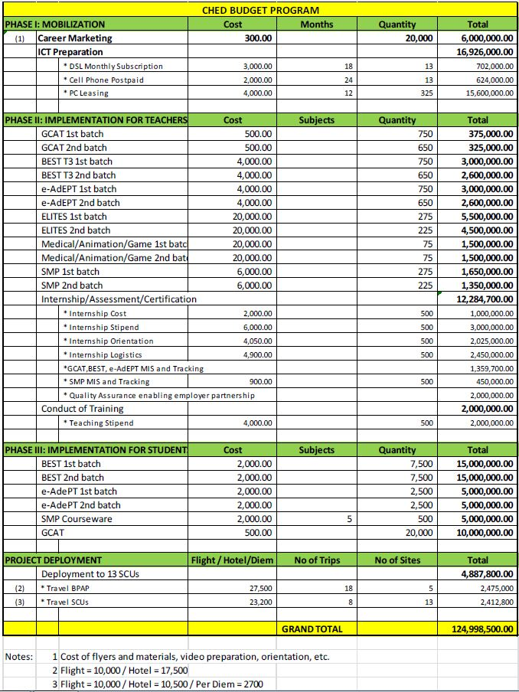

## Resume

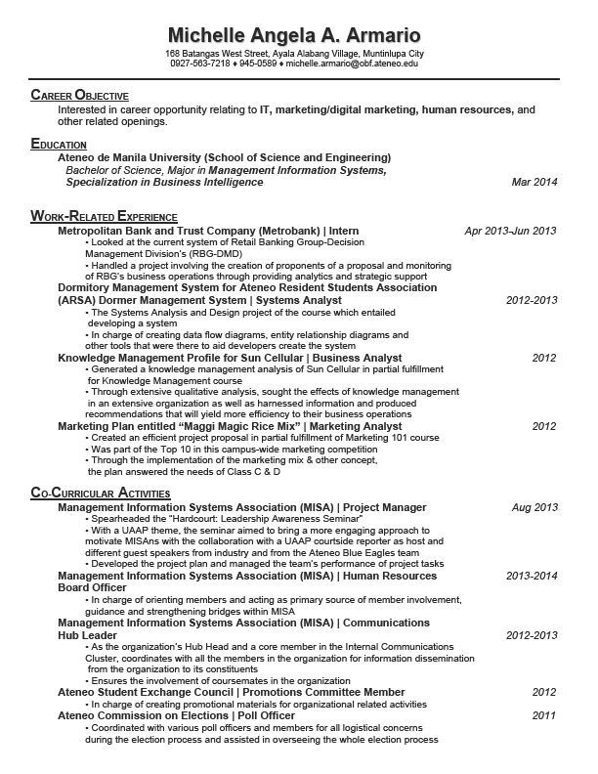

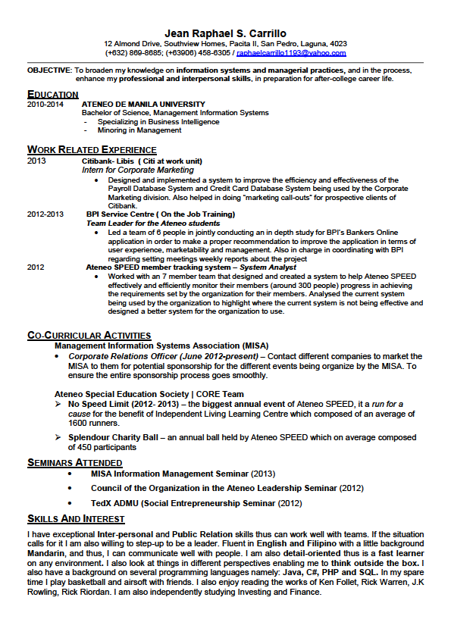

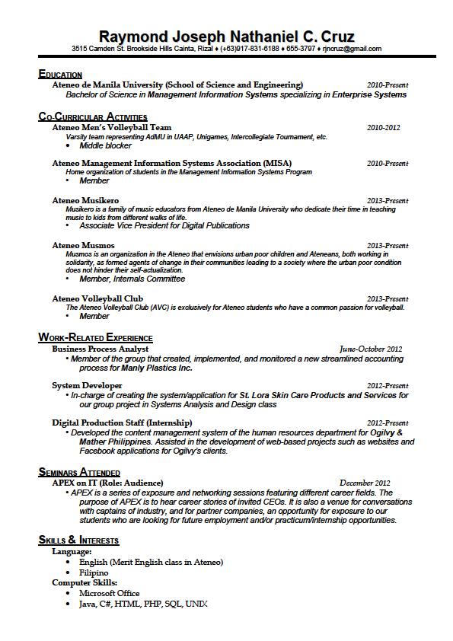

90

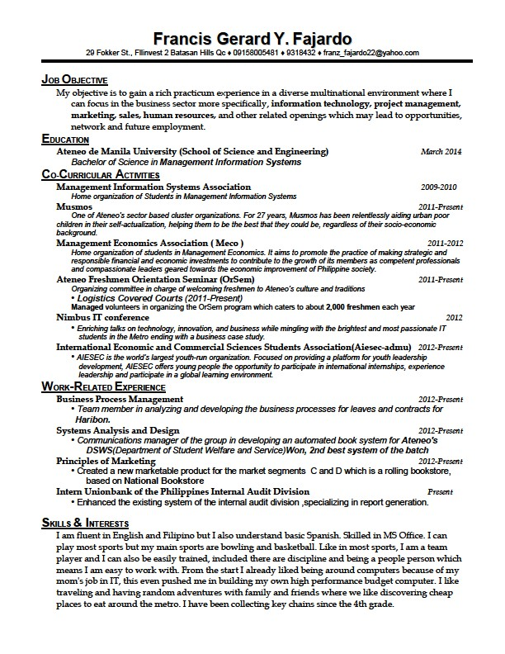

91

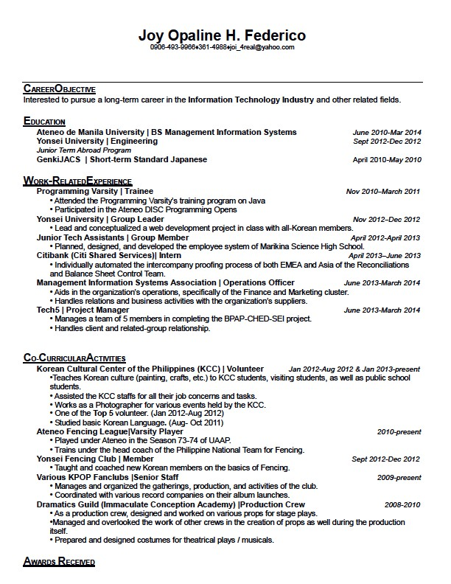

92

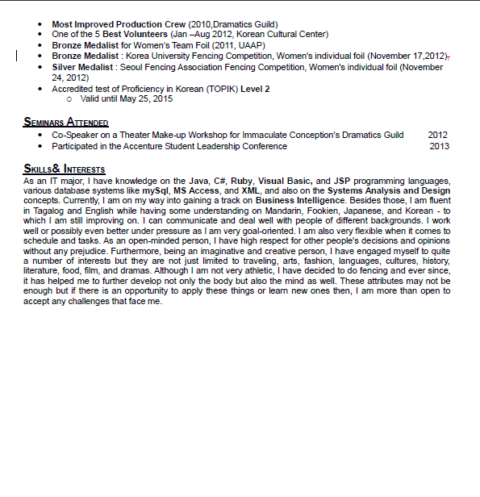

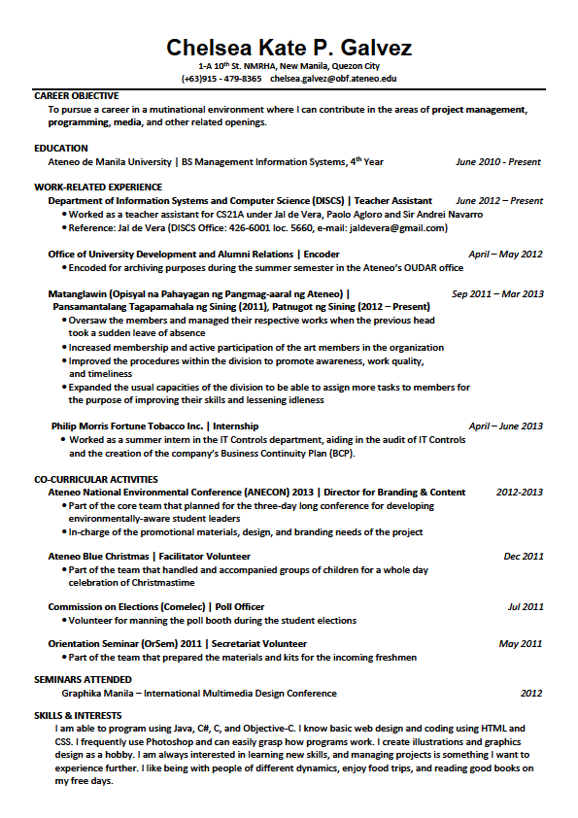

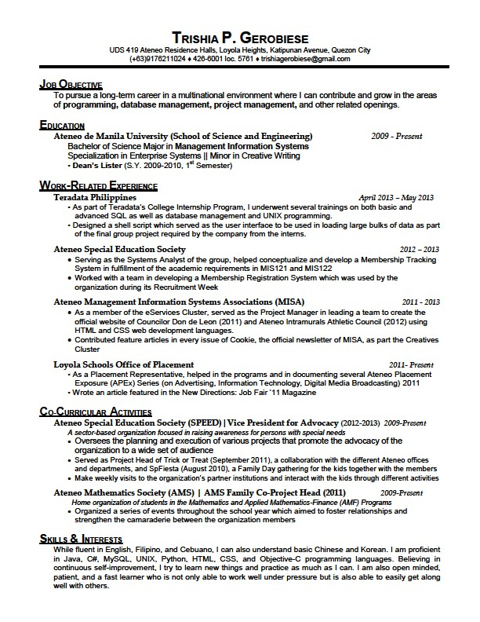

95



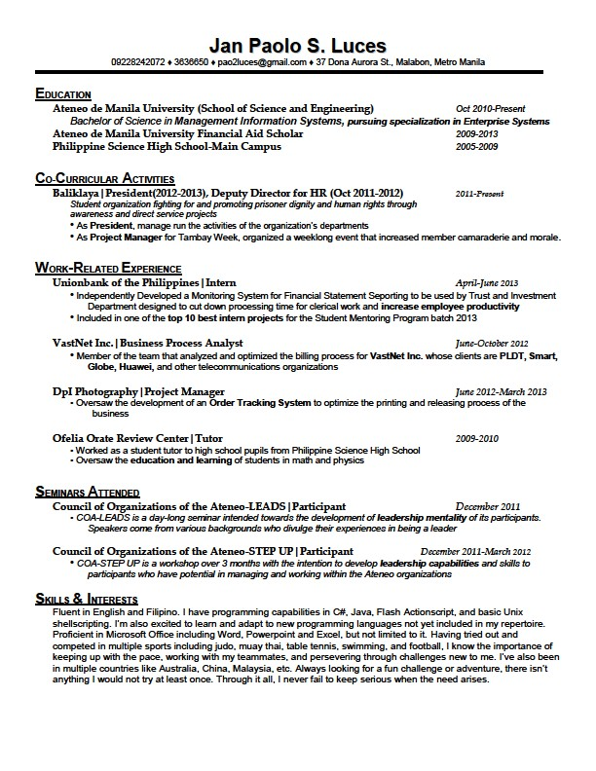

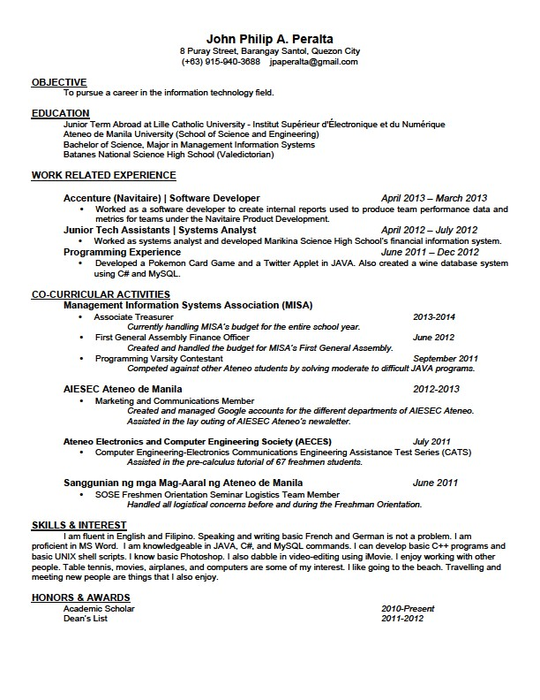

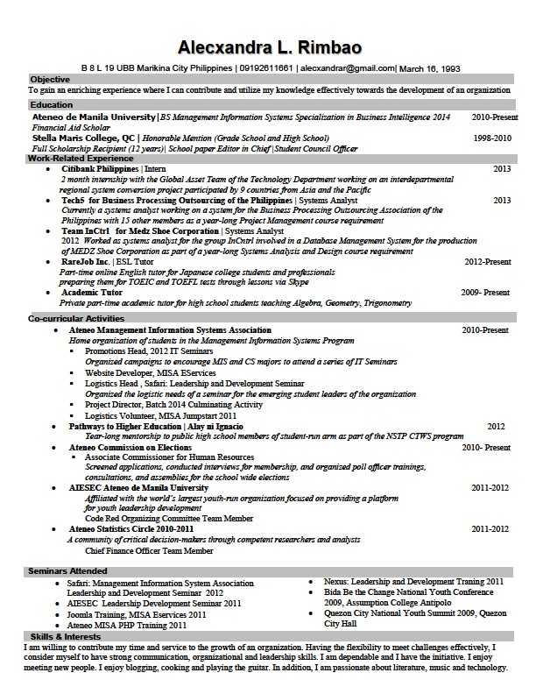

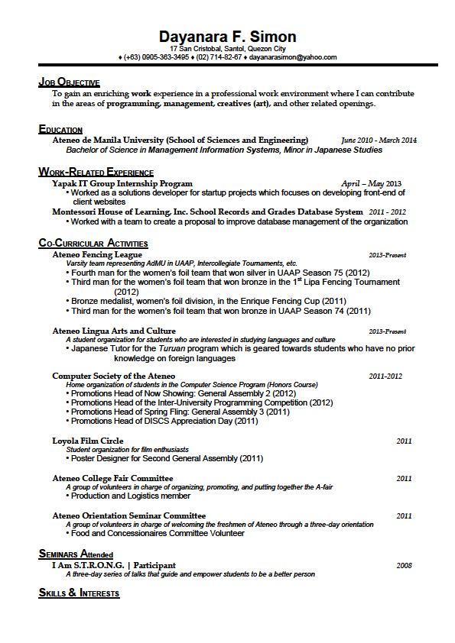



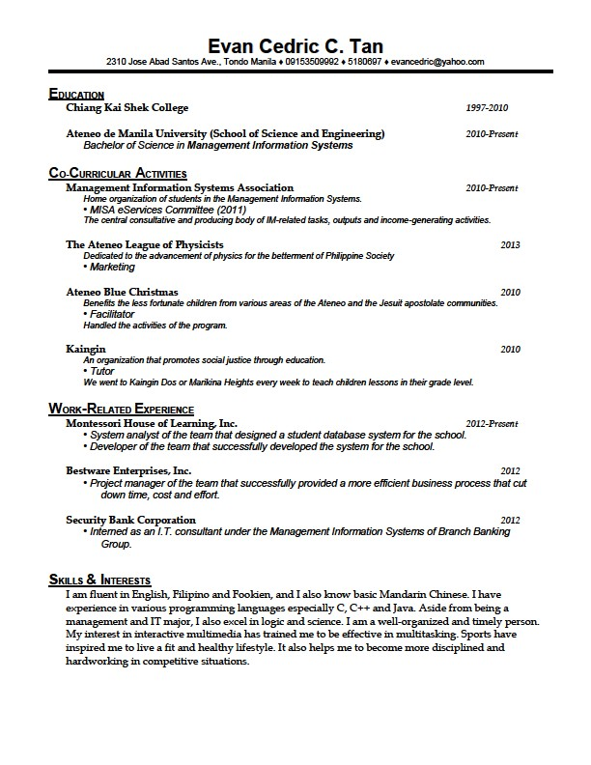

## WBS Dictionary

### Task Description Worksheets

|  |  |
| --- | --- |
| **Project Name** | BPAP-CHED-SEI |
| **Project Manager** | Joy Federico |
| **Date Prepared** | September 11,2013 |
| |  |  | | --- | --- | | **Task ID** | 1.1.1.1 | | **Task Name** | Obtain GCAT Data | | **Task Owner** | Francis Fajardo |   **Task Description**  This activity involves obtaining all data related to the GCAT used by the Project Delivery team. These data would be used for reference and analysis. | |
| **Deliverable Description**  A consolidated file containing the all the data from the GCAT that would serve as a reference for the proposed system. | |
| **Performance Criteria**  The group obtains all the necessary data related to the GCAT. | |
| **Resource Needed/Tentative Schedule**  Involved project managers of BPAP | |
| **Assumptions**  The information gathered from the GCAT can be shared with the group.  The involved project manager has access to all the data related to the GCAT. | |

|  |  |
| --- | --- |
| **Task ID** | 1.1.1.2 |
| **Task Name** | Obtain SMP Data |
| **Task Owner** | Francis Fajardo |

|  |
| --- |
| **Task Description**  This activity involves obtaining all data related to the SMP program used by the Project Delivery team. These data would be used for reference and analysis. |
| **Deliverable Description**  A consolidated file containing the all the data from the SMP program that would serve as a reference for the proposed system. |
| **Performance Criteria**  The group obtains all the necessary data related to the SMP program. |
| **Resource Needed/Tentative Schedule**  Involved project managers of BPAP |
| **Assumptions**  The information gathered from the SMP can be shared with the group.  The involved project manager has access to all the data related to the SMP program. |

|  |  |
| --- | --- |
| **Task ID** | 1.1.1.3 |
| **Task Name** | Obtain Documents for BEST/AdEPT |
| **Task Owner** | Francis Fajardo |

|  |
| --- |
| **Task Description**  This activity involves obtaining all data related to the BEST and AdEPT program used by the Project Delivery team. These data would be used for reference and analysis. |
| **Deliverable Description**  A consolidated file containing the all the data from the BEST and AdEPT program that would serve as a reference for the proposed system. |
| **Performance Criteria**  The group obtains all the necessary data related to the BEST and AdEPT program. |
| **Resource Needed/Tentative Schedule**  Involved project managers of BPAP |
| **Assumptions**  The information gathered from the BEST and AdEPT can be shared with the group.  The involved project manager has access to all the data related to the BEST and AdEPT program. |

|  |  |
| --- | --- |
| **Task ID** | 1.1.1.4 |
| **Task Name** | Obtain T3 Data |
| **Task Owner** | Francis Fajardo |

|  |
| --- |
| **Task Description**  This activity involves obtaining all data related to the T3 program used by the Project Delivery team. These data would be used for reference and analysis. |
| **Deliverable Description**  A consolidated file containing the all the data from the T3 program that would serve as a reference for the proposed system. |
| **Performance Criteria**  The group obtains all the necessary data related to the T3 program. |
| **Resource Needed/Tentative Schedule**  Involved project managers of BPAP |
| **Assumptions**  The information gathered from the T3 program can be shared with the group.  The involved project manager has access to all the data related to the T3 program. |

|  |  |
| --- | --- |
| **Task ID** | 1.1.2 |
| **Task Name** | Obtain Existing Frameworks |
| **Task Owner** | Raphael Carillo |

|  |
| --- |
| **Task Description**  This activity involves obtaining existing frameworks used by the Monitoring and Evaluation team for other similar projects. These data would serve as reference and analysis for the project. |
| **Deliverable Description**  A consolidated file containing the existing frameworks that would serve as a reference for the proposed system. |
| **Performance Criteria**  The group obtains all the necessary frameworks. |
| **Resource Needed/Tentative Schedule**  Involved project managers of BPAP |
| **Assumptions**  The information found in the frameworks can be shared with the group.  The involved project manager has a copy of the frameworks. |

|  |  |
| --- | --- |
| **Task ID** | 1.1.3 |
| **Task Name** | Obtain Existing Reports and Templates |
| **Task Owner** | Joy Federico |

|  |
| --- |
| **Task Description**  This activity involves obtaining existing reports and templates used by the Monitoring and Evaluation and the Project Delivery team for reference and analysis. |
| **Deliverable Description**  A consolidated file containing the existing reports and templates that would serve as a reference for the proposed system. |
| **Performance Criteria**  The group obtains all the necessary reports and templates. |
| **Resource Needed/Tentative Schedule**  Involved project managers of BPAP |
| **Assumptions**  The information found in the templates and reports can be shared with the group.  The involved project manager has a copy of the reports and templates. |

|  |  |
| --- | --- |
| **Task ID** | 1.1.4 |
| **Task Name** | Obtain M&E Manual |
| **Task Owner** | Chelsea Galvez |

|  |
| --- |
| **Task Description**  This activity involves talking to the involved project manager from the Monitoring and Evaluation team and obtaining a copy of their manual to be used for reference and analysis. |
| **Deliverable Description**  An M&E Manual that would serve as a reference for the generation of the framework to be used by the Monitoring and Evaluation team. |
| **Performance Criteria**  The group obtains the M&E manual. |
| **Resource Needed/Tentative Schedule**  Involved project managers of BPAP |
| **Assumptions**  The information found in the M&E manual can be shared with the group.  The involved project manager has a copy of the M&E manual. |

|  |  |
| --- | --- |
| **Task ID** | 1.1.5.2 |
| **Task Name** | Interview Project Manager of M&E |
| **Task Owner** | Paolo Luces |

|  |
| --- |
| **Task Description**  This activity involves conducting an interview and a discussion regarding the project with the different project managers of the Project Delivery Team. Included in the activity is the setting of the date, time, and place of the interview. |
| **Deliverable Description**  A document named "M&E Team Meeting Minutes" that includes the comments and minutes of all the discussions and interviews made with the Project Delivery Team. |
| **Performance Criteria**  Talk was able to proceed on schedule.  Relevant information was gathered from the project managers of BPAP.  The involved project managers reviews and approved the document named “M&E Team Meeting Minutes”. |
| **Resource Needed/Tentative Schedule**  Computer  Involved project managers of BPAP |
| **Assumptions**  Project manager is available for interview/talk on a chosen date, time, and place.  Insightful areas concerning the project are discussed. |

|  |  |
| --- | --- |
| **Task ID** | 1.1.5.2 |
| **Task Name** | Interview Project Manager of the Project Delivery Team |
| **Task Owner** | Francis Fajardo |

|  |
| --- |
| **Task Description**  This activity involves conducting an interview and a discussion regarding the project with the different project managers of the Project Delivery Team. Included in the activity is the setting of the date, time, and place of the interview. |
| **Deliverable Description**  A document named "Project Delivery Team Meeting Minutes" that includes the comments and minutes of all the discussions and interviews made with the Project Delivery Team. |
| **Performance Criteria**  Talk was able to proceed on schedule.  Relevant information was gathered from the project managers of BPAP  The involved project managers reviews and approved the document named “Project Delivery Team Meeting Minutes”. |
| **Resource Needed/Tentative Schedule**  Computer  Involved project managers of BPAP |
| **Assumptions**  Project manager is available for interview/talk on a chosen date, time, and place.  Insightful areas concerning the project are discussed. |

|  |  |
| --- | --- |
| **Task ID** | 1.2.1 |
| **Task Name** | Analyze GCAT Data |
| **Task Owner** | Alecxandra Rimbao |

|  |
| --- |
| **Task Description**  This activity involves the analysis of the data obtained from the GCAT program. This would include findings, process mapping, and such. |
| **Deliverable Description**  A document entitled, “GCAT Data Analysis”, would include all the discussions made during the analysis of all the data related to GCAT. |
| **Performance Criteria**  Information and data relevant to the contribution of the generation of policies, procedures, and frameworks are included in the document.  The involved project manager receives, reviews, and approves the document named “GCAT Data Analysis”. |
| **Resource Needed/Tentative Schedule**  Computer, White board and marker  Involved project manager from BPAP |
| **Assumptions**  All information relating to GCAT is obtained. |

|  |  |
| --- | --- |
| **Task ID** | 1.2.2 |
| **Task Name** | Analyze SMP Data |
| **Task Owner** | Trishia Gerobiese |

|  |
| --- |
| **Task Description**  This activity involves the analysis of the data obtained from the SMP program. This would include findings, process mapping, and such. |
| **Deliverable Description**  A document entitled, “SMP Data Analysis”, would include all the discussions made during the analysis of all the data related to SMP. |
| **Performance Criteria**  Information and data relevant to the contribution of the generation of policies, procedures, and frameworks are included in the document.  The involved project manager receives, reviews, and approves the document named “SMP Data Analysis”. |
| **Resource Needed/Tentative Schedule**  Computer  White board and marker  Involved project manager from BPAP |
| **Assumptions**  All information relating to SMP is obtained. |

|  |  |
| --- | --- |
| **Task ID** | 1.2.3 |
| **Task Name** | Analyze T3 Data |
| **Task Owner** | Simone Jaldon |

|  |
| --- |
| **Task Description**  This activity involves the analysis of the data obtained from the T3 program. This would include findings, process mapping, and such. |
| **Deliverable Description**  A document entitled, “T3 Data Analysis”, would include all the discussions made during the analysis of all the data related to T3. |
| **Performance Criteria**  Information and data relevant to the contribution of the generation of policies, procedures, and frameworks are included in the document.  The involved project manager receives, reviews, and approves the document named “T3 Data Analysis”. |
| **Resource Needed/Tentative Schedule**  Computer  White board and marker  Involved project manager from BPAP |
| **Assumptions**  All information relating to T3 is obtained. |

|  |  |
| --- | --- |
| **Task ID** | 1.2.4 |
| **Task Name** | Analyze BEST and AdEPT Data |
| **Task Owner** | Aaron Casurao |

|  |
| --- |
| **Task Description**  This activity involves the analysis of the data obtained from both BEST and AdEPT. This would include findings, process mapping, and such. |
| **Deliverable Description**  A document entitled, “BEST and AdEPT Data Analysis”, would include all the discussions made during the analysis of all the data related to BEST and AdEPT. |
| **Performance Criteria**  Information and data relevant to the contribution of the generation of policies, procedures, and frameworks are included in the document.  The involved project manager receives, reviews, and approves the document named “BEST and AdEPT Data Analysis”. |
| **Resource Needed/Tentative Schedule**  Computer  White board and marker  Involved project manager from BPAP |
| **Assumptions**  All information relating to BEST and AdEPT is obtained. |

|  |  |
| --- | --- |
| **Task ID** | 1.2.5 |
| **Task Name** | Analyze frameworks |
| **Task Owner** | Paolo Luces |

|  |
| --- |
| **Task Description**  This activity involves the analysis of the sample frameworks obtained from the Monitoring and Evaluation team of BPAP. This would include findings, process mapping, and such. |
| **Deliverable Description**  A document entitled, “Frameworks Analysis”, would include all the discussions made during the analysis. |
| **Performance Criteria**  Information and data relevant to the contribution of the generation of policies, procedures, and frameworks are included in the document.  The involved project manager receives, reviews, and approves the document named “Frameworks Analysis”. |
| **Resource Needed/Tentative Schedule**  Computer, White board and marker  Involved project manager from BPAP |
| **Assumptions**  All information related to frameworks is obtained. |

|  |  |
| --- | --- |
| **Task ID** | 1.2.6 |
| **Task Name** | Analyze Existing Reports and Templates |
| **Task Owner** | Joy Federico |

|  |
| --- |
| **Task Description**  This activity involves the analysis of the existing reports and templates obtained from the project managers BPAP. This would include findings, process mapping, and such. |
| **Deliverable Description**  A document entitled, “Existing Reports and Templates Analysis”, would include all the discussions made during the analysis. |
| **Performance Criteria**  Information and data relevant to the contribution of the generation of policies, procedures, and frameworks are included in the document.  The involved project manager receives, reviews, and approves the document named “Existing Reports and Templates Analysis”. |
| **Resource Needed/Tentative Schedule**  Computer  White board and marker  Involved project manager from BPAP |
| **Assumptions**  All existing reports and templates related to the project is obtained. |

|  |  |
| --- | --- |
| **Task ID** | 1.3.1.1 |
| **Task Name** | Draft the Policy Content for BEST and AdEPT |
| **Task Owner** | Francis Fajardo |

|  |
| --- |
| **Task Description**  This activity involves formulation of policy content and procedures for the BEST and AdEPT programs |
| **Deliverable Description**  A document named “Policy Content Document for BEST and AdEPT” containing the policies and procedures related to the BEST and AdEPT programs |
| **Performance Criteria**  Policies formulated accordingly to client meeting minutes and researches |
| **Resource Needed/Tentative Schedule**  Computer  Microsoft Word  Interview Minutes with involved project managers |
| **Assumptions**  Interviews, research, and data needed to draft policies and procedures were already obtained.  The computer has Microsoft Word installed and ready for use. |

|  |  |
| --- | --- |
| **Task ID** | 1.3.1.2 |
| **Task Name** | Evaluate the Policy Content for BEST and AdEPT |
| **Task Owner** | Joy Federico |

|  |
| --- |
| **Task Description**  This activity involves the evaluation of policy content and procedures for the BEST and AdEPT programs |
| **Deliverable Description**  A word document named “Policy Content Evaluation for BEST and AdEPT" that includes the comments and minutes of made during the evaluation of the document. |
| **Performance Criteria**  Revisions, errors, and other insights were presented and taken into account in the minutes. |
| **Resource Needed/Tentative Schedule**  Computer, Microsoft Word  Involved project managers of BPAP  Florentino Dulce (BPAP representative) |
| **Assumptions**  A draft for the policy and procedures is already available  Those present in the evaluation also has sufficient knowledge on the subject matter  The computer has Microsoft Word installed and ready for use.  The involved project managers and Sir Dulce is available of the chosen date. |

|  |  |
| --- | --- |
| **Task ID** | 1.3.1.3 |
| **Task Name** | Create a Final Version for the Policy Content for BEST and AdEPT |
| **Task Owner** | Francis Fajardo |

|  |
| --- |
| **Task Description**  This activity involves the creation of the finalized policy content and procedures of the BEST and AdEPT programs |
| **Deliverable Description**  An edited document named "Policy Content for BEST and AdEPT" that includes all policies and procedures to be followed by the BEST and AdEPT programs |
| **Performance Criteria**  The Policy Content draft is revised accordingly to the evaluation that was conducted  The involved project managers and client receive and approve the final Policy Content |
| **Resource Needed/Tentative Schedule**  Computer  Microsoft Word  Meeting Minutes |
| **Assumptions**  The evaluation was conducted successfully  The computer has Microsoft Word installed and ready for use |

|  |  |
| --- | --- |
| **Task ID** | 1.3.2.1 |
| **Task Name** | Draft the Policy Content for SMP Data Collection |
| **Task Owner** | Francis Fajardo |

|  |
| --- |
| **Task Description**  This activity involves formulation of policy content and procedures for the SMP programs |
| **Deliverable Description**  A document named “Policy Content Document for SMP” containing the policies and procedures related to the SMP programs |
| **Performance Criteria**  List of policies and procedures ere formulated accordingly to client meeting minutes and researches |
| **Resource Needed/Tentative Schedule**  Computer  Microsoft Word  Interview Minutes with involved client and project managers |
| **Assumptions**  Interviews, research, and data needed to draft policies and procedures were already obtained.  The computer has Microsoft Word installed and ready for use. |

|  |  |
| --- | --- |
| **Task ID** | 1.3.2.2 |
| **Task Name** | Evaluate the Policy Content for SMP Data Collection |
| **Task Owner** | Joy Federico |

|  |
| --- |
| **Task Description**  This activity involves the evaluation of policy content and procedures for the SMP programs |
| **Deliverable Description**  A word document named “Policy Content Evaluation for SMP" that includes the comments and minutes of made during the evaluation of the document. |
| **Performance Criteria**  Revisions, errors, and other insights were presented and taken into account in the minutes. |
| **Resource Needed/Tentative Schedule**  Computer, Microsoft Word  Involved project managers of BPAP  Florentino Dulce (BPAP representative) |
| **Assumptions**  The computer has Microsoft Word and Excel installed and ready for use.  The involved project managers and Sir Dulce is available of the chosen date. |

|  |  |
| --- | --- |
| **Task ID** | 1.3.2.3 |
| **Task Name** | Create a Final Version for the Policy Content for SMP Data Collection |
| **Task Owner** | Francis Fajardo |

|  |
| --- |
| **Task Description**  This activity involves the creation of the finalized policy content and procedures of the SMP programs |
| **Deliverable Description**  An edited document named "Policy Content for SMP" that includes all policies and procedures to be followed by the SMP programs. |
| **Performance Criteria**  The Policy Content draft is revised accordingly to the evaluation that was conducted  The involved project managers and client receive and approve the final Policy Content |
| **Resource Needed/Tentative Schedule**  Computer, Microsoft Word  Meeting Minutes |
| **Assumptions**  The evaluation was conducted successfully  The computer has Microsoft Word installed and ready for use |

|  |  |
| --- | --- |
| **Task ID** | 1.3.3.1 |
| **Task Name** | Draft Input Data Forms for BEST and AdEPT |
| **Task Owner** | Francis Fajardo |

|  |
| --- |
| **Task Description**  This activity involves formulation of input forms for the data to be collected by the BEST and AdEPT programs |
| **Deliverable Description**  A document named “Input Data Forms for BEST and AdEPT” which acts as a sample input form for the BEST and AdEPTprograms |
| **Performance Criteria**  Sample input form for data collection is provided taking into account meeting minutes and research on related readings and AdEPT programs |
| **Resource Needed/Tentative Schedule**  Computer  Microsoft Word  Meeting Minutes |
| **Assumptions**  Interviews, research, and data needed to create a sample input form were already obtained.  The computer has Microsoft Word installed and ready for use. |

|  |  |
| --- | --- |
| **Task ID** | 1.3.3.2 |
| **Task Name** | Evaluate Input Data Forms for BEST and AdEPT |
| **Task Owner** | Joy Federico |

|  |
| --- |
| **Task Description**  This activity involves the evaluation of the sample input data form for the BEST and AdEPT programs |
| **Deliverable Description**  A word document named “Input Data Forms Evaluation for BEST and AdEPT" that includes the comments and minutes of made during the evaluation of the document. |
| **Performance Criteria**  Revisions, errors, and other insights were presented and taken into account in the minutes. |
| **Resource Needed/Tentative Schedule**  Computer  Microsoft Word  Involved project managers of BPAP |
| **Assumptions**  The computer has Microsoft Word and Excel installed and ready for use.  The involved project managers are available on the chosen date. |

|  |  |
| --- | --- |
| **Task ID** | 1.3.3.3 |
| **Task Name** | Create a Final Version for the Input Data Forms for BEST and AdEPT |
| **Task Owner** | Francis Fajardo |

|  |
| --- |
| **Task Description**  This activity involves the creation of the finalized input form needed to collect the data for BEST and AdEPT programs |
| **Deliverable Description**  An edited document named "Input Data Forms for BEST and AdEPT" that acts as the finalized Input Data Form for the BEST and AdEPT programs |
| **Performance Criteria**  The sample input form is revised accordingly to the evaluation that was conducted  The involved project managers and client receive and approve the final Input Data Forms |
| **Resource Needed/Tentative Schedule**  Computer  Microsoft Word  Meeting Minutes |
| **Assumptions**  The evaluation was conducted successfully  The computer has Microsoft Word installed and ready for use |

|  |  |
| --- | --- |
| **Task ID** | 1.3.4.1 |
| **Task Name** | Draft Input Data Forms for SMP |
| **Task Owner** | Francis Fajardo |

|  |
| --- |
| **Task Description**  This activity involves formulation of input forms for the data to be collected by the SMP programs |
| **Deliverable Description**  A document named “Input Data Forms for SMP” which acts as a sample input form for the SMP programs |
| **Performance Criteria**  Sample input form for data collection is provided taking into account meeting minutes and research on related readings |
| **Resource Needed/Tentative Schedule**  Computer  Microsoft Word  Meeting Minutes |
| **Assumptions**  Interviews, research, and data needed to create a sample input form were already obtained.  The computer has Microsoft Word installed and ready for use. |

|  |  |
| --- | --- |
| **Task ID** | 1.3.4.2 |
| **Task Name** | Evaluate Input Data Forms for SMP Data Collection |
| **Task Owner** | Joy Federico |

|  |
| --- |
| **Task Description**  This activity involves the evaluation of the sample input data form for the SMP programs |
| **Deliverable Description**  A word document named “Input Data Forms Evaluation for SMP" that includes the comments and minutes of made during the evaluation of the document. |
| **Performance Criteria**  Revisions, errors, and other insights were presented and taken into account in the minutes. |
| **Resource Needed/Tentative Schedule**  Computer  Microsoft Word  Involved project managers of BPAP |
| **Assumptions**  The computer has Microsoft Word and Excel installed and ready for use.  The involved project managers are available on the chosen date. |

|  |  |
| --- | --- |
| **Task ID** | 1.3.4.3 |
| **Task Name** | Create a Final Version for the Input Data Forms for SMP Data Collection |
| **Task Owner** | Francis Fajardo |

|  |
| --- |
| **Task Description**  This activity involves the creation of the finalized input form needed to collect the data for SMP programs |
| **Deliverable Description**  An edited document named "Input Data Forms for SMP" that acts as the finalized Input Data Form for the SMP programs |
| **Performance Criteria**  The sample input form is revised accordingly to the evaluation that was conducted  The involved project managers and client receive and approve the final Input Data Forms |
| **Resource Needed/Tentative Schedule**  Computer  Microsoft Word  Meeting Minutes |
| **Assumptions**  The evaluation was conducted successfully  The computer has Microsoft Word installed and ready for use |

|  |  |
| --- | --- |
| **Task ID** | 1.3.5.1.1 |
| **Task Name** | Draft M&E Report Templates |
| **Task Owner** | Paolo Luces |

|  |
| --- |
| **Task Description**  This activity involves the drafting of the templates that would be used for the reports of M&E. |
| **Deliverable Description**  A document name "M&E Report Templates" that includes all the necessary report templates of the BPAP-CHED-SEI project. |
| **Performance Criteria**  The templates include all the information needed by the client. |
| **Resource Needed/Tentative Schedule**  Computer  Microsoft Word  M&E Framework  Interview Minutes with involved project managers |
| **Assumptions**  The computer has Microsoft Word and Excel installed and ready for use. |

|  |  |
| --- | --- |
| **Task ID** | 1.3.5.1.2 |
| **Task Name** | Evaluate M&E Report Templates |
| **Task Owner** | Joy Federico |

|  |
| --- |
| **Task Description**  This activity involves the evaluation of the M&E Report Templates that would be used for the reports of M&E. |
| **Deliverable Description**  A word document named "M&E Report Templates Evaluation" that includes the comments and minutes of made during the evaluation of the document. |
| **Performance Criteria**  Revisions, errors, and other insights were presented and taken into account in the minutes.  The involved project managers receive and approve the document "M&E Report Templates Evaluation". |
| **Resource Needed/Tentative Schedule**  Computer  Microsoft Word  Involved project managers of BPAP  Florentino Dulce (BPAP representative) |
| **Assumptions**  The computer has Microsoft Word and Excel installed and ready for use.  The involved project managers and Sir Dulce is available of the chosen date. |

|  |  |
| --- | --- |
| **Task ID** | 1.3.5.1.3 |
| **Task Name** | Create Final Version of M & E Report Templates |
| **Task Owner** | Paolo Luces |

|  |
| --- |
| **Task Description**  This activity involves the development of the finalized templates that would be used for the reports of M&E |
| **Deliverable Description**  An edited document named "M&E Report Templates" that includes all the necessary report templates of the BPAP-CHED-SEI project. |
| **Performance Criteria**  The document named “M&E Report Templates” is revised according to the comments in the “M&E Report Templates Evaluation” document. The involved project managers receive and approve the document "M&E Report Templates". The templates include all the information needed by the client. |
| **Resource Needed/Tentative Schedule**  Computer, M&E Reports Template Evaluation document, Microsoft Word / Excel  M&E Framework |
| **Assumptions**  Evaluation of the sample templates was conducted  The computer has Microsoft Word and Excel installed. |

|  |  |
| --- | --- |
| **Task ID** | 1.3.5.2.1 |
| **Task Name** | Draft M&E Policies and Procedures |
| **Task Owner** | Paolo Luces |

|  |
| --- |
| **Task Description**  This activity involves the drafting of the policies and procedures that would be used by the Monitoring and Evaluation team. |
| **Deliverable Description**  A document named "M&E Policies and Procedures" that includes all the necessary policies and procedures of the Monitoring and Evaluation team. |
| **Performance Criteria**  The policies and procedures include all the information needed by the client. |
| **Resource Needed/Tentative Schedule**  Computer  Microsoft Word  M&E Framework  Interview Minutes with involved project managers |
| **Assumptions**  The computer has Microsoft Word and Excel installed and ready for use. |

|  |  |
| --- | --- |
| **Task ID** | 1.3.5.2.2 |
| **Task Name** | Evaluate M&E Policies and Procedures |
| **Task Owner** | Joy Federico |

|  |
| --- |
| **Task Description**  This activity involves the evaluation of the M&E Policies and Procedures that would be used by Monitoring and Evaluation team. |
| **Deliverable Description**  A word document named "M&E Policies and Procedures Evaluation" that includes the comments and minutes of made during the evaluation of the document. |
| **Performance Criteria**  Revisions, errors, and other insights were presented and taken into account in the minutes.  The involved project managers receive and approve the document "M&E Policies and Procedures Evaluation". |
| **Resource Needed/Tentative Schedule**  Computer  Microsoft Word  Involved project managers of BPAP  Florentino Dulce (BPAP representative) |
| **Assumptions**  The computer has Microsoft Word and Excel installed and ready for use.  The involved project managers and Sir Dulce is available of the chosen date. |

|  |  |
| --- | --- |
| **Task ID** | 1.3.5.2.3 |
| **Task Name** | Create Final Version of M&E Policies and Procedures |
| **Task Owner** | Paolo Luces |

|  |
| --- |
| **Task Description**  This activity involves the development of the finalized policies and procedures that would be used by the Monitoring and Evaluation team. |
| **Deliverable Description**  An edited document named "M&E Policies and Procedures" that includes all the necessary policies and procedures of the Monitoring and Evaluation team. |
| **Performance Criteria**  The document named “M&E Policies and Procedures” is revised according to the comments in the “M&E Policies and Procedures Evaluation” document.  The involved project managers receive and approve the document "M&E Policies and Procedures".  The policies and procedures include all the information needed by the client. |
| **Resource Needed/Tentative Schedule**  Computer  M&E Policies and Procedures Evaluation document  Microsoft Word / Excel |
| **Assumptions**  Evaluation of the policies and procedures was conducted.  The computer has Microsoft Word and Excel installed. |

|  |  |
| --- | --- |
| **Task ID** | 1.3.6 |
| **Task Name** | Create Brainstorming Session |
| **Task Owner** | Paolo Luces |

|  |
| --- |
| **Task Description**  This activity involves the discussion of ideas with regards to the policy formulation of the Monitoring and Evaluation team. |
| **Deliverable Description**  A document named “Brainstorming Minutes” contains all the discussions held during the brainstorming sessions. |
| **Performance Criteria**  All discussions are included in the document.  The involved project manager signs and approves the minutes. |
| **Resource Needed/Tentative Schedule**  Computer, Ma’am Reli Neo (BPAP project manager for Monitoring and Evaluation) |
| **Assumptions**  Ma’am Reli Neo is available on the chosen date. |

|  |  |
| --- | --- |
| **Task ID** | 1.4.1 |
| **Task Name** | Researching on Software Requirements |
| **Task Owner** | Raymond Cruz |

|  |
| --- |
| **Task Description**  This activity involves the researching of suitable software that would be used in implementing the required system. |
| **Deliverable Description**  Relevant data related to the research has been consolidated and appended to a document entitled “Research Findings”. |
| **Performance Criteria**  Requirements were identified and listed down.  Requirements fit to the budget of the client. |
| **Resource Needed/Tentative Schedule**  Computer  Florentino Dulce (BPAP representative)  Experts on the programming and systems development field ( Professors, industry experts) |
| **Assumptions**  The researcher has a general understanding of the system requirements.  There is a working internet connection.  The experts on the related field are available for consultation on the chosen date. |

|  |  |
| --- | --- |
| **Task ID** | 1.4.2 |
| **Task Name** | Researching on Hardware Requirements |
| **Task Owner** | Philip Peralta |

|  |
| --- |
| **Task Description**  This activity involves the researching of a suitable hardware that would be used in implementing the required system. |
| **Deliverable Description**  Relevant data related to the research has been consolidated and appended to a document entitled “Research Findings”. |
| **Performance Criteria**  Requirements were identified and listed down.  Requirements fit to the budget of the client. |
| **Resource Needed/Tentative Schedule**  Computer  Florentino Dulce (BPAP representative)  Experts on the programming and systems development field ( Professors, industry experts) |
| **Assumptions**  The researcher has a general understanding of the system requirements.  There is a working internet connection.  The experts on the related field are available for consultation on the chosen date. |

|  |  |
| --- | --- |
| **Task ID** | 1.4.3 |
| **Task Name** | Researching on Programming Language |
| **Task Owner** | Raymond Cruz |

|  |  |
| --- | --- |
| **Task Description**  This activity involves the researching of a suitable programming language that would be used in implementing the required system. | |
| **Deliverable Description**  Relevant data related to the research has been consolidated and appended to a document entitled “Research Findings”. | |
| **Performance Criteria**  Required programming language/s were identified and evaluated. | |
| **Resource Needed/Tentative Schedule**  Computer  Experts on the programming and systems development field ( Professors, industry experts) | |
| **Assumptions**  The experts on the related field are available for consultation on the chosen date.  There is a working internet connection. | |
| **Project Name** | BPAP-CHED-SEI |
| **Project Manager** | Joy Federico |
| **Date Prepared** | September 12, 2013 |

|  |  |
| --- | --- |
| **Task ID** | 1.5.1 |
| **Task Name** | Generate the Functional Requirements Document |
| **Task Owner** | Joy Federico |

|  |  |
| --- | --- |
| **Task Description** | This activity involves describing all the critical and non-critical functions of the proposed system. |
| **Deliverable Description** | A word document named "Functional Requirements" containing the list of functions of the proposed system. |
| **Performance Criteria** | The Functional Requirements document contains all the required function for the BPAP-CHED-SEI project.  The involved project managers receives and approves the document entitled "Functional Requirements". |
| **Resource Needed/Tentative Schedule** | Florentino Dulce (BPAP representative), Computer, Microsoft Word  Involved project managers from the Project Delivery team of the BPAP project. |
| **Assumptions** | The computer has an available internet connection.  The computer has Microsoft Word installed and ready for use.  There is sufficient knowledge on the functionalities to be implemented by the system. |

|  |  |
| --- | --- |
| **Project Name** | BPAP-CHED-SEI |
| **Project Manager** | Joy Federico |
| **Date Prepared** | September 12, 2013 |

|  |  |
| --- | --- |
| **Task ID** | 1.5.2.1 |
| **Task Name** | Create a Wireframe |
| **Task Owner** | Dayanara Simon |

|  |  |
| --- | --- |
| **Task Description** | This activity involves creating a wireframe diagram for the proposed system. |
| **Deliverable Description** | A word document named "System Wireframe" containing the layout and design wireframes. |
| **Performance Criteria** | The System Wireframe document contains all the required function for the BPAP-CHED-SEI project.  The involved project managers receive and approve the document "System Wireframe". |
| **Resource Needed/Tentative Schedule** | Adobe Photoshop  Computer |
| **Assumptions** | The computer has Adobe Photoshop installed and ready for use.  The person handling the task has knowledge on website development.  The computer has an available internet connection. |

|  |  |
| --- | --- |
| **Project Name** | BPAP-CHED-SEI |
| **Project Manager** | Joy Federico |
| **Date Prepared** | September 12, 2013 |

|  |  |
| --- | --- |
| **Task ID** | 1.5.2.2 |
| **Task Name** | Design Forms |
| **Task Owner** | Dayanara Simon |

|  |  |
| --- | --- |
| **Task Description** | This activity involves designing the forms to be used in the proposed system. |
| **Deliverable Description** | A word document named "Form Designs" containing the designed forms for the proposed system. |
| **Performance Criteria** | The form designs are both user-friendly and visually appealing.  The involved project managers receive and approve the document "Form Designs". |
| **Resource Needed/Tentative Schedule** | Microsoft Excel and Adobe Photoshop  Templates formulated by the teams in charge in Monitoring and Evaluation and Data Capture  Computer |
| **Assumptions** | The computer has Microsoft Excel and Adobe Photoshop installed and ready for use.  The task owner and the designer has sufficient knowledge on both design and website development.  The computer has an available internet connection. |

|  |  |
| --- | --- |
| **Project Name** | BPAP-CHED-SEI |
| **Project Manager** | Joy Federico |
| **Date Prepared** | September 12, 2013 |

|  |  |
| --- | --- |
| **Task ID** | 1.5.3.1 |
| **Task Name** | Create the Current Logical Data Flow Diagram |
| **Task Owner** | Simone Jaldon |

|  |  |
| --- | --- |
| **Task Description** | This activity involves creating the logical Data Flow Diagram of the current system. |
| **Deliverable Description** | A word document named "Current Logical DFD" containing the logical data flow diagram of the current system. |
| **Performance Criteria** | The current Logical Data Flow Diagram captures the processes involved in the BPAP project with relation to the BPAP-CHED-SEI.  The involved project managers receive and approve the document "Current Logical DFD". |
| **Resource Needed/Tentative Schedule** | Microsoft Visio  Computer |
| **Assumptions** | The computer has Microsoft Visio installed and ready for use.  There is sufficient knowledge of the logical data flow of the system currently being implemented.  The computer has an available internet connection. |

|  |  |
| --- | --- |
| **Project Name** | BPAP-CHED-SEI |
| **Project Manager** | Joy Federico |
| **Date Prepared** | September 12, 2013 |

|  |  |
| --- | --- |
| **Task ID** | 1.5.3.2 |
| **Task Name** | Create the Current Physical Data Flow Diagram |
| **Task Owner** | Simone Jaldon |

|  |  |
| --- | --- |
| **Task Description** | This activity involves creating the physical Data Flow Diagram of the current system. |
| **Deliverable Description** | A word document named "Current Physical DFD" containing the physical data flow diagram of the current system |
| **Performance Criteria** | The current Physical Data Flow Diagram captures the processes involved in the BPAP project with relation to the BPAP-CHED-SEI.  The involved project managers receive and approve the document "Current Logical DFD". |
| **Resource Needed/Tentative Schedule** | Microsoft Visio  Computer |
| **Assumptions** | The computer has Microsoft Visio installed and ready for use.  There is sufficient knowledge of the physical data flow of the system currently being implemented.  The computer has an available internet connection. |

|  |  |
| --- | --- |
| **Project Name** | BPAP-CHED-SEI |
| **Project Manager** | Joy Federico |
| **Date Prepared** | September 12, 2013 |

|  |  |
| --- | --- |
| **Task ID** | 1.5.3.3 |
| **Task Name** | Create the Proposed Logical Data Flow Diagram |
| **Task Owner** | Evan Tan |

|  |  |
| --- | --- |
| **Task Description** | This activity involves creating the logical Data Flow Diagram of the proposed system. |
| **Deliverable Description** | A word document named "Proposed Logical DFD" containing the logical data flow diagram of the proposed system. |
| **Performance Criteria** | The proposed logical Data Flow Diagram captures the processes involved in the BPAP project with relation to the BPAP-CHED-SEI.  The involved project managers receive and approve the document "Proposed Logical DFD". |
| **Resource Needed/Tentative Schedule** | Microsoft Visio  Computer |
| **Assumptions** | The computer has Microsoft Visio installed and ready for use.  There is sufficient knowledge of the logical data flow of the proposed system.  The computer has an available internet connection. |

|  |  |
| --- | --- |
| **Project Name** | BPAP-CHED-SE |
| **Project Manager** | Joy Federico |
| **Date Prepared** | September 12, 2013 |

|  |  |
| --- | --- |
| **Task ID** | 1.5.3.4 |
| **Task Name** | Create the Proposed Physical Data Flow Diagram |
| **Task Owner** | Evan Tan |

|  |  |
| --- | --- |
| **Task Description** | This activity involves creating the physical Data Flow Diagram of the proposed system. |
| **Deliverable Description** | A word document named "Proposed Physical DFD" containing the physical data flow diagram of the proposed system. |
| **Performance Criteria** | The proposed logical Data Flow Diagram captures the processes involved in the BPAP project with relation to the BPAP-CHED-SEI.  Development PM receives and approves the document "Proposed Physical DFD". |
| **Resource Needed/Tentative Schedule** | Microsoft Visio  Computer |
| **Assumptions** | The computer has Microsoft Visio installed and ready for use.  There is sufficient knowledge of the physical data flow of the proposed system.  The computer has an available internet connection. |

|  |  |
| --- | --- |
| **Project Name** | BPAP-CHED-SEI |
| **Project Manager** | Joy Federico |
| **Date Prepared** | September 12, 2013 |

|  |  |
| --- | --- |
| **Task ID** | 1.5.4 |
| **Task Name** | Create the Data Dictionary |
| **Task Owner** | Alecxandra Rimbao |

|  |  |
| --- | --- |
| **Task Description** | This activity involves creating the data dictionary for the proposed system. |
| **Deliverable Description** | A word document named "Data Dictionary" containing the dictionary of data that is used by the system. |
| **Performance Criteria** | The current Data Dictionary captures the data involved in the BPAP project with relation to the BPAP-CHED-SEI.  The involved project managers receive and approve the document "Data Dictionary". |
| **Resource Needed/Tentative Schedule** | Microsoft Word  Computer |
| **Assumptions** | The computer has Microsoft Word installed and ready for use.  There is sufficient knowledge of the needed data fields in the proposed system.  The computer has an available internet connection. |

|  |  |
| --- | --- |
| **Project Name** | BPAP-CHED-SEI |
| **Project Manager** | Joy Federico |
| **Date Prepared** | September 12, 2013 |

|  |  |
| --- | --- |
| **Task ID** | 1.5.5 |
| **Task Name** | Creating a Use Case Diagram |
| **Task Owner** | Chelsea Galvez |

|  |  |
| --- | --- |
| **Task Description** | This activity involves creating the use case diagram for the proposed system. |
| **Deliverable Description** | A word document named "Use Case Diagram" containing the use case diagram of the system. |
| **Performance Criteria** | The Use Case Diagram captures the activities involved in the BPAP project with relation to the BPAP-CHED-SEI.  The involved project managers receive and approve the document "Use Case Diagram." |
| **Resource Needed/Tentative Schedule** | Microsoft Visio  Computer |
| **Assumptions** | The computer has Microsoft Visio installed and ready for use.  There is sufficient knowledge of the users and activities involved in the system.  The computer has an available internet connection. |

|  |  |
| --- | --- |
| **Project Name** | BPAP-CHED –SEI |
| **Project Manager** | Joy Federico |
| **Date Prepared** | September 12, 2013 |

|  |  |
| --- | --- |
| **Task ID** | 1.5.6 |
| **Task Name** | Creating an Entity Relationship Diagram |
| **Task Owner** | Michelle Armario |

|  |  |
| --- | --- |
| **Task Description** | This activity involves creating the entity relationship diagram for the proposed system. |
| **Deliverable Description** | A word document named "Entity Relationship Diagram" containing the entity relationship diagram of the system. |
| **Performance Criteria** | The Entity Relationship Diagram captures the relationships between the participants and programs involved in the BPAP-CHED-SEI.  The Entity Relationship Diagram captures the involved attributes of the participants and programs involved in the BPAP-CHED-SEI.  The involved project managers receive and approve the document "Entity Relationship Diagram.” |
| **Resource Needed/Tentative Schedule** | Microsoft Visio  Computer |
| **Assumptions** | The computer has Microsoft Visio installed and ready for use.  There is sufficient knowledge of the entities involved in the proposed system.  The computer has an available internet connection. |

|  |  |
| --- | --- |
| **Project Name** | BPEP-CHED-SE |
| **Project Manager** | Joy Federico |
| **Date Prepared** | September 12, 2013 |

|  |  |
| --- | --- |
| **Task ID** | 1.5.7 |
| **Task Name** | Creating a Logical Data Map |
| **Task Owner** | Raphael Carillo |

|  |  |
| --- | --- |
| **Task Description** | This activity involves creating the logical data map for the proposed system. |
| **Deliverable Description** | A word document named "Logical Data Map" containing the logical data map of the proposed system. |
| **Performance Criteria** | The Logical Data Map captures the relationships of the tables between the participants and programs involved in the BPAP-CHED-SEI.  The Logical Data Map captures the involved table attributes of the participants and programs involved in the BPAP-CHED-SEI.  Development PM receives and approves the document "Logical Data Map.” |
| **Resource Needed/Tentative Schedule** | Microsoft Visio  Computer |
| **Assumptions** | The computer has Microsoft Visio installed and ready for use.  There is sufficient knowledge of the data involved and processed in the proposed system.  The computer has an available internet connection. |

|  |  |
| --- | --- |
| **Project Name** | BPAP-CHED-SEI |
| **Project Manager** | Joy Federico |
| **Date Prepared** | September 12, 2013 |

|  |  |
| --- | --- |
| **Task ID** | 1.5.8 |
| **Task Name** | Get System Design Approved |
| **Task Owner** | Joy Federico |

|  |  |
| --- | --- |
| **Task Description** | This activity involves the approval of the design for the proposed system. |
| **Deliverable Description** | A word document named "Formal Signoff of System Approval" containing the system design. |
| **Performance Criteria** | The involved project managers receive, reviews, and approve the document "Formal Signoff of System Approval.” |
| **Resource Needed/Tentative Schedule** | Involved project managers of BPAP  Florentino Dulce (BPAP representative)  Computer  Microsoft Word |
| **Assumptions** | A proposed system designed was already created and drafted.  The involved project managers and Sir Dulce is available of the chosen date.  The computer has an available internet connection.  The computer has Microsoft Word installed and ready for use. |

|  |  |
| --- | --- |
| **Project Name** | BPAP-CHED-SEI |
| **Project Manager** | Joy Federico |
| **Date Prepared** | September 12, 2013 |

|  |  |
| --- | --- |
| **Task ID** | 1.5.9 |
| **Task Name** | Get Database Design Approved |
| **Task Owner** | Joy Federico |

|  |  |
| --- | --- |
| **Task Description** | This activity involves the approval of the database design for the proposed system. |
| **Deliverable Description** | A word document named "Formal Signoff of Database Approval" containing the database design |
| **Performance Criteria** | The involved project managers receive, review, and approve the document "Formal Signoff of Database Approval.” |
| **Resource Needed/Tentative Schedule** | Involved project managers of BPAP  Florentino Dulce (BPAP representative)  Computer  Microsoft Word |
| **Assumptions** | A database design for the proposed system has been created.  The involved project managers and Sir Dulce is available of the chosen date.  The computer has an available internet connection.  The computer has Microsoft Word installed and ready for use. |

|  |  |
| --- | --- |
| **Project Name** | BPAP-CHED-SEI |
| **Project Manager** | Joy Federico |
| **Date Prepared** | October 6, 2013 |

|  |  |
| --- | --- |
| **Task ID** | 1.6.1.1 |
| **Task Name** | Develop the Prototype for GCAT |
| **Task Owner** | Philip Peralta |

|  |  |
| --- | --- |
| **Task Description** | This activity involves the development of the prototype for the GCAT module of the proposed system. |
| **Deliverable Description** | A functional code or the required functionality for the GCAT component that would be included in the program named "CRISP Prototype". |
| **Performance Criteria** | The GCAT aspect of the proposed system includes all the required functionalities. |
| **Resource Needed/Tentative Schedule** | FilleZilla  Notepad++  Approved Functional Requirements document  Computer  MySQL  XAMPP |
| **Assumptions** | The computer has FilleZilla, XAMPP, Notepad++ and MySQL installed and ready for use  The developers have a sufficient knowledge on: (1) designing websites, (2) programming in PHP, (3) querying using MySQL.  The computer has an available internet connection |

|  |  |
| --- | --- |
| **Project Name** | BPAP-CHED-SEI |
| **Project Manager** | Joy Federico |
| **Date Prepared** | October 6, 2013 |

|  |  |
| --- | --- |
| **Task ID** | 1.6.1.2 |
| **Task Name** | Develop the Prototype for BEST and AdEPT |
| **Task Owner** | Dayanara Simon |

|  |  |
| --- | --- |
| **Task Description** | This activity involves the development of the prototype for the BEST and AdEPT module of the proposed system. |
| **Deliverable Description** | A functional code or the required functionality for the BEST and AdEPT component that would be included in the program named "CRISP Prototype". |
| **Performance Criteria** | The BEST and AdEPT aspects of the proposed system includes all the required functionalities. |
| **Resource Needed/Tentative Schedule** | FilleZilla  Notepad++  Approved Functional Requirements document  Computer  MySQL  XAMPP |
| **Assumptions** | The computer has FilleZilla, XAMPP, Notepad++ and MySQL installed and ready for use  The developers have a sufficient knowledge on: (1) designing websites, (2) programming in PHP, (3) querying using MySQL.  The computer has an available internet connection |

|  |  |
| --- | --- |
| **Project Name** | BPAP-CHED-SEI |
| **Project Manager** | Joy Federico |
| **Date Prepared** | October 6, 2013 |

|  |  |
| --- | --- |
| **Task ID** | 1.6.1.3 |
| **Task Name** | Develop the Prototype for SMP |
| **Task Owner** | Raymond Cruz |

|  |  |
| --- | --- |
| **Task Description** | This activity involves the development of the prototype for the SMP module of the proposed system. |
| **Deliverable Description** | A functional code or the required functionality for the SMP component that would be included in the program named "CRISP Prototype". |
| **Performance Criteria** | The SMP aspect of the proposed system includes all the required functionalities. |
| **Resource Needed/Tentative Schedule** | FilleZilla  Notepad++  Approved Functional Requirements document  Computer  MySQL  XAMPP |
| **Assumptions** | The computer has FilleZilla, XAMPP, Notepad++ and MySQL installed and ready for use  The developers have a sufficient knowledge on: (1) designing websites, (2) programming in PHP, (3) querying using MySQL.  The computer has an available internet connection |

|  |  |
| --- | --- |
| **Project Name** | BPAP-CHED-SEI |
| **Project Manager** | Joy Federico |
| **Date Prepared** | October 6, 2013 |

|  |  |
| --- | --- |
| **Task ID** | 1.6.2.1 |
| **Task Name** | Evaluate the Prototype of GCAT |
| **Task Owner** | Gerard Uygongco |

|  |  |
| --- | --- |
| **Task Description** | This activity involves evaluating the GCAT component of the proposed system prototype. |
| **Deliverable Description** | A word document named CRISP Prototype Evaluation- GCAT" that includes the comments and minutes of the evaluation of the proposed system. |
| **Performance Criteria** | The involved project managers receive and approve the document "CRISP Prototype Evaluation- GCAT" |
| **Resource Needed/Tentative Schedule** | Involved project managers of BPAP  Florentino Dulce (BPAP representative)  Computer  Microsoft Word |
| **Assumptions** | The computer has Microsoft Word installed and ready for use.  The involved project managers and Sir Dulce is available of the chosen date.  The computer has an available internet connection. |

|  |  |
| --- | --- |
| **Project Name** | BPAP-CHED-SEI |
| **Project Manager** | Joy Federico |
| **Date Prepared** | October 6, 2013 |

|  |  |
| --- | --- |
| **Task ID** | 1.6.2.2 |
| **Task Name** | Evaluate the Prototype of BEST and AdEPT |
| **Task Owner** | Gerard Uygongco |

|  |  |
| --- | --- |
| **Task Description** | This activity involves evaluating the BEST and AdEPT component of the proposed system prototype. |
| **Deliverable Description** | A word document named CRISP Prototype Evaluation- BEST and AdEPT" that includes the comments and minutes of the evaluation of the proposed system. |
| **Performance Criteria** | The involved project managers receive and approve the document "CRISP Prototype Evaluation- BEST and AdEPT" |
| **Resource Needed/Tentative Schedule** | Involved project managers of BPAP  Florentino Dulce (BPAP representative)  Computer  Microsoft Word |
| **Assumptions** | The computer has Microsoft Word installed and ready for use.  The involved project managers and Sir Dulce is available of the chosen date.  The computer has an available internet connection. |

|  |  |
| --- | --- |
| **Project Name** | BPAP-CHED-SEI |
| **Project Manager** | Joy Federico |
| **Date Prepared** | October 6, 2013 |

|  |  |
| --- | --- |
| **Task ID** | 1.6.2.2 |
| **Task Name** | Evaluate the Prototype of SMP |
| **Task Owner** | Gerard Uygongco |

|  |  |
| --- | --- |
| **Task Description** | This activity involves evaluating the SMP component of the proposed system prototype. |
| **Deliverable Description** | A word document named CRISP Prototype Evaluation- SMP" that includes the comments and minutes of the evaluation of the proposed system. |
| **Performance Criteria** | The involved project managers receive and approve the document "CRISP Prototype Evaluation- SMP" |
| **Resource Needed/Tentative Schedule** | Involved project managers of BPAP  Florentino Dulce (BPAP representative)  Computer  Microsoft Word |
| **Assumptions** | The computer has Microsoft Word installed and ready for use.  The involved project managers and Sir Dulce is available of the chosen date.  The computer has an available internet connection. |

|  |  |
| --- | --- |
| **Project Name** | BPAP-CHED-SEI |
| **Project Manager** | Joy Federico |
| **Date Prepared** | October 6, 2013 |

|  |  |
| --- | --- |
| **Task ID** | 1.6.3.1 |
| **Task Name** | Generating the Final Version for GCAT |
| **Task Owner** | Philip Peralta |

|  |  |
| --- | --- |
| **Task Description** | This activity involves developing the release version of the GCAT component of the proposed system. |
| **Deliverable Description** | An edited functional code or the required functionality for the GCAT component that would be included in the program named "CRISP Prototype". |
| **Performance Criteria** | The functional code for the GCAT component is revised according to the comments in the “CRISP Prototype Evaluation-GCAT” document.  The involved project managers receive and approve the GCAT component for the program "CRISP.” |
| **Resource Needed/Tentative Schedule** | XAMPP  Notepad++  Approved Functional Requirements document  Computer  MySQL  FilleZilla |
| **Assumptions** | The computer has XAMPP, FilleZilla, Notepad++, and MySQL installed and ready for use  The developers have a sufficient knowledge on: (1) designing websites, (2) programming in PHP, (3) querying using MySQL.  The computer has an available internet connection. |

|  |  |
| --- | --- |
| **Project Name** | BPAP-CHED-SEI |
| **Project Manager** | Joy Federico |
| **Date Prepared** | October 6, 2013 |

|  |  |
| --- | --- |
| **Task ID** | 1.6.3.2 |
| **Task Name** | Generating the Final Version for BEST and AdEPT |
| **Task Owner** | Dayanara Simon |

|  |  |
| --- | --- |
| **Task Description** | This activity involves developing the release version of the BEST and AdEPT component of the proposed system. |
| **Deliverable Description** | An edited functional code or the required functionality for the BEST and AdEPT component that would be included in the program named "CRISP Prototype". |
| **Performance Criteria** | The functional code for the BEST and AdEPT component is revised according to the comments in the “CRISP Prototype Evaluation-BEST and AdEPT” document.  The involved project managers receive and approve the BEST and AdEPT component for the program "CRISP.” |
| **Resource Needed/Tentative Schedule** | XAMPP  Notepad++  Approved Functional Requirements document  Computer  MySQL  FilleZilla |
| **Assumptions** | The computer has XAMPP, FilleZilla, Notepad++, and MySQL installed and ready for use  The developers have a sufficient knowledge on: (1) designing websites, (2) programming in PHP, (3) querying using MySQL.  The computer has an available internet connection. |

|  |  |
| --- | --- |
| **Project Name** | BPAP-CHED-SEI |
| **Project Manager** | Joy Federico |
| **Date Prepared** | October 6, 2013 |

|  |  |
| --- | --- |
| **Task ID** | 1.6.3.2 |
| **Task Name** | Generating the Final Version for SMP |
| **Task Owner** | Raymond Cruz |

|  |  |
| --- | --- |
| **Task Description** | This activity involves developing the release version of the SMP component of the proposed system. |
| **Deliverable Description** | An edited functional code or the required functionality for the SMP component that would be included in the program named "CRISP Prototype". |
| **Performance Criteria** | The functional code for the SMP component is revised according to the comments in the “CRISP Prototype Evaluation-SMP” document.  The involved project managers receive and approve the SMPcomponent for the program "CRISP.” |
| **Resource Needed/Tentative Schedule** | XAMPP  Notepad++  Approved Functional Requirements document  Computer  MySQL  FilleZilla |
| **Assumptions** | The computer has XAMPP, FilleZilla, Notepad++, and MySQL installed and ready for use  The developers have a sufficient knowledge on: (1) designing websites, (2) programming in PHP, (3) querying using MySQL.  The computer has an available internet connection. |

|  |  |
| --- | --- |
| **Project Name** | BPAP-CHED-SEI |
| **Project Manager** | Joy Federico |
| **Date Prepared** | October 6, 2013 |

|  |  |
| --- | --- |
| **Task ID** | 1.6.3.1 |
| **Task Name** | Systems Integration |
| **Task Owner** | Raymond Cruz |

|  |  |
| --- | --- |
| **Task Description** | This activity involves integrating all the components of the CRISP (GCAT, SMP, BEST, and AdEPT) to make it one functional application / program. |
| **Deliverable Description** | A functional system called “CRISP” that includes all the required components stated in the “Functional Requirements” document. |
| **Performance Criteria** | All requirements found in the “Functional Requirements” document are included in the CRISP.  All functionalities included in the system are functioning and producing the correct outputs.  The involved project managers receive and approve the program "CRISP.” |
| **Resource Needed/Tentative Schedule** | XAMPP  Notepad++  Approved Functional Requirements document  Computer  MySQL  FilleZilla |
| **Assumptions** | The computer has XAMPP, FilleZilla, Notepad++, and MySQL installed and ready for use  The developers have a sufficient knowledge on: (1) designing websites, (2) programming in PHP, (3) querying using MySQL.  The computer has an available internet connection. |

|  |  |
| --- | --- |
| **Project Name** | BPAP-CHED-SEI |
| **Project Manager** | Joy Federico |
| **Date Prepared** | September 12, 2013 |

|  |  |
| --- | --- |
| **Task ID** | 1.7.1.1 |
| **Task Name** | Generate Tester Applications |
| **Task Owner** | Gerard Uygongco |

|  |  |  |
| --- | --- | --- |
| **Task Description** | | This activity involves developing the applications to be used for testing the prototype of the proposed system. |
| **Deliverable Description** | | A collection of programs named "Tester Applications" that includes all the applications used for testing the system prototype. |
| **Performance Criteria** | | The involved project managers receive and approve the collection of programs "Tester Applications.” |
| **Resource Needed/Tentative Schedule** | | XAMPP  Notepad++  MySQL  Computer  PHP  FilleZilla |
| **Assumptions** | | The computer has XAMPP, FilleZilla, Notepad++, and MySQL installed and ready for use  The developers have a sufficient knowledge on: (1) designing websites, (2) programming in PHP, (3) querying using MySQL.  The computer has an available internet connection |
| **Project Name** | BPAP-CHED-SEI | |
| **Project Manager** | Joy Federico | |
| **Date Prepared** | September 12, 2013 | |

|  |  |
| --- | --- |
| **Task ID** | 1.7.1.2 |
| **Task Name** | Generate Dummy Data |
| **Task Owner** | Gerard Uygongco |

|  |  |
| --- | --- |
| **Task Description** | This activity involves generating non-live data to be used for the alpha testing of the prototype of the proposed system. |
| **Deliverable Description** | A file named "Dummy Data" that includes all the non-live data used for the alpha and stress testing of the system prototype. |
| **Performance Criteria** | The involved project managers receive and approve the file "Dummy Data.” |
| **Resource Needed/Tentative Schedule** | MySQL  Computer |
| **Assumptions** | The computer has MySQL installed and ready for use.  The computer has an available internet connection. |

|  |  |
| --- | --- |
| **Project Name** | BPAP-CHED-SEI |
| **Project Manager** | Joy Federico |
| **Date Prepared** | September 12, 2013 |

|  |  |
| --- | --- |
| **Task ID** | 1.7.1.3 |
| **Task Name** | Generate Test Cases |
| **Task Owner** | Gerard Uygongco |

|  |  |
| --- | --- |
| **Task Description** | This activity involves generating the test cases used for testing the prototype of the proposed system. |
| **Deliverable Description** | A document named "Test Cases" that includes all the test cases used for testing the system prototype. |
| **Performance Criteria** | The involved project managers receive and approve the document "Test Cases.” |
| **Resource Needed/Tentative Schedule** | Microsoft Word  Computer |
| **Assumptions** | The computer has Microsoft Word installed and ready for use.  The computer has an available internet connection. |

|  |  |
| --- | --- |
| **Project Name** | BPAP-CHED-SEI |
| **Project Manager** | Joy Federico |
| **Date Prepared** | September 12, 2013 |

|  |  |
| --- | --- |
| **Task ID** | 1.7.2 |
| **Task Name** | Conduct Alpha Testing |
| **Task Owner** | Gerard Uygongco |

|  |  |
| --- | --- |
| **Task Description** | This activity involves testing the prototype of the proposed system using non-live data. |
| **Deliverable Description** | A document named "Alpha Test Results" that includes all the alpha test cases performed on the system prototype and their corresponding results. |
| **Performance Criteria** | The Alpha Test covered all the functionalities of the system.  The involved project managers receive, review, and approve the documents, "Alpha Test Cases" and "Alpha Test Result.” |
| **Resource Needed/Tentative Schedule** | Test cases  Tester application  Dummy data  Computer  Microsoft Word |
| **Assumptions** | The computer has Microsoft Word installed and ready for use.  The computer has an available internet connection. |

|  |  |
| --- | --- |
| **Project Name** | BPAP-CHED-SEI |
| **Project Manager** | Joy Federico |
| **Date Prepared** | September 12, 2013 |

|  |  |
| --- | --- |
| **Task ID** | 1.7.3 |
| **Task Name** | Conduct Beta Testing |
| **Task Owner** | Gerard Uygongco |

|  |  |
| --- | --- |
| **Task Description** | This activity involves testing the prototype of the proposed system using live data. |
| **Deliverable Description** | A document named "Beta Test Result" that includes all the beta test cases done on the proposed system and their corresponding results. |
| **Performance Criteria** | The Alpha Test covered all the functionalities of the system.  The involved project managers receive, review, and approve the documents, "Beta Test Cases" and "Beta Test Result.” |
| **Resource Needed/Tentative Schedule** | Test cases  Tester application  Dummy data  Computer  Microsoft Word |
| **Assumptions** | The computer has Microsoft Word installed and ready for use  The computer has an available internet connection. |

|  |  |
| --- | --- |
| **Project Name** | BPAP-CHED-SEI |
| **Project Manager** | Joy Federico |
| **Date Prepared** | September 12, 2013 |

|  |  |
| --- | --- |
| **Task ID** | 1.7.4 |
| **Task Name** | Conduct Stress Testing |
| **Task Owner** | Gerard Uygongco |

|  |  |
| --- | --- |
| **Task Description** | This activity involves testing the data, software, and hardware capacity of the prototype of the proposed system. |
| **Deliverable Description** | A document named "Stress Test Result" that includes all the stress test cases done on the proposed system and their corresponding results. |
| **Performance Criteria** | The involved project managers receive and approve the documents, "Stress Test Cases" and “Stress Test Results.” |
| **Resource Needed/Tentative Schedule** | Test cases  Tester application  Dummy data  Computer  Microsoft Word |
| **Assumptions** | The computer has Microsoft Word installed and ready for use.  The computer has an available internet connection. |

|  |  |
| --- | --- |
| **Project Name** | BPAP-CHED-SEI |
| **Project Manager** | Joy Federico |
| **Date Prepared** | September 13, 2013 |

|  |  |
| --- | --- |
| **Task ID** | 1.8.1.1.1 |
| **Task Name** | Draft Operational Manual |
| **Task Owner** | Raymond Cruz |

|  |
| --- |
| **Task Description**  This activity allows the construction of the operational manual that will be used by the operators and technical users of the system. |
| **Deliverable Description**  A word document named “Operational Manual Draft” containing a draft of the operational manual. |
| **Performance Criteria**  The involved project managers receive and approve “Operational Manual Draft”.  Operational processes and technical details involved have been properly and completely documented. |
| **Resource Needed/Tentative Schedule**  Computer  Microsoft word  Codes used in developing CRISP  System design documents (Entity Relationship Diagram, Data Dictionary, etc.) |
| **Assumptions**  The computer has an available internet connection.  MS word is installed and ready to use. |

|  |  |
| --- | --- |
| **Project Name** | BPAP-CHED-SEI |
| **Project Manager** | Joy Federico |
| **Date Prepared** | September 13, 2013 |

|  |  |
| --- | --- |
| **Task ID** | 1.8.1.1.2 |
| **Task Name** | Evaluate Operational Manual |
| **Task Owner** | Raymond Cruz |

|  |
| --- |
| **Task Description**  This activity involves reviewing and evaluating the draft of the operational manual. |
| **Deliverable Description**  A word document named “Operational Manual Evaluation” that includes the comments and minutes of the evaluation of the operational manual. |
| **Performance Criteria**  The involved project managers receive and approve the document “Operational Manual Evaluation”. |
| **Resource Needed/Tentative Schedule**  Computer  Microsoft word  Involved project managers of BPAP  Florentino Dulce (BPAP representative) |
| **Assumptions**  The computer has an available internet connection.  MS word is installed and ready to use.  The involved project managers and Sir Dulce is available of the chosen date. |

|  |  |
| --- | --- |
| **Project Name** | BPAP-CHED-SEI |
| **Project Manager** | Joy Federico |
| **Date Prepared** | September 13, 2013 |

|  |  |
| --- | --- |
| **Task ID** | 1.8.1.1.3 |
| **Task Name** | Create Final Version of Operational Manual |
| **Task Owner** | Raymond Cruz |

|  |
| --- |
| **Task Description**  This activity involves developing the release version of the operational manual. |
| **Deliverable Description**  A word document named “Operational Manual” containing the final version of the operational manual. |
| **Performance Criteria**  The involved project managers receive and approve “Operational Manual Final”.  The operational manual is revised according to the comments in the “Operational Manual Evaluation” document. |
| **Resource Needed/Tentative Schedule**  Computer  Microsoft word  Operational Manual Evaluation document |
| **Assumptions**  The computer has an available internet connection.  MS word is installed and ready to use. |

|  |  |
| --- | --- |
| **Project Name** | BPAP-CHED-SEI |
| **Project Manager** | Joy Federico |
| **Date Prepared** | September 13, 2013 |

|  |  |
| --- | --- |
| **Task ID** | 1.8.1.2.1 |
| **Task Name** | Draft User Manual |
| **Task Owner** | Simone Jaldon |

|  |
| --- |
| **Task Description**  This activity allows the construction of the user manual intended for the users of the system. |
| **Deliverable Description**  A word document named “User Manual Draft” containing a draft of the user manual |
| **Performance Criteria**  The involved project managers receive and approve the document “User Manual Draft”.  Operational processes and system details involved have been properly and completely documented. |
| **Resource Needed/Tentative Schedule**  Computer  Microsoft word |
| **Assumptions**  The computer has an available internet connection.  MS word is installed and ready to use. |

|  |  |
| --- | --- |
| **Project Name** | BPAP-CHED-SEI |
| **Project Manager** | Joy Federico |
| **Date Prepared** | September 13, 2013 |

|  |  |
| --- | --- |
| **Task ID** | 1.8.1.2.2 |
| **Task Name** | Evaluate User Manual |
| **Task Owner** | Michelle Armario |

|  |
| --- |
| **Task Description**  This activity involves reviewing and evaluating the draft of the user manual. |
| **Deliverable Description**  A word document named "User Manual Evaluation" that includes the comments and minutes of the evaluation of the proposed system. |
| **Performance Criteria**  The involved project managers receive and approve the document “User Manual Evaluation”. |
| **Resource Needed/Tentative Schedule**  Computer  Microsoft word  Involved project managers of BPAP  Florentino Dulce (BPAP representative) |
| **Assumptions**  The computer has an available internet connection.  MS word is installed and ready to use.  The involved project managers and Sir Dulce is available of the chosen date. |

|  |  |
| --- | --- |
| **Project Name** | BPAP-CHED-SEI |
| **Project Manager** | Joy Federico |
| **Date Prepared** | September 13, 2013 |

|  |  |
| --- | --- |
| **Task ID** | 1.8.1.2.3 |
| **Task Name** | Create Final Version of User Manual |
| **Task Owner** | Simone Jaldon |

|  |
| --- |
| **Task Description**  This activity is to finalize the user manual. |
| **Deliverable Description**  A word document named “User Manual Final” containing the final version of the user manual. |
| **Performance Criteria**  A word document named “User Manual Final” containing the final version of the user manual. |
| **Resource Needed/Tentative Schedule**  Computer  Microsoft word |
| **Assumptions**  The computer has an available internet connection.  MS word is installed and ready to use. |

|  |  |
| --- | --- |
| **Project Name** | BPAP-CHED-SEI |
| **Project Manager** | Joy Federico |
| **Date Prepared** | September 13, 2013 |

|  |  |
| --- | --- |
| **Task ID** | 1.9.1.1 |
| **Task Name** | Install System Onsite |
| **Task Owner** | Raymond Cruz |

|  |
| --- |
| **Task Description**  This activity aims to install the final proposed system on the equipment to be used. |
| **Deliverable Description**  A document named “System Installed on the Equipment” certifying the validation of completion of the installation submitted to the involved project managers. |
| **Performance Criteria**  The involved project managers receive and approve the document “System Installed on the Equipment”.  Equipment to be used already has the system installed and is ready for use. |
| **Resource Needed/Tentative Schedule**  The equipment to be used for the proposed system  Client representative  Final proposed system |
| **Assumptions**  Equipment is functional and readily available.  A client representative is available.  System to be installed has passed all the initial tests. |

|  |  |
| --- | --- |
| **Project Name** | BPAP-CHED-SEI |
| **Project Manager** | Joy Federico |
| **Date Prepared** | September 13, 2013 |

|  |  |
| --- | --- |
| **Task ID** | 1.9.1.2 |
| **Task Name** | Set-up Network |
| **Task Owner** | Raymond Cruz |

|  |
| --- |
| **Task Description**  This activity aims to set up the network of the system among users. |
| **Deliverable Description**  A document named “Network Set-Up” certifying the validation of completion of the network set-up. |
| **Performance Criteria**  The involved project managers receive and approve “Network Set-Up”.  The user is able to connect to the network. |
| **Resource Needed/Tentative Schedule**  Network equipment  System equipment to be installed upon  Client representative |
| **Assumptions**  Network equipment is readily available.  System equipment is functional and readily available.  A client representative is available. |

|  |  |
| --- | --- |
| **Project Name** | BPAP-CHED-SEI |
| **Project Manager** | Joy Federico |
| **Date Prepared** | September 13, 2013 |

|  |  |
| --- | --- |
| **Task ID** | 1.9.2 |
| **Task Name** | On-Site Testing |
| **Task Owner** | Gerard Uygonco |

|  |
| --- |
| **Task Description**  This activity aims to conduct field testing of the proposed system. |
| **Deliverable Description**  A word document named “On Site Testing Results” containing the results of the on-site testing. |
| **Performance Criteria**  The involved project manager receives and approves “On Site Testing Results”.  The onsite testing covered all functionalities of the system. |
| **Resource Needed/Tentative Schedule**  System equipment with a working copy of the proposed system |
| **Assumptions**  System equipment is functional and readily available.  Internet connection is up. |

|  |  |
| --- | --- |
| **Project Name** | BPAP-CHED-SEI |
| **Project Manager** | Joy Federico |
| **Date Prepared** | September 13, 2013 |

|  |  |
| --- | --- |
| **Task ID** | 1.9.3 |
| **Task Name** | Conduct User Training |
| **Task Owner** | Trishia Gerobiese |

|  |
| --- |
| **Task Description**  This activity involves the training of the users and other key people of the system to gain necessary knowledge of the system. |
| **Deliverable Description**  A word document named “User Training Contract” that contains the list of users and other key people trained .Also included in the document are the details of the user training. |
| **Performance Criteria**  A user training was organized and held.  The involved project managers receive and approve the document “User Training Contract”.  Users sign the User Training Contract before and after the training program. |
| **Resource Needed/Tentative Schedule**  Trainees  Training logistics  System equipment  BPAP representatives |
| **Assumptions**  Trainees attend the seminar on the chosen date.  Training Logistics have been set-up properly.  System equipments are functional and readily available. |

|  |  |
| --- | --- |
| **Project Name** | BPAP-CHED-SEI |
| **Project Manager** | Joy Federico |
| **Date Prepared** | September 13, 2013 |

|  |  |
| --- | --- |
| **Task ID** | 1.10 |
| **Task Name** | Go Live |
| **Task Owner** | Joy Federico |

|  |
| --- |
| **Task Description**  This activity aims for the proposed system to be fully functional and implemented with regards to the system’s objectives. |
| **Deliverable Description**  The formal launch of the system that would signify that the system is already up and running. |
| **Performance Criteria**  The system is free from errors.  The system captures all the required functional requirements as mentioned in the “Functional Requirements” document.  The system is live and available for the users to use. |
| **Resource Needed/Tentative Schedule**  Equipment with system installed  Client representative  Functional Requirements document  Florentino Dulce (BPAP representative)  Involved BPAP Project Managers |
| **Assumptions**  System equipment is functional and readily available.  A client representative is available on the chosen date. |

|  |  |
| --- | --- |
| **Project Name** | BPAP-CHED-SEI |
| **Project Manager** | Joy Federico |
| **Date Prepared** | September 13, 2013 |

|  |  |
| --- | --- |
| **Task ID** | 1.11 |
| **Task Name** | Project Sign-Off |
| **Task Owner** | Joy Federico |

|  |
| --- |
| **Task Description**  This activity aims to formally close the project between BPAP and the team. |
| **Deliverable Description**  A collection of files named “Formal Sign-off of BPAP-CHED-SEI Project” containing legal documents necessary for proper project closure. |
| **Performance Criteria**  Head PM and Client’s relevant project managers receive and approve “Formal Sign-off of CRISP”. |
| **Resource Needed/Tentative Schedule**  Client’s relevant PMs  Florentino Dulce (BPAP representative)  Microsoft Word |
| **Assumptions**  The client’s relevant project managers and Sir Dulce are available on the chosen date.  All the necessary documents and other deliverables have been fulfilled by the project team. |

## Risk Management Documents

|  |  |
| --- | --- |
| Project Name | BPAP-CHED-SEI Project |
| Project Manager | Joy Federico |
| Date Prepared | September 28, 2013 |
| **Description of Risk:**  Project deliverables and requirements are behind schedule. | **Preventive Plans:**  Schedule of deliverables, requirements, and objectives must be followed to ensure that the project remains on schedule. |
| **Probable Causes:**  **Inactivity or unavailability to contact responsible project member.**  Other academic and non-academic commitments are weighed to be heavier than MIS 141 requirements.  Scheduled project activities took longer to accomplish (e.g. lack of resources, underestimation of work tasks, other unforeseen events). | **Contingency Plans:**  Adjustment of the project schedule.  Project group will work over time to make up for lost time.  Temporary reallocation of resources, job descriptions, and tasks among project members. |
| **Type of Risk:**  Probability:    High  Impact:    High  Severity:    High | **Trigger Points:**  Additional incoming academic requirements from other teachers.  Involved PM’s are geographically dispersed during critical time periods due to BPAP-CHED project implementation.  Project schedule allocates minimal time for completion of activities and tasks.  Members are unavailable because of personal appointments, commitments, natural disasters, illness, and other incapacities. |

|  |  |
| --- | --- |
| Project Name | BPAP-CHED-SEI Project |
| Project Manager | Joy Federico |
| Date Prepared | September 28, 2013 |

|  |  |
| --- | --- |
| **Description of Risk:**  Data needed are not provided or lacking. | **Preventive Plans:**  All data and other related information needed must be double and/or triple checked with the source to cross check for completeness, validity, and usefulness to the project. |
| **Probable Causes:**  **Miscommunication and/or misunderstanding between or among group members and client during meetings, interviews, or emails and mobile communication.**  Project members or client underestimate the value of a certain piece of information that might be considered by either side to be crucial. | **Contingency Plans:**  Rush or emergency meeting with the responsible client representative or project member will be conducted in order to validate or provide more details on the disputed or lack of information and data.  Appointment of a better point person/s for the retrieval of required information.  The span of the activities affected will have to go overtime. |
| **Type of Risk:**  Probability:    High  Impact:    High  Severity:    High | **Trigger Points:**  A meeting with the client or with the project group turns out to be a one-sided discussion.  There is little or no initiative to ask questions or to seek for clarifications.  The project team and/or client is pressured by time hence cannot completely discuss all there is to be discuss and abruptly ends the meeting.  Information and data are weighed against each other and is subject to bias when included in decisions. |

|  |  |
| --- | --- |
| Project Name | BPAP-CHED-SEI Project |
| Project Manager | Joy Federico |
| Date Prepared | September 28, 2013 |
| **Description of Risk:**  Schedule conflict between client and project team. | **Preventive Plans:**  Meetings between the client and the project team should be announced/scheduled within a given number of days to allow for confirmation or schedule changes. |
| **Probable Causes:**  **The client is unavailable on the scheduled meeting date due to other commitments and priorities that was scheduled before.**  Most or all of the project team are not available on the scheduled meeting date due to other commitments and priorities.  Either the client or the project team is unavailable to meet due to unforeseen events (illness, weather, and other incapacities). | **Contingency Plans:**  The scheduled meeting between the client and the project team will be rescheduled as soon as one party has informed the other of their inability to be present.  A brief description of what the scheduled meeting was supposed to address is given by either sides as to help in the preparation for the next meeting. |
| **Type of Risk:**    Probability:    Medium  Impact:    Medium  Severity:    High | **Trigger Points:**  Proposed meeting between the client and the project team is scheduled abruptly (either very late or at the day of the scheduled meeting itself).  Proposed meeting is scheduled on when either parties are extremely busy (the client with critical business operations and the project team with cumulating academic requirements)  Proposed meeting is scheduled on when either party is unavailable (holidays, sickness, weather, etc.) |

|  |  |
| --- | --- |
| Project Name | BPAP-CHED-SEI Project |
| Project Manager | Joy Federico |
| Date Prepared | September 28, 2013 |
| **Description of Risk:**  Academic related activities prevent project team from accomplishing tasks. | **Preventive Plans:**  Accomplish academic related deliverables and activities ahead of time.  Schedules of each member must be jotted down on google calender for everyone to see. |
| **Probable Causes:**  There is a lot of tests, quizzes, and other school related activities.  Exam week. | **Contingency Plans:**  Reschedule the project tasks that are not to be accomplished immediately. |
| **Type of Risk:**  Probability: High  Impact:        Medium  Severity: High | **Trigger Points:**  The group is behind schedule. |

|  |  |
| --- | --- |
| Project Name | BPAP-CHED-SEI Project |
| Project Manager | Joy Federico |
| Date Prepared | September 28, 2013 |

|  |  |
| --- | --- |
| **Description of Risk:**  Software, hardware, and other technologies to be used are unavailable. | **Preventive Plans:**  Check beforehand if the technologies to be used are available.  Consult with the faculty or with people knowledgeable about the technology. |
| **Probable Causes:**  **The software, hardware, and other technologies are unavailable in the market.**  The companies selling the technologies are no longer operating. | **Contingency Plans:**  Change the technology to be used. |
| **Type of Risk:**  Probability: Low  Impact: High  Severity: Medium | **Trigger Points:**  The technologies needed are not provided for a day before development starts. |

|  |  |
| --- | --- |
| Project Name | BPAP-CHED-SEI Project |
| Project Manager | Joy Federico |
| Date Prepared | September 28, 2013 |
| **Description of Risk:**  Software, hardware, and other technologies to be used are incompatible. | **Preventive Plans:**  Check beforehand if the technologies to be used are compatible.  Consult with the faculty or with people knowledgeable with the technology.  Test if the technologies are compatible beforehand. |
| **Probable Causes:**  New technologies will be used which have not been used extensively. | **Contingency Plans:**  Change the technology to be used. |
| **Type of Risk:**  Probability: Low  Impact: High  Severity: Medium | **Trigger Points:**  The technologies used are not responding properly to one another. |

|  |  |
| --- | --- |
| Project Name | BPAP-CHED-SEI Project |
| Project Manager | Joy Federico |
| Date Prepared | September 28, 2013 |
| **Description of Risk:**  BPAP fails to finish the documents / frameworks needed by the group on time. | **Preventive Plans:**  Monitor the client’s progress with the documents on a regular basis. |
| **Probable Causes:**  There’s conflict within the BPAP organization.  There were sudden changes to the system. | **Contingency Plans:**  Inform the client of the delays that would occur because of the lack of documents. |
| **Type of Risk:**  Probability:      Medium  Impact:        Medium  Severity: High | **Trigger Points:**The documents are not available on the deadline set by the group.  The clients are not responding to the group’s texts, calls, or emails. |

|  |  |
| --- | --- |
| Project Name | BPAP-CHED-SEI Project |
| Project Manager | Joy Federico |
| Date Prepared | September 28, 2013 |
| **Description of Risk:**  There were last minute changes to the group project. | **Preventive Plans:**  Refer back to the clients and system analysts at least once a week every week for any changes to the system. |
| **Probable Causes:**  The clients forgot to mention an important aspect of the system. The team fails to check with the clients regularly.  The systems analysts weren’t thorough enough with their investigation of the system. | **Contingency Plans:**  Assemble the project team and work on the changes together. |
| **Type of Risk:**  Probability:    Medium  Impact:    Medium  Severity: High | **Trigger Points:**  There were unexpected calls and meetings from the client. |

|  |  |
| --- | --- |
| Project Name | BPAP-CHED-SEI Project |
| Project Manager | Joy Federico |
| Date Prepared | September 28, 2013 |
| **Description of Risk:**  BPAP or CHED backs out from the project. | **Preventive Plans:**  The group shows that the project is making good progress. |
| **Probable Causes:**  Top-level management decides to discontinue the project.  The group fails to show good progress.  BPAP decides to look for another group to do the project. | **Contingency Plans:**  The group looks for a new project within or outside the organization. |
| **Type of Risk:**  Probability   :       Low  Impact:   High  Severity: Medium | **Trigger Points:**  BPAP is displaying signs of doubt in the group’s capabilities to accomplish the project. |

|  |  |
| --- | --- |
| Project Name | BPAP-CHED-SEI Project |
| Project Manager | Joy Federico |
| Date Prepared | September 28, 2013 |

|  |  |
| --- | --- |
| **Description of Risk:**  The system developed might be unstable due to it being a new technology. | **Preventive Plans:**  Standards in development and coding will be followed.  There will be training of programmers.  Regular testing of the system during the development. |
| **Probable Causes:**  Programmers have little to no experience in the field. | **Contingency Plans:**  The programmers fix code immediately after error is met. |
| **Type of Risk:**  Probability:      Medium  Impact:            Medium  Severity:   High | **Trigger Points:**  There is a lag in schedule that will affect system development.  There is little to no contact or communication with the programmers |

|  |  |
| --- | --- |
| Project Name | BPAP-CHED-SEI Project |
| Project Manager | Joy Federico |
| Date Prepared | September 28, 2013 |

|  |  |
| --- | --- |
| **Description of Risk:**  The quality of the project might not meet client expectation | **Preventive Plans:**  Update and get the approval of the client on the project progress  Keep the client and other stakeholders involved at each phase of the project. |
| **Probable Causes:**  New functionalities and requirements were required by the client that was not originally in the project scope  The project did not deliver the desired outcome | **Contingency Plans:**  Project review and revision with the client |
| **Type of Risk:**  Probability: Medium  Impact:        Medium  Severity: High | **Trigger Points:**  Client is doubtful about the system and its capabilities  Client is doubtful of the capabilities of the project team. |

|  |  |
| --- | --- |
| Project Name | BPAP-CHED-SEI Project |
| Project Manager | Joy Federico |
| Date Prepared | September 28, 2013 |
| **Description of Risk:**  There might be legal risks involved since this project is funded by the government | **Preventive Plans:**  Comply to the client and government standards  Regularly update the client of the project progress along with any changes that comes along with it. |
| **Probable Causes:**  Standards and other documentation is in conflict with the standards of government agencies  Leakage of confidential information  Inappropriate project implementation that is not accepted by government standards | **Contingency Plans:**  Wait for an official statement from the client  Venture to another project |
| **Type of Risk:**  Probability: Low  Impact:        High  Severity: Medium | **Trigger Points:** Limited knowledge of which component of the project is subjected to government standards  A legal case has been filed against the client and/or stakeholder |

## Data Flow Diagrams

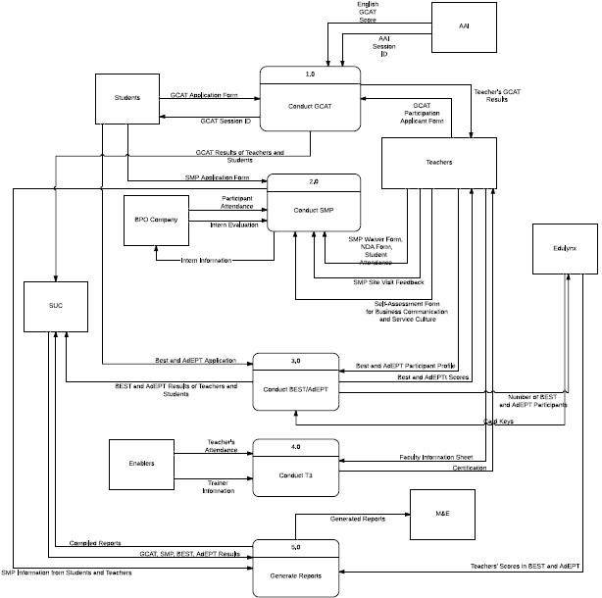

**Figure 3. Data Flow Diagram- Level 0**

## Status Reports

### Status Report # 1

|  |  |
| --- | --- |
| Project Status |  |

|  |  |
| --- | --- |
| Project Name | BPAP-CHED-SEI Project |
| Project Manager | Joy Federico |
| Date Prepared | September 28, 2013 |

**Meeting Information**

|  |  |
| --- | --- |
| When | September 9, 2013 (for the week of September 9 - September 15) |
| Reason | Pre-deliverable Meeting |

**I.**                  **Activities and Accomplishments During the Reporting Period**

Progress Description

·       For the week of September 9, the group concentrated in accomplishing the first deliverable before starting with the aforementioned activities. Nevertheless, upon the three groups merging the first deliverable was completed.

·       Here are the following completed activities:

o   Create Project Charter

o   Devise the Project Plan

§  Which includes: Skills Inventory Worksheet, Responsibility Matrix, Group Skills Analysis and Discussion, Organizational Structure, Work Breakdown Structure, Project Estimation

**II.**         **Problems Encountered**

a. Final Defense Issues

·       Based on the results from the final defense, the panelists discussed the difficulty to present the value of the project if done individually since the proposed scopes for each group were interdependent with each other. There were overlaps in terms of the scope for each of the three groups such as the dependency of the outputs from one system of one group to another. If ever one system does not execute its functionalities effectively, for instance the data capturing aspect, the backend and the output part will be suffering as well.

·       As a result, the three groups held a meeting to discuss the possibility of merging as one big group. The project manager for each group headed the meeting as everyone deliberated about the issue.

b. On the Deliverable

·       Upon consultation with Ms. Sandra, the group was advised to improve the paper in preparation for the first deliverable. Several of the concepts that were laid out vaguely and lacking further explanations (e.g. for the background, programs, current situation, project aim) from the previous deliverable.

·       On that account, the project assigned an equal distributions of members to do the editing (inclusive of the proofreading and expounding of certain parts).

**III.**         **Problems Solved**

a. Organizational Structure

·    Upon previous consultations and meetings, the three groups (i.e. Myriad, Tech5 and DoubleTap) decided to merge as one big group. However, this decision needs further justification and definition of roles considering the size of the group.

·       The best recourse that the group decided is to make the scope more complex in such a way that defending it as a group of 15 will be worth that level. As such certain restructuring of the group were carried out. The individual groups decided to come together as one team with the members to be assigned to different teams (i.e. Monitoring and Evaluation, Data Capturing, Development) led by each subproject managers and spearheaded by an overall project manager.

·       With this, each member were assigned to the aforementioned teams based on their skills sets to utilize their capabilities extensively. Alongside this, the scope is then broadened with the assignment of different roles and tasks for each member.

**IV.**         **Problems Still Outstanding**

a. Project Scoping

·       After merging, the team needs to consult with BPAP (c/o Mr. Dulce) as to how the project can be given more more value in order to broaden its scope.

**V.**         **Schedule progress vs. Planned progress**

|  |  |  |
| --- | --- | --- |
| **Activities** | **Planned Schedule** | **Actual Schedule (Status)** |
| Conduct Data Gathering | Sept 12 - Sept 27 | Pipelined |
| Analyze Data Gathered | Sept 22 - Sept 27 | Pipelined |
| Formulate Policies and Procedures | Sept 11 - Sept 22 | Pipelined |
| Researching for Technical Requirements | Sept 28 | Pipelined |
| Create System Design | Oct 2 - Dec 5 | Pipelined |
| System Development | Dec 6  - Jan 16 | Pipelined |
| Conduct Testing | Jan 3 - 24 | Pipelined |
| Create Manuals | Sept 19 - Jan 28 | Pipelined |

**VI.**         **Expenses vs. Budget  *(if applicable)***

Expenses for this meeting are in compliance with the estimated project.

**VII.**         **Plan for the succeeding periods**

·       meeting with Ms. Sandra/Sir Olpoc

·       meeting regarding the first deliverable

### Status Report # 2

|  |  |
| --- | --- |
| Project Status |  |

|  |  |
| --- | --- |
| Project Name | BPAP-CHED-SEI Project |
| Project Manager | Joy Federico |
| Date Prepared | September 28, 2013 |

**Meeting Information**

|  |  |
| --- | --- |
| When | September 16, 2013 (for the week of September 16 - September 22) |
| Reason | Post-First Deliverable Meeting |

**I.**                  **Activities and Accomplishments During the Reporting Period**

a. Conduct Data Gathering

·       The Monitoring & Evaluation sources and book references were gathered and distributed to the M&E members to be read and reviewed for future meetings and framework design.

·       Existing data, forms, and other relevant information were also requested from the project managers of the BPAP Project Delivery team. Constant communication between the Head PM and Ma’m Arra was developed.

·       The existing forms that the Project Delivery team and SUC were obtained.

·       Meetings with the Project Delivery team and Ma’m Reli Neo were requested to be conducted within the week.

·       Project Delivery meeting

o   Members of the Data Capture and M&E team attended the meeting.

o   It was an in-depth orientation/walkthrough of the programs and courses of the project. The project managers also explained their criteria, goals, and processes for each course.

·       Monitoring and Evaluation meeting

o   Ma’m Reli explained the criteria and requirements for creating the framework and outputs design. She also explained how the LFAs will be the basis of constructing the forms, policies, framework, etc. Expectations from both parties were also laid down during the meeting.

**II.**         **Problems Encountered**

a. First Deliverable issues

·       There were several issues concerning the submission of the first deliverable paper. First, the hard copy of the paper was crammed and submitted late. Second, the lack of people responsible with regard to the completion of the paper. Third, there were also technical issues that arose during the making of the paper.

·       The paper was crammed and submitted late despite the large number of people who could have helped. The final paper also did not look professional and had to be polished in a short amount of time.

·       The large of number people allowed others to become loafers and depend on the active few people to complete the paper. Because of this, the time and quality of the paper were compromised.

·       The technical issues became a problem for a few people when the central document repository application, Google Drive, failed to sync the necessary documents. This cost the paper the time and effort to complete it earlier.

·       The problems were likely to be caused because of the changes brought about by the adjustment of the group structure. Even though individual roles were defined, the clear-cut rules and instructions were not instituted as of yet. Because of the cramming, controls were also not put in place.

·       These issues cost the group the ability to submit the documents on time. The Head Project Manager and the sub-project managers addressed these issues immediately. New methods, policies, and work ethics are being implemented to prevent the situation happening again.

**III.**         **Problems Solved**

a. Task responsibility

·       To address the issue concerning the loafers, a new method of responsibility was implemented. Instead of specifically assigning tasks to each members, a group of members were instead given general assignments that the group must work on together.

·       This method aims to avoid putting too little work on one person and preventing people from thinking their job in the whole deliverable-making is done once their own individual task is completed.

·       To better monitor the tasks, activities, and persons responsible, a Trello account was made that included all of the members. This web tracking will enable us to view which activities are completed and pending, who we will contact for the particular task, and which ones need more work or help. This Trello will be managed by the project managers of the group but will also be viewed and updated by the members.

        b. Technical difficulties

·       Since the desktop application of Google Drive was posing problems for the group, the group decided that using the web application was more feasible since it did not show the issues such as syncing problem in the desktop application.

        c. Organizational structure

·       The controls to monitor and track member progress must also be addressed through human means. Considering the size of the group, each project manager has devised ways in which members are better monitored. Most of all, it took an adjustment with regard to time and experience between the project manager and the member to get accustomed to their roles.

**IV.**         **Problems Still Outstanding**

        N/A

**V.**         **Schedule progress vs. Planned progress**

|  |  |  |
| --- | --- | --- |
| **Activities** | **Planned Schedule** | **Actual Schedule (Status)** |
| Conduct Data Gathering | Sept 12 - Sept 27 | On-going |
| Analyze Data Gathered | Sept 22 - Sept 27 | Pipelined |
| Formulate Policies and Procedures | Sept 11 - Sept 22 | Pipelined |
| Researching for Technical Requirements | Sept 28 | Pipelined |
| Create System Design | Oct 2 - Dec 5 | Pipelined |
| System Development | Dec 6  - Jan 16 | Pipelined |
| Conduct Testing | Jan 3 - 24 | Pipelined |
| Create Manuals | Sept 19 - Jan 28 | Pipelined |

**VI.**         **Expenses vs. Budget  *(if applicable)***

Expenses for this meeting are in compliance with the estimated project.

**VII.**         **Plan for the succeeding periods**

·       General

o   Meet with the respective team’s PMs

·       M&E Team

o   Submit outputs and frameworks for review by Ma’m Reli

o   Conduct more client meetings

o   Obtain additional relevant documents and forms to be analyzed

### Status Report # 3

|  |  |
| --- | --- |
| Project Status |  |

|  |  |
| --- | --- |
| Project Name | BPAP-CHED-SEI Project |
| Project Manager | Joy Federico |
| Date Prepared | September 28, 2013 |

**Meeting Information**

|  |  |
| --- | --- |
| When | September 24, 2013 (for the week of September 24, 2013 - September 28, 2013) |
| Reason | Pre-Second Deliverable Meeting, SMP Implementation for Students |

**I.**                  **Activities and Accomplishments During the Reporting Period**

a. Data Capture Team

·       Analyze forms given by Ms. Arra

·       Meeting with SMP Project Managers

·       Accomplished communications management

b. M&E Team

·       Obtained all forms & LFAs

·       Gathered all the lists from GCAT, SMP, BEST, Adept

·       Construct measures of the LFAs

c. General

·       Deliverables: change management, risk management, communications management, status reports, lessons learned, project closure

o   The September 27 meeting focused on the LFA and its implication on SMP.  Data needed for SMP have been noted, as well as the possible ways to the program may be offered by the SUC to be able to track and monitor the program. The process by which it is offered is completely dependent on how the SUC has decided to offer it.

o   Data needed for SMP would be student name, student number, gender, course and college as well as the SMP subject/components taken (if already taken and reason why it is being taken again) and the date the student has taken each subject and status if it has been failed or passed. SMP includes internship so the company name should also be noted including the immediate supervisor and if the student has passed or failed internship and if the student has been considered for employment or not.

o   According to the project managers, it has been agreed that GCAT will no longer be given after the program. It was also noted that BEST and e-Adept components can be credited as substitutes for an SMP subject.

**II.**         **Problems Encountered**

·       Not all members were present for the meeting

·       No definite time for M&E tasks to schedule

·       Data were insufficient to start on certain deliverable and analysis

**III.**         **Problems Solved**

·    A developer of the group has noted the issue of ad hoc reporting and suggested possible alternatives so there won’t be a need for ad hoc reports. Necessary pre-generated reports would be more convenient.

**IV.**         **Problems Still Outstanding**

·       Some SUC compliance documents have yet to be addressed such as MOA and how the program will be integrated and the group will be informed of the processes once BPAP received these documents.

**V.**         **Schedule progress vs. Planned progress**

|  |  |  |
| --- | --- | --- |
| **Activities** | **Planned Schedule** | **Actual Schedule (Status)** |
| Conduct Data Gathering | Sept 12 - Sept 27 | On-going |
| Analyze Data Gathered | Sept 22 - Sept 27 | On-going |
| Formulate Policies and Procedures | Sept 11 - Sept 22 | On-going |
| Researching for Technical Requirements | Sept 28 | Pipelined |
| Create System Design | Oct 2 - Dec 5 | Pipelined |
| System Development | Dec 6  - Jan 16 | Pipelined |
| Conduct Testing | Jan 3 - 24 | Pipelined |
| Create Manuals | Sept 19 - Jan 28 | Pipelined |

**VI.**         **Expenses vs. Budget  *(if applicable)***

Expenses for this meeting are in compliance with the estimated project.

**VII.**         **Plan for the succeeding periods**

·       Data Capture Team

o   Meeting with PMs to gather more data

·       M&E Team

o   Start formulating policies & procedures

o   Obtain additional relevant forms and documents to be analyzed

·       Development Team

o   Conduct more client meetings

o   Research technical requirements

·    More meetings would be held regarding other components such as SEI and the group would be updated if changes have been discussed between the project managers. Shared Services will also have to be consulted regarding other processes involved.

## Minutes of the Meeting

### Meeting Date: 09/09/13

### Meeting Location

* Building: Research Lab (AdMU)

### Meeting Start

* Meeting Schedule Start: 4:30 PM
* Meeting Actual Start: 4:45 PM

### Agenda

* Ask for Ma’am Sandra and Sir Olpoc’s advice for the project scope
* Questions raised:
  + How to present the value of the project as one big group or three separate group?
  + Is it distinct enough to see the output?
  + How to validate the data? (as per sir Doy’s assumption, encoders are not knowledgeable that is why you end up cleaning)
* Rethink the scope
* Discuss with Ma’am Sandra about paper and her comments

### Meeting End

* Meeting Schedule End: 6:00 PM
* Meeting Actual End: 5:40 PM

### Decisions/recommendations

* Either:
  + Retain as group of 15 (one big group)
    - Prove the project’s worth for that team size
    - Have 1 PM, 3 assistant PMs
  + One group needs to break away and look for another project
* Descope and find more value for the project
* Revise paper to be ready for next deliverable

### Next Meeting

* Next Meeting: BPAP, 09/11/2013 4:30 PM

### Meeting Date: 09/11/13

### Meeting Location

* Building: BPAP (Bonifacio Global City)

### Meeting Start

* Meeting Schedule Start: 4:40 PM
* Meeting Actual Start: 4:45 PM

### Agenda

* Meet with Ma’am Reli (PM for M&E)
* Refresh with the status of the group
* Discussed:
  + Terms
    - MNE = Monitoring and Evaluation
    - LFA = Logical Framework Analysis
    - POC = Point of contact
  + Workplan of Ma’am Reli
    - Main request is to start as soon as possible
    - Procedure, templates ( she has hard copies of these because she is still looking for it ) FOLLOW UP
    - Standard for future meetings 🡪 bring a hard copy, and send it in advance.
    - MNE book 🡪 Provides an idea what MNE does in terms of project management. And expected roles role for MNE
    - Book 2  🡪 compare MNE of proj management office and book. Come up with an MNE framework READ THE DAMN BOOK.
    - What processes do we look at in MNE.
    - Ms Reli will give the starting documents LFA (document the meetings, document policies. )
    - Policy for the implementation of project and MNE are different.
    - How does MNE talk to proj delivery - bpap point of view *iba yung performance indicators para masagot kahit sino magtanong*
    - MNE is a decision making tool
    - Project delivery team 🡪 demo GCAT BEST ADEPT and how they would be tracking the students.
    - 3rd column of LFA, compare it sa bago vs sa luma ( she made us look into this )
    - Value = not only for ched, can also be used for sei dost etc with almost the same products corporate report ( annual report )

### Meeting End

* Meeting Schedule End: 6:00 PM
* Meeting Actual End: 6:00 PM

### Decisions/recommendations

* Know LFA BY HEART
* Book given will tell you how to set up MNE ( read up )
* Ask policies templates hard copy from Ma’am Reli

### Next Meeting

Next Meeting: BPAP, 09/20/2013 3:30 PM

### Meeting Date: 09/20/13

**Meeting Location**

* Building: BPAP (Bonifacio Global City)

**Meeting Start**

* Meeting Schedule Start: 3:30 PM
* Meeting Actual Start: 3:40 PM

**3 agenda**

* Data Gathering and M&E meeting
* **Data Gathering meeting**
  + People:
    - Myra santos - sei only program manager
    - Ella - southern tagalong
    - Arra - visayas Mindanao
    - Victor ched northern Luzon schools
    - Sir Jopat
  + Drafts are provided
  + SEI and CHED have same project components. Deployment is almost the same except for the geographical coverage difference.
  + **SEI**
    - NCR 15 schools. SEI has private schools
  + **CHED**
    - Covers the 3 major islands 17 SUCs.
  + What the deployment team does (Ma’am Ella, Ma’am Myra, Ma’am Arra, etc.)
    - Their team is the deployment team, the rollout, they design what needs to be done. In every project there is a monitoring but it is not their turf.
    - Monitoring and evaluation is not from them they just deploy.
    - Their goal:
    - # of teachers trained for track
    - goals for the students
    - divided the allocation
    - divide that among 17 SUCs (for CHED project)
    - training of master trainers (deployment)
    - target beneficiary - both have students and teachers
    - we need to ensure students will take all subjects (need to be complete)
    - be able to link the students take a particular subj the semester
  + DEPLOYMENT TEAM
    - does the roll out
    - there is an M&E component
    - not has been defined
    - beyond scope of deployment team
    - they generate data
  + **Some other extra details the deployment team shared about the project:**
* The projects are not essentially data gathering but in the course of deployment, we gather data.
* More of a monitoring thing than data gathering.
* Partners with enablers then with master trainers who will teach trainers then teach the students.
* They already submitted what they wanted to accomplish and divided it into the 17 SUCs
* Intervention for teachers and intervention for students. (GCAT, BEST, ADEPT, SMP)
* Goal is to give intervention to the ones who need it and 70 % of students for employment.
* Teachers training has an immersion part- for teachers to have an understanding on how the environment is and how the IT-BPO industry is. Immersion = site visit. Attendance is strict for the teachers because it is part of their submission to audit. Teachers should complete the faculty information sheet this will be the basis of information for the teachers. They don’t have that for students yet, only for faculty.
* link all info with regard to monitoring of students who took GCAT and CHED in particular year; scholar and other information
* **Problems on standardizing the forms**
* Resistance to change of the SUCs on the different forms. Difficult to have them follow one format because their registration processes are different from each other. (Ma’am Reli mentioned that we could still find ways to standardize the forms, but it is not our job to worry about fixing the format of forms the SUCs give because it’s the deployment team’s responsibility—could someone clarify or confirm this?)
* **Meeting with Ma’am Ella About Processes**
* **GCAT**
  + - 5 skills and a behavioural component part.
    - preGCAT -not necessarily taking SMP will GCAT
    - Selection of the student/teacher are IT AND BM students. Priority are SMP students and 2 schools are mandatory for IT and BM. It is different for every school as to how they apply SMP. Others are just electives. Some are majors such as "Business Management Major in SMP", although not yet approved. If they apply it as major that solves their problem.
    - Link on test permit where there would be a session id = pins. **Wala na daw pins.** They get the results 2 1/2 to 3 hours after. AAI generates report and sends excel to BPAP, usually to the project manager. BPAP gives out the pin. Each pin will serve as an identifier of the students to whom they will be given to. If it hangs, pin would solve the problem.
    - Either teacher or student take the exam online where they put their information that’s the one that was forwarded to us by Arra.
    - In determining those who need to take the best and adept, they look at their English proficiency scores.
    - If they score between 40-45(percentile), then they take BEST. If 45-85 AdEPT. If 90 and above, sometimes they don’t need to take BEST or AdEPT. CHED and SEI: No GCAT, no program. It may be different for other interventions. GCAT depends but at least 1 test.
    - Reporting: school level reporting by course, by school. For now, by student results, school, course within school, to follow. Report will be given to the students more on percentile. Reports are given out to the schools so that they would know their strengths.
* **BEST and AdEPT**
  + For the teachers
    - Criteria
      * Faculty development, for personal gains - still part of the CHED BPAP project. - anyone who would want to develop English skills.
      * T3 - they require English teachers.
      * Once identified they fill in faculty info sheet. For BEST T3, no more assessment. For T3 for students for best2 days
      * Faculty dev still inconsistent but so far 3 days. It is expected t3 to teach dev no. They can see their scores they can take it multiple times. Best and adept have software components that have similar features. Extract from Edulynx is important. We need to track the scores from the excel file from Edulynx. We just collect the data. Data in database. Gets pre and post assessment results for reporting. Edulynx 🡪bpap 🡪 students.
      * They need to capture the card keys to prove that they used the keys. They install the cd card is the key for succeeding log in is the card key. 2 components login name and password. “We're limited with the current software provider but we noted it out for future references.”
* **SMP** 
  + No software, teachers first they have a criteria on who would teach but the school decides on the criteria
  + Different schools have different implementations of SMP
  + Criteria
    - * Email to follow from Ma’am Ella.
      * Once chosen fills faculty info sheet which is then given to master trainer. No more assessment. However, at the end of the class, the master trainer assesses/recommends the teachers who should be teaching or not teaching. They give that information to BPAP that could be discussed with the school or principal of the school. Training will give Lvl 1 certification after completion of training. After that they would be teaching but the master trainer visits and again assesses the teacher. There will be another criteria for level 2 certification. Level 2 means they can teach. Freedom! This just means they have completed the training. May lvl 1 kahit di recommended to teach. Must track the teachers certification.
      * Fyi master trainers have 3 levels of certification * data to be given for that *
      * Wala na grades but number of people who took the course.
      * record pass or fail hindi na rin but must take note that the student took the student again.
      * Monitor enrolled because they want to know if they're close to the goal of number of students enrolled.
* **Additional Notes on PM Checklist:**
* after signing with CHED, go to 17 SUCs and tell them abt the proj and components (orientation)
* have an agreement with SUCs (goals with budget, subdivided by 17 SUCs)
* now they have work and financial plan for each 17 SUCs (attachment of tripartite MOA)
* next, sign MOA with SUCs
* now implementing programs with SUCs (but no tripartite moa yet --need to be sign by ched, suc, bpap)
* immediate action.
* suc meeting? --needs basis how to divide in 17 sucs
* STEP: SCHOOL READINESS ASSESSMENT (check possible success of proj in a particular suc)
* T3 run
  + during the T3 and after that, identify who will be the master trainers to be assigned per schools and teachers participants
  + CRITERIA for selecting teachers for particular tracks (for better appreciation)
  + determine the logistics for master trainers
  + training guidelines (for preparing daily sched of T3 run ; normally 6 days per track)
  + IMMERSION: go to BPO company so teachers will have an understanding of the process of students applying in IT BPO industry (site visits)
* Forms
  + attendance sheet must be prepared
  + faculty info sheet (For the teachers)
  + manuals and other materials
* graduation program (track in database who completed the training- Level 1 certification)
* once T3 is done, prepare reports for liquidation (attendance sheets etc.)
  + gcat results for storage
  + teachers now handle classes
* need to be able to get the names and info of students to be tracked til they completed SMP
* at this pt, 1000 students enrolled in SMP subjs (biscom, service culture, bpo 101 --dont need prereq)
* get data rom school then it's all about migration (hope the sys can accommodate )
* **M&E meeting**
* CHED
* 17 SUCs with 4 products to deploy on diff numbers
* 2 levels (student and teacher)
* M&E framework
* for BEST, GCAT, ADEPT, T3, immersion
* OPIF - reference guide in terms of govt rules and reg
* Doing the M&E framework - Refer to the Gantt chart sent by Ms Reli (activities for setting up the M&E)
* M&E
  + based on data generating form
  + based on the LFA
* **Some other extra details Ms. Reli shared about the M&E**
* level of performance indicators of CHED are shorter because the things included there are the relevant ones
* LFA of CHED are higher set of indicators (more general)
* needs to see the contract because that is what is to be reported to CHED
* ADEPT and BEST are short courses
* in 1 reporting period (quarterly report) = it can finish quickly
* ex.1=  5000 students from Adept
* under that, u have on going classes, and completed classes (breakdown into classes)
* if the indicator is number of students in on going classes and # of students who completed
* reporting ng results for # of students who completed will be placed in completed classes
* M&E reports should be able to answer everything from the LFA
  + based sa LFA performance indicators (dahil doon iaaudit)
  + just be guided na kung ano nasa perf indicator,
  + more of a status report
* reporting period for the government: march, june september and december

Meeting End

* Meeting Schedule End: 6:00 PM
* Meeting Actual End: 6:37 PM

### Decisions/recommendations

* **Data Gathering: What they want us to do**
* We need to track and make sure the students take all subjects. It needs to be complete and link the student to subject. Show history.
  + - * **tag when a student takes a program and how many times/when they took it** (is it before or after the intervention)
* They need the information of the students (as of now 1000 students enrolled in the program).
* Profile of students so that they would be able to choose the proper students for the intervention. **How students are chosen:** First priority would be dost scholars (first to 5th year) then non dost, then graduating students.
* They prefer more of pc based than on the cloud and they’re avoiding repetitive encoding.
* Graduates who work in the IT-BPM industry should be tracked. May not be working in the IT-BPM industry. There should be a way of checking that the students took GCAT because GCAT will also determine if they’re employable.
* When the students took the GCAT. Make sure that they only took it once because it’s a waste of resources to have them take it multiple times.
* We need to track the scores from the excel file from Edulynx. We just collect the data. Data in database. Gets pre and post assessment results for reporting. Edulynx 🡪bpap 🡪 students. They need to capture the card keys to prove that they used the keys. They install the cd card is the key for succeeding log in is the card key. 2 components login name and password. “We're limited with the current software provider but we noted it out for future references.”
* Must track the teachers certification.
* Number of people who took the course (this does not include the grades anymore, only record “pass” or “fail” or in other words, keep track of whether the course was completed or not)
* Monitor enrolled because they want to know if they're close to the goal of number of students enrolled.
* We have to design our framework and design a monitoring database
  + present file designs (create DFDs, ERDs)
* do form design for students for diff tracks (needs student info first--prereq)
  + reports based on the LFA (LFA contains the goals of the project)
* for M&E
  + sync with the objective (providing hirable grads for IT BPO industry)
* way of checking GCAT scores = translate to employability
* create another app that will create a file then interface it to main file/db
* better to be PC based (than web based)
* need to have a database to capture info of SUCs - school information
* provide a draft tripartite MOA (necessary)
* **M&E: What they want us to do**
* imagine a way to put all the fields into 1 sheet (summarizing report)
* profiles (for individuals) - do a summary sheet for this form
* the data gathering forms answering to what LFA is asking for
* the measurements to be used for M&E reports are found in LFA
* ex. If you have a profile and inventory of GCAT etc –all should be captured 🡪 and is able to answer the LFA performance indicator
* identify which data gathering forms are to be transmitted to the SUCs
* need to see if data gathering forms respond to LFA
  + FRAMEWORK THAT WE NEED TO APPLY FOR ALL PROJS
* take a look at LFA and if we are able to generate more indicators, the better
  + look at data gathering forms and check if theres indicators in LFA that are not answered; if so we need to make a proposal for the things that need to be added
* proj level (summary sheet na SUC submitted to CHED/SEI) and summary sheet/form should look like:

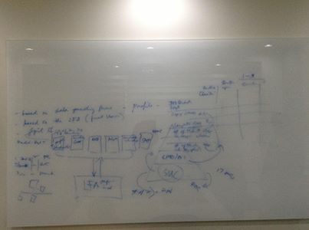

* envision how the framework should look like
* framework of data kung paano pumupunta sa M&E
* broader framework and a more specific framework
* create a process flow diagram (and digitize it)
* come up with MIS forms and templates, M&E system and policies
* the key to coming up with policies and guidelines is to define each box (what does this form mean?)
* since 17 SUCs to report to the project
* dapat may summary sheets ng lahat ng indicator
* summary sheets in database in SUC and CHED/SEI
* things needed by database:
* how many are on going this sem
* quarterly reports (take into acct profiles [ilan ang male/female], different reporting periods, kinds of reports [teachers, students])
* division of the M&E big bang team in creating the framework:
* LFA for each: (2 people per program) – GCAT, ADEPT etc.

### Next Meeting

Next Meeting: BPAP, 09/27/2013 3:30 PM

### Meeting Date: 09/27/13

Meeting Location

* Building: BPAP (Bonifacio Global City)

Meeting Start

* Meeting Schedule Start: 3:30 PM
* Meeting Actual Start: 3:45 PM

Agenda

* Meeting discussion
  + Based discussion on the LFA
  + Process should be with shared services
  + They will give what they need to track and monitor
  + Note: other ways of getting information from the SUCS.
  + SMP
    - Student enrols get name student number, subjects taken, the possibility of taking more than once with reason ex overcut. Not really after the grade. Must see if pass or fail. What are the smp subjects. Plus if they took best/adept/gcat. When they took it, which teacher were they under. How many times they took it
    - Data needed: Gender, course and college, when did they take Gcat (this can be verified through AAI)
    - Status Pass or fail to verify
  + Ways to offer - Will be offered as elective, specific set of students, specialization, or as a major, as a seminar or training, or as a scholarship
  + Should be unique - what if they changed schools
  + They’re after sustainability
  + 1 already signed MOA signed by bpap ched sucs notice to proceed ◊just numbers
  + Reporting total number na nagGCAt must be segregated.#best # of adept. # of smp ( any subject segregation , example completed 5 smp subj and completed even the internship.  # of those who have undergone internship. if internship, which bpo company wat job and immediate superior. Smp must be -70% of employability***( employable and not employable). Must know if ched or sei (for gcat adept)
  + **Process is different per school**
  + Employability will be based on the bpo company's assessment or
  + Note: PRE na lang ang GCAT*
  + Best and adept
    - May be a substitute for eng 3
  + GCAT
    - Students: recommendation for students who started to take gcat.
  + Sap Business objects - for reporting.

Meeting End

* Meeting Schedule End: 6:00 PM
* Meeting Actual End: 5:00 PM

## Decisions/RECOMMENDATIONS

* Work on the paper – data gathering and M&E

### Next Meeting

* Next Meeting: BPAP, date and time TBA

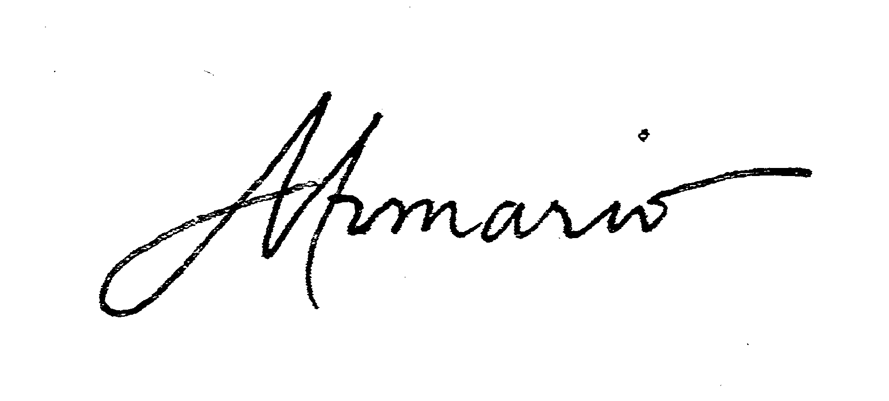

## CONTRACT OF AGREEMENT

KNOW ALL MEN BY THESE PRESENTS:

ontract made and entered into by and among:

This C

Michelle Angela Armario, student of MIS 141 and151 (IT Project Management and IT Management) in the first and second semester of 2013 respectively at the Ateneo de Manila University

Jean Raphael Carillo, student of MIS 141 and151 (IT Project Management and IT Management) in the first and second semester of 2013 respectively at the Ateneo de Manila University

Aaron Basco Casurao, student of MIS 141 and151 (IT Project Management and IT Management) in the first and second semester of 2013 respectively at the Ateneo de Manila University

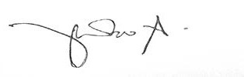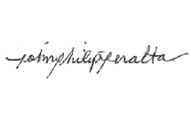

Raymond Joseph Nathaniel Castaneda Cruz, student of MIS 141 and151 (IT Project Management and IT Management) in the first and second semester of 2013 respectively at the Ateneo de Manila University

Francis Gerard Fajardo, student of MIS 141 and151 (IT Project Management and IT Management) in the first and second semester of 2013 respectively at the Ateneo de Manila University

ent) sity



Joy Federico, student of MIS 141 and151 (IT Project Management and IT Managem in the first and second semester of 2013 respectively at the Ateneo de Manila Univer

T

de

Chelsea Kate P. Galvez, student of MIS 141 and151 (IT Project Management and I Management) in the first and second semester of 2013 respectively at the Ateneo Manila University

Trishia Gerobiese, student of MIS 141 and151 (IT Project Management and IT ment) in the first and second semester of 2013 respectively at the Ateneo de niversity

Manage

Manila U

Simone Celina Enciso Jaldon, student of MIS 141 and151 (IT Project Management and IT Management) in the first and second semester of 2013 respectively at the Ateneo de Manila University

up

ater

e

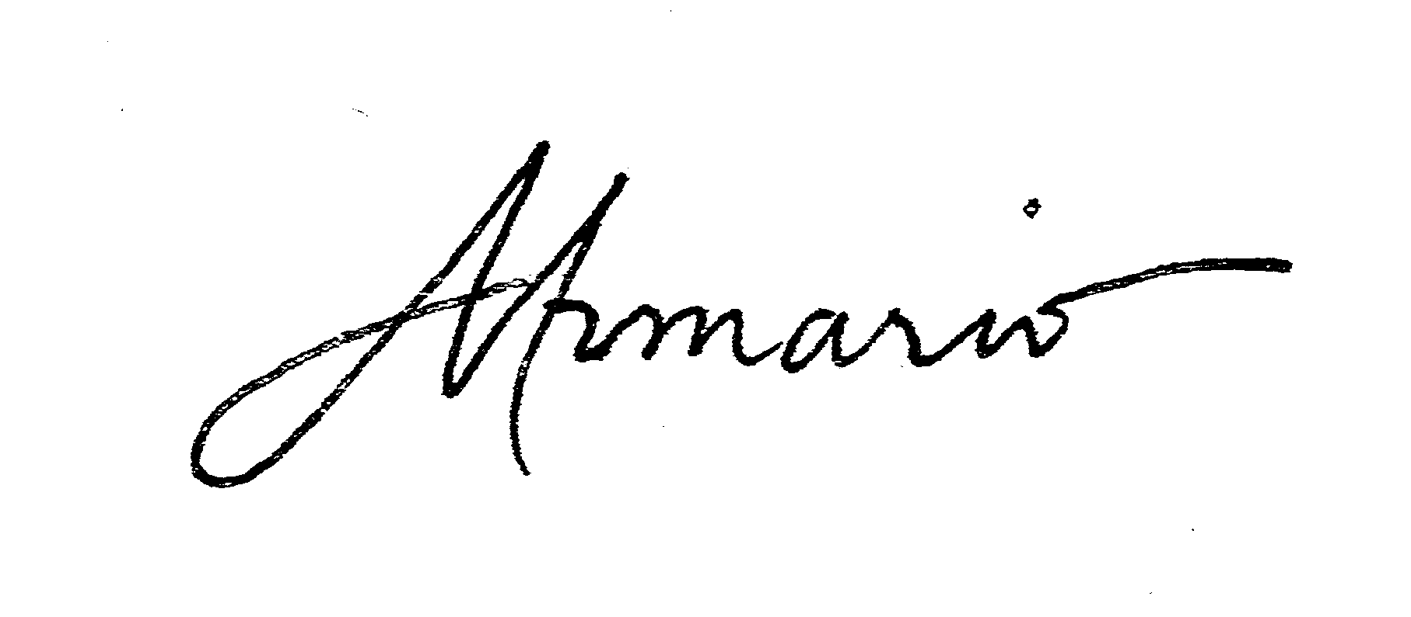Jan Paolo S. Luces, student of MIS 141 and151 (IT Project Management and IT Management) in the first and second semester of 2013 respectively at the Ateneo de Manila University

John Philip Peralta, student of MIS 141 and151 (IT Project Management and IT Management) in the first and second semester of 2013 respectively at the Ateneo de Manila University

Alecxandra Rimbao, student of MIS 141 and151 (IT Project Management and IT Management) in the first and second semester of 2013 respectively at the Ateneo de Manila University

Dayanara Simon, student of MIS 141 and151 (IT Project Management and IT Management) in the first and second semester of 2013 respectively at the Ateneo de Manila University

Evan Cedric C. Tan, student of MIS 141 and151 (IT Project Management and IT Management) in the first and second semester of 2013 respectively at the Ateneo de Manila University

Gerard Uygonco, student of MIS 141 and151 (IT Project Management and IT Management) in the first and second semester of 2013 respectively at the Ateneo de Manila University



W I T N E S S E T H



WHEREAS, on June 20, 2013 the course instructor instituted team work in MIS 141 and MIS 151.



EAS, said courses aim to expand the learning experience of the students through gro s.

WHER

project

WHER

EAS, said group projects aim to provide students with the opportunities to acquire gr ation of the relevance of the courser material to real-life situations.

appreci WHER

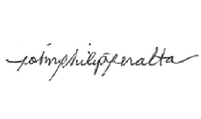EAS, said projects aim to afford the students with the opportunities to put into practice their communication and project management skills.

NOW, THEREFORE, for a consideration of the foregoing premises, the above-mentioned students agreed as follows:

ur

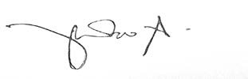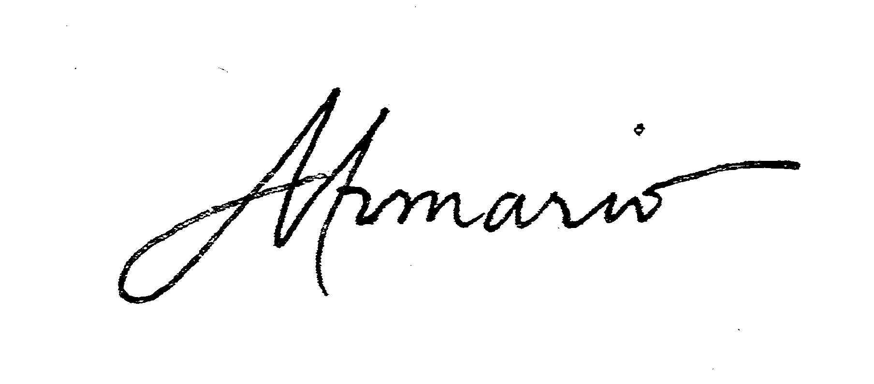

### 1. On team identity

1. The team is identified under the Big Bang

1.2 The team believes in exerting their best to ensure that the project that we undertake will succeed.

1.3. The team has an official e-group, which would be found at Facebook.

4 The team will use Google Drive as the main repository for project related documents, will also serve as backup for supporting files needed by the team.

1.

and

1.

5. The team will also use a collaboration website 'Trello' to keep track of the group's cuments and progress. this will also serve as an emergency countermeasure.

do

1.6.

ve

 The team will also use a development tool, subversion, to keep track of the latest

rsion of the software being developed.

1.7. The team is organized as a committee of peers with specialized roles and functions, where no one individual is of higher rank or status, and all have equal rights, responsibilities, and privileges in matters of voting, operations of the group, and other participation.

1.8 The team believes in making sure that the client's problems are gone, permanently by providing quality project execution.





### On task and role assignments

2.

o p

* 1. Each member must fulfill the task assigned to him/her, and deliver the expected utput 2 days before the deadline or in an agreed upon date. Late submissions will inc enalties.

2.

* 1. Assignments will be handed out during the weekly meetings.



* + 1. Meetings will be scheduled on Mondays, 3:30PM – 6:00PM at various locations, otherwise agreed upon by the group and/or Tuesdays from 4:30 to

0 PM, to be announced the week before.

6:0

* + 1. Meetings are mandatory unless otherwise stated and given consent.
    2. Meetings may be cancelled because of long tests or other pressing projects.
    3. Emergency meetings may be called only by the project manager and may not necessarily be posted on Facebook because of urgency.
    4. Emergency meetings may be called only by the project manager.
       1. Meeting must be announced at least 12 hours prior.
       2. Rules on attendance may be waived if a member will not be able to attend due to prior engagements.
    5. Meetings will be cancelled and moved to an agreed upon date if only at least one member from each committee are available and/or present during the meeting.

2.3

. Minutes of the meeting will be kept by either Michelle Armario or Trishia Gerobiese ard Uygongco.

or Ger

2.4. M

inutes will be uploaded to theTeam's official Facebook Group and Google Drive as secondary backup.

2.4.1. All assigned work should be uploaded through Google Drive on the agreed time regardless of hardware, software, or any logistical concerns. Failure to do so will result to agreed upon consequences.



**n participation**

**3. O**

3.1. All project-related costs incurred by the team will be divided among members; total cost is to be based on the expense log maintained by the group. Failure to record an expense by an individual will not be accountable by the group.



Members are required to be present in crucial team meetings, emergency or eduled.

3.2.

sch

3.2.1. Members are required to confirm attendance upon announcements of meetings, to be announced on the Facebook group, with consent to be agreed upon by the rest of the members.

* 1. All decisions will be voted upon by the members.





* 1. All documents relevant to the team and to the project should be uploaded to the official Facebook group or Dropbox regardless of hardware, software, or any logistical concerns. Failure to do so will result to agreed upon consequences.

ed

* 1. 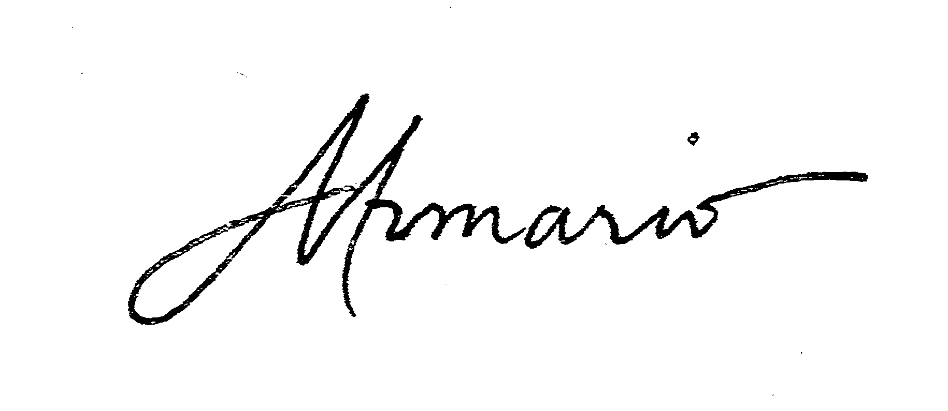Members must participate in all activities during the project, i.e. creation of deliverables.

3.

th

6 The setting and cancellation of meetings are to be agreed upon by the majority of e group at least 24 hours before the said date.

* 1. Members are allowed to be late within 15 minutes but more than that. The member

 must have a valid reason. Failure to do so will result to agreed upon consequences.

* 1. Absences must be informed 24 hours before the meeting.
  2. Deliberation of the nature of the absences will be handled by the project manager or he person-in-charge of the meeting in case the project manager is absent if absentee s excused or not.

t i

3.10. A quorum is defined by 60% presence of official group members.

3.11.

mem

All foreseen problems should be relayed to the group immediately. It is the ber’s responsibility to shoulder the consequence and provide solution to the

problem at hand.

3.12 Reasons and notices for an absence or tardiness in a meeting should be made at least an hour before meeting.



**On the consequences of failure to abide by abovementioned agreement**

**4.**

* 1. If the reason for an absence in a meeting is inexcusable (e.g. laziness, forgetfulness), the member must pay penalties.



* + 1. P100/absence
    2. Five (5) invalid excuses will put the person under group deliberation for termination or other consequences.
    3. A 15-minute grace period is allotted for every meeting. Beyond that, the member will be subjected to a fine of P2.00/min. An hour late will be consider an absence.



* + 1. Failure of a member to give notice of tardiness or absence in a meeting before the said scheduled will incur an initial penalty of P50.00 and will increment by 100% in succeeding violations.



4.1.4. Failure to post non-emergency meeting will incur a P100.00 fine.

o

* 1. 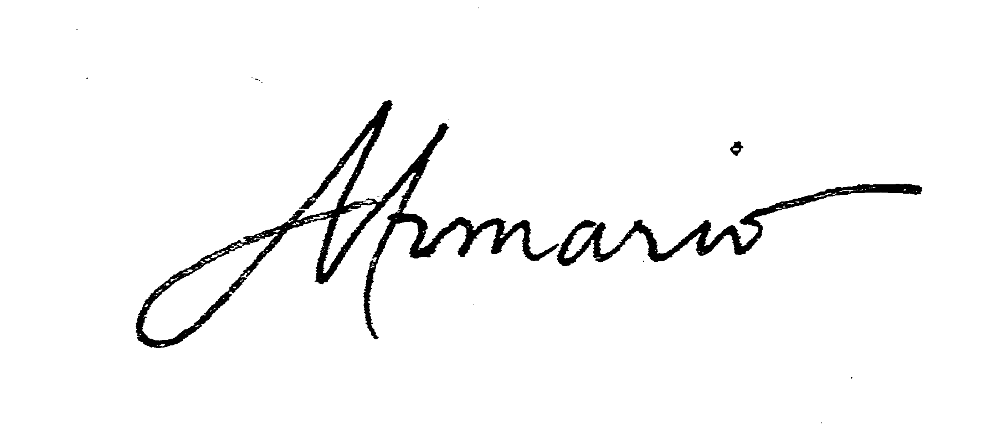A member may disobey any part of the abovementioned agreement only once. Succeeding offences will incur penalties.

4.

* 1. All members are required to submit assigned deliverables on time.
     1. First late submission – P100.00
     2. Second late submission – P200.00
     3. Third late submission or non-submission– A letter grade lower for the submitted deliverable

4.4. Undesired behavior will not be tolerated. Any problems with fellow team members that may affect the group’s performance will be reported to the project manager. Penalties will be discussed accordingly.

5 Academic penalties

4.

* + 1. Academic penalties can be activated by a simple majority through a formal verbal request or a letter to Mr. Olpoc aka "Intervention". The Intervention cannot be revoked once activated



* + 1. Academic penalties can apply either to the project manager or a team member
    2. The following academic penalties may apply:



4.3.3.1 Failure of team member to sufficiently participate or contribute during the execution phase of the project will receive one letter grade lower (e.g. B+ to C+) than the group grade received during the final defense.

* + - 1. Non participation of a team member will receive a D for the project component of the final grade.
      2. Failure of team member to sufficiently participate or contribute t any deliverable, will receive a deduction of 15 points of the raw score

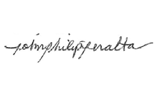





IN WITNESS WHEREOF, the parties have hereunto set their hands this 16th of September 2013.

Joy Federico Francis Fajardo Paolo Luces



Raymond Cruz Dayanara Simon Philip Peralta



Gerard Uygongco Alecxandra Rimbao Aaron Casurao

Trishia Gerobiese Simone Jaldon Michelle Armario

____________

Chelsea Galvez Evan Tan Raphael Carrillo



SIGNED IN THE PRESENCE OF

Mr. Joselito C. Olpoc

MIS 141, IT Project Management Instructor Ateneo de Manila University

1. See Appendix for NPV
2. See Appendix for ROI